# Pre-Requisites

* Export Custom Notification Templates from Production Environment and keep as backup. After upgrade all the custom notification templates will be overridden to default.
* Email Driver Properties of production IAM system

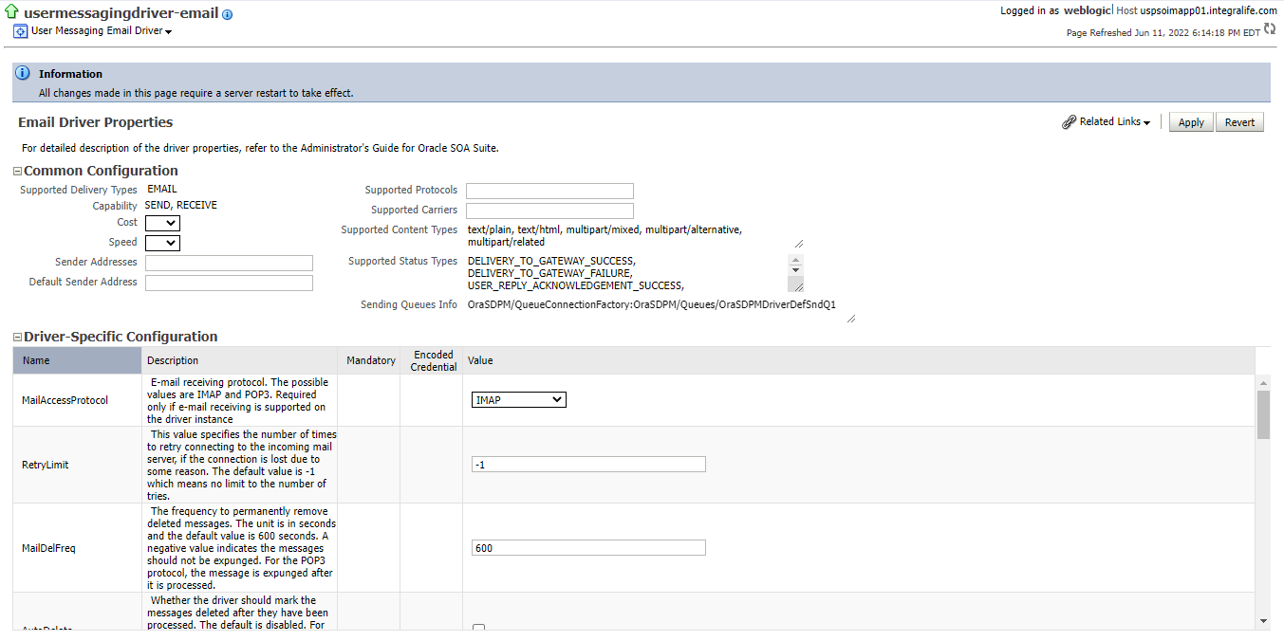

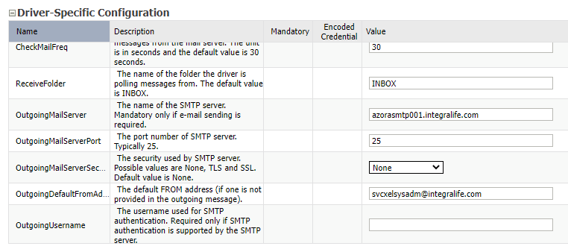

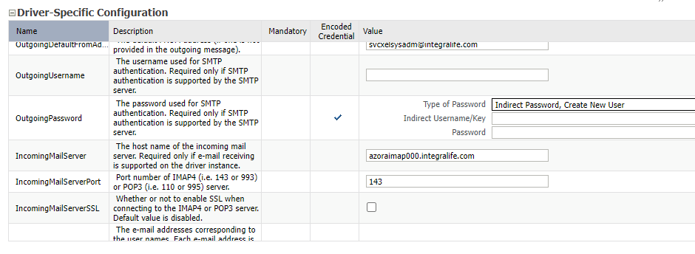

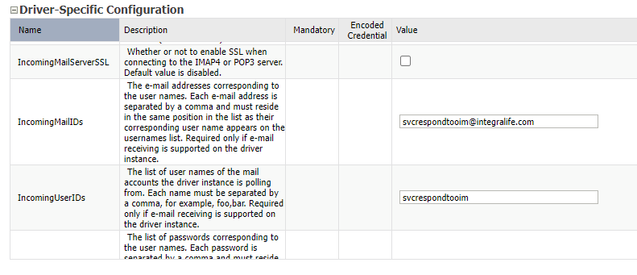

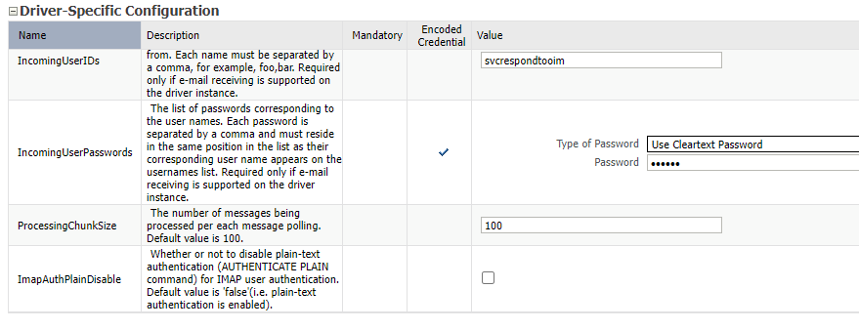

* Verify Manager is getting user creation email notification with username and password on new identity creation in IAM system

# Download Required Software’s

1. Download the below Software’s from Oracle Software Delivery Cloud.

<https://edelivery.oracle.com/osdc/faces/SoftwareDelivery>

* fmw_12.2.1.4.0_infrastructure.jar
* fmw_12.2.1.4.0_soa.jar
* fmw_12.2.1.4.0_idm.jar

1. Downloaded the above Software’s and copied in the location “/stage/SOFTWARE/OIM1224”.
2. Create a new mount point(u03) to install the OIM 12c infrastructure and copy the above-mentioned software’s to /u03 directory.

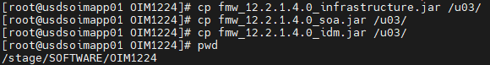

1. Downloaded the jdk-8u311 and latest OIM 12c bundle patch(p33762692_122140_Linux-x86-64.zip) and copied in the location /u03.

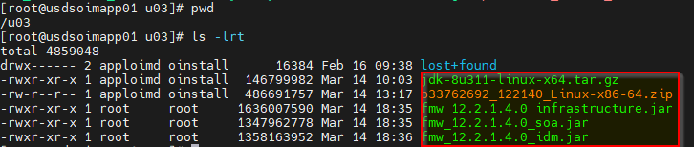

1. Change the permissions to the local user i.e., “**apploimd**” for the downloaded software’s using below command with root privileges.

**chown -R apploimd:oinstall fmw_12.2.1.4.0_idm.jar fmw_12.2.1.4.0_soa.jar fmw_12.2.1.4.0_infrastructure.jar p33762692_122140_Linux-x86-64.zip jdk-8u311-linux-x64.tar.gz**

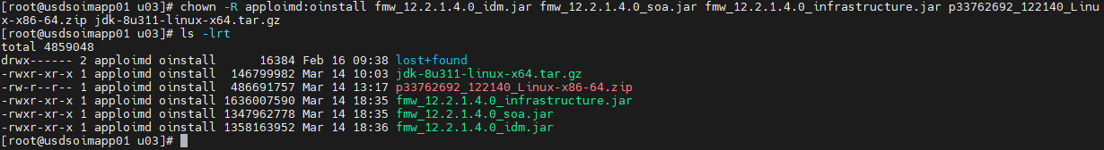

# Create Directories

1. Switch to the user “**apploimd**”.

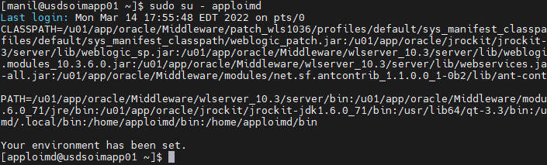

1. Create the below directory structure under /u03.

**/u03-**

**| - oracle –**

**| - java –**

**| - product –**

**| - config –**

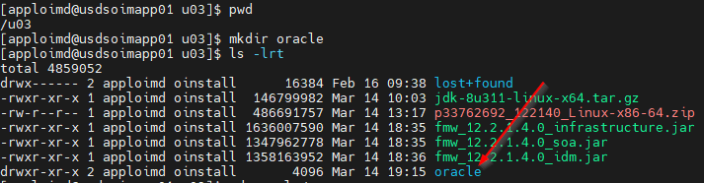

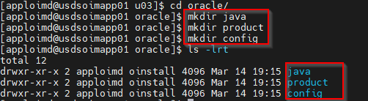

# Install Java

1. Copy the “**jdk-8u311-linux-x64.tar.gz**” file from “/u03” to the location “/u03/oracle/java”.

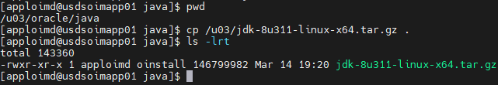

1. Unzip the file using below commands from the location “/u03/oracle/java”.

**gunzip jdk-8u311-linux-x64.tar.gz**

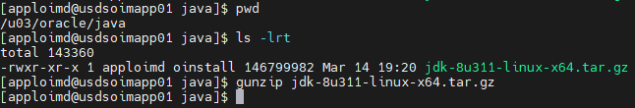

**tar -xf jdk-8u311-linux-x64.tar --strip-components 1**

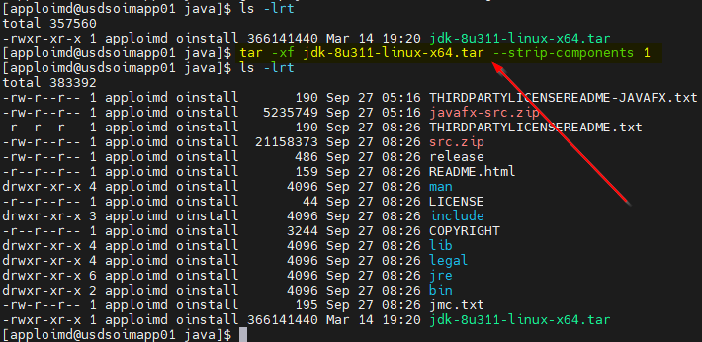

1. Remove the “jdk-8u311-linux-x64.tar” file from the directory “/u03/oracle/java”.

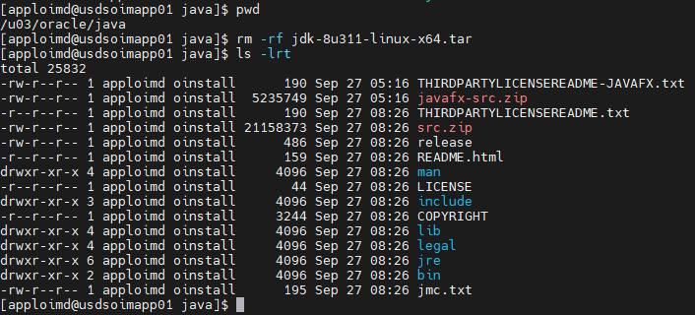

# Install OIM 12c Components

## Install WebLogic 12c Infrastructure

1. Run the below command from the location “/u03”.

**/u03/oracle/java/bin/java -jar fmw_12.2.1.4.0_infrastructure.jar**



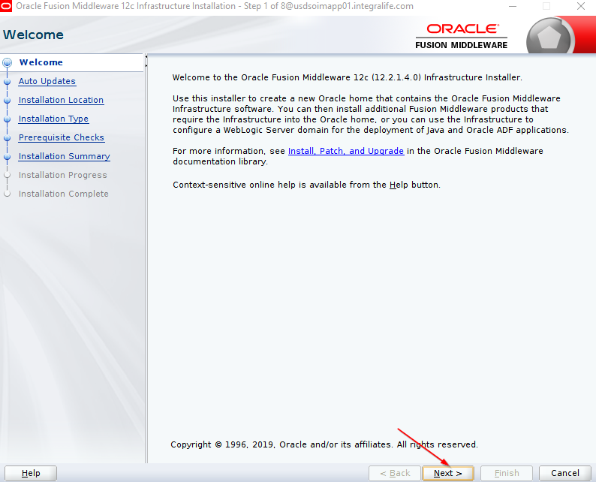

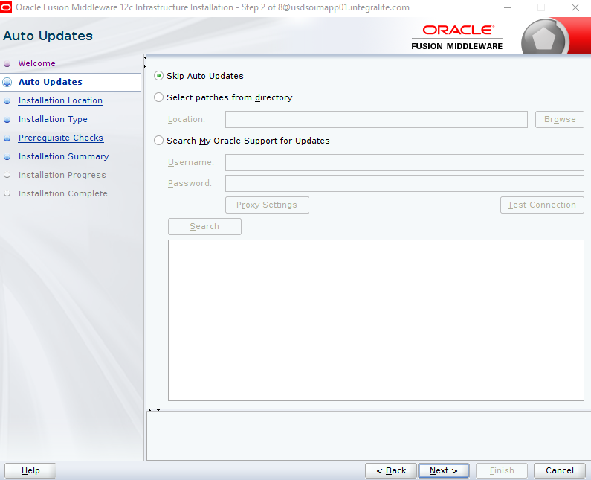

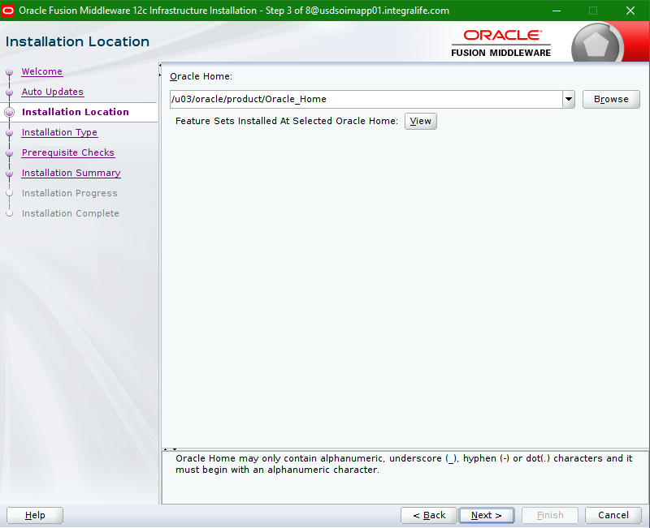

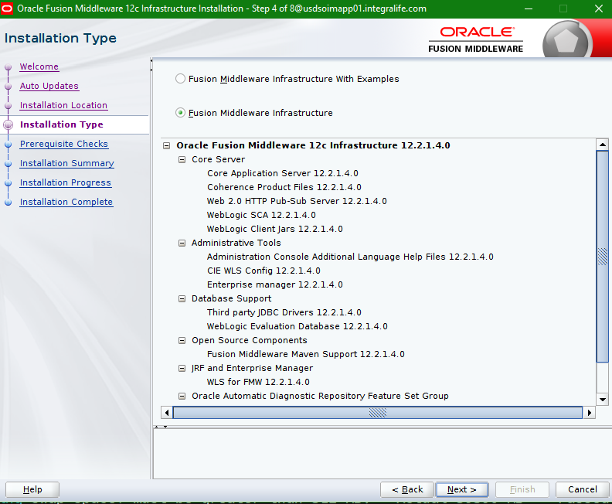

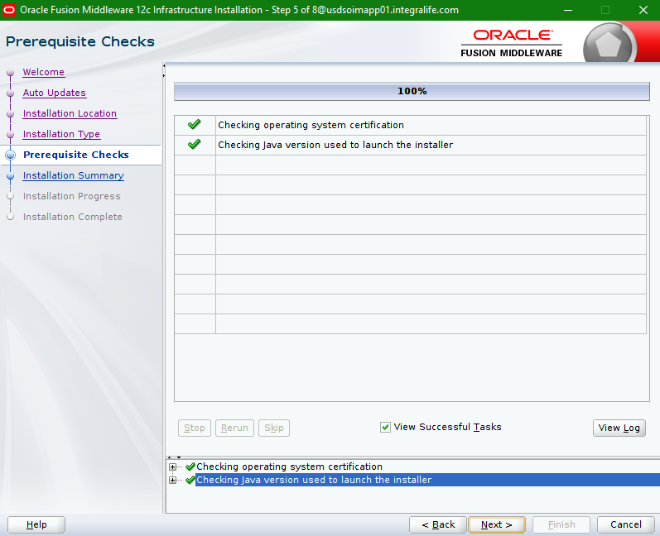

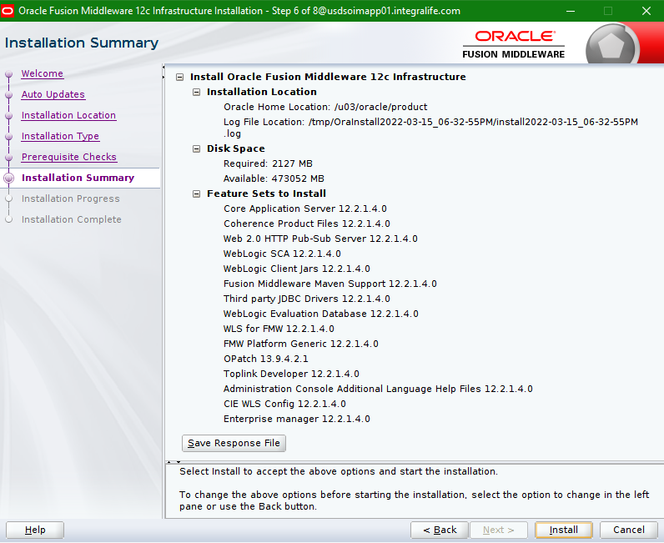

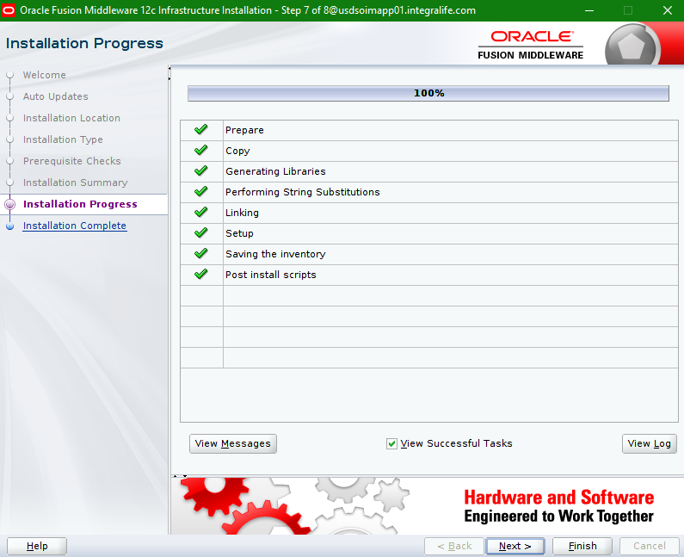

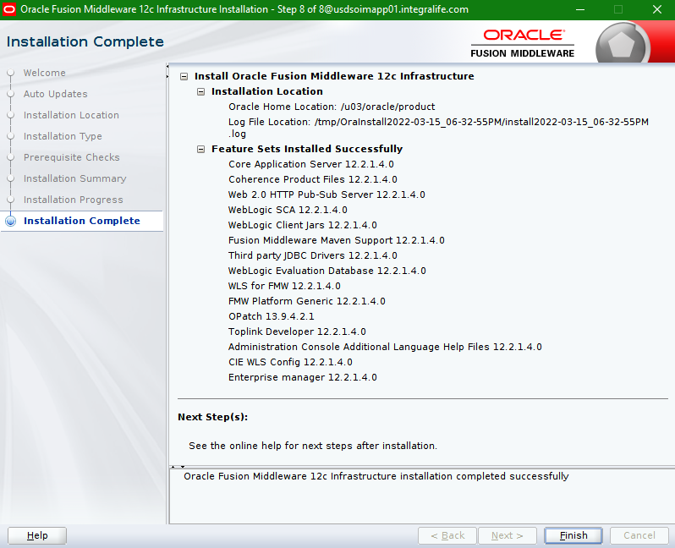

Verify the Infrastructure installation.

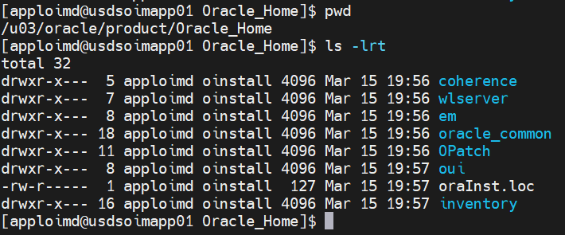

## Install SOA 12c

* Run the below command from the location “/u03”.

**/u03/oracle/java/bin/java -jar fmw_12.2.1.4.0_soa.jar**



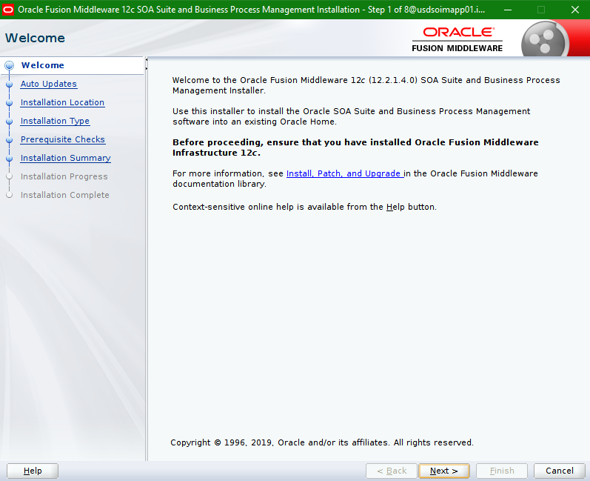

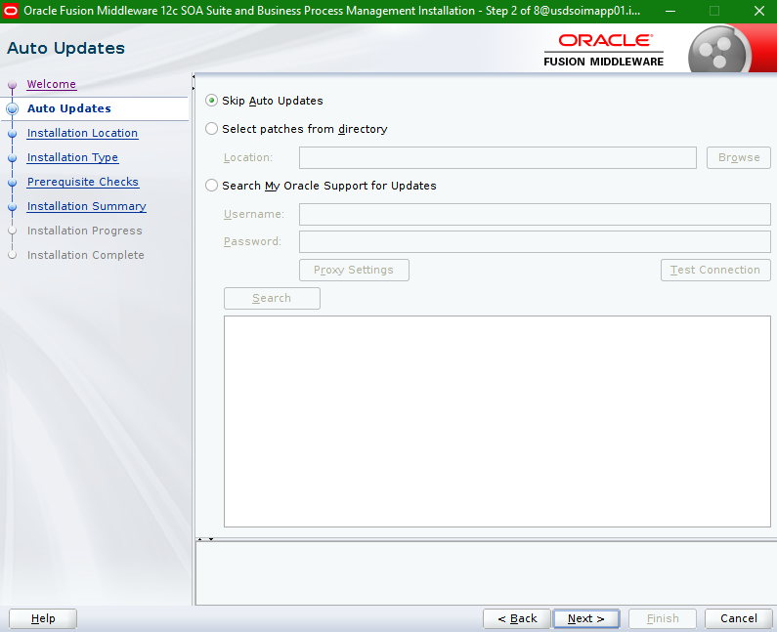

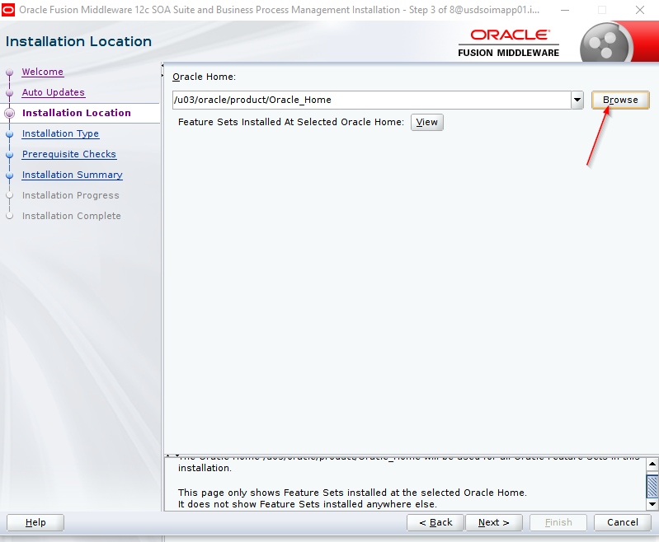

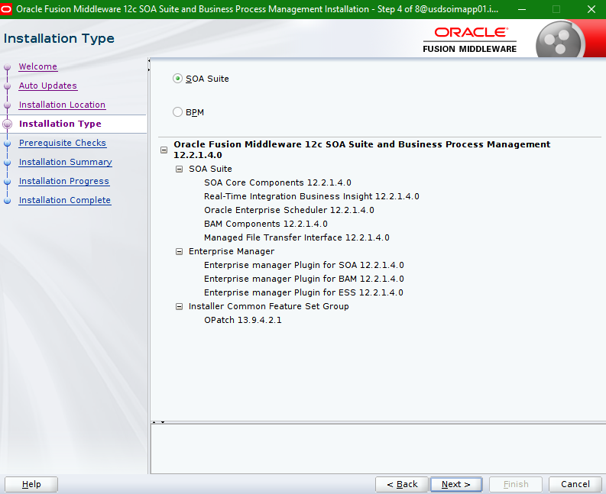

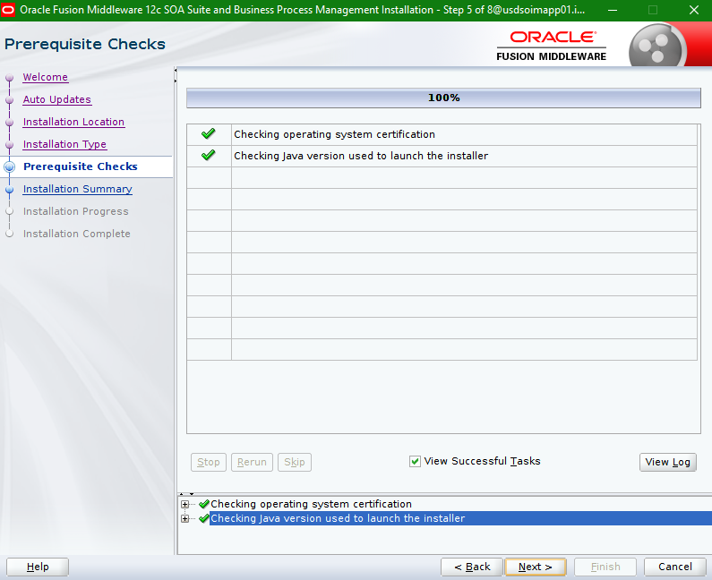

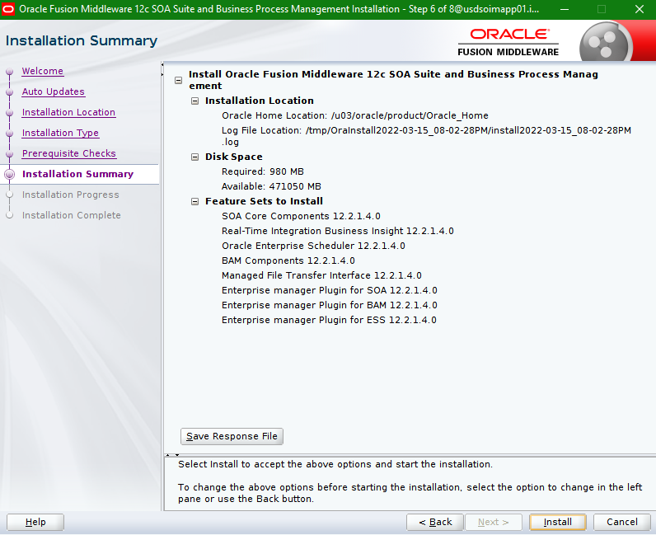

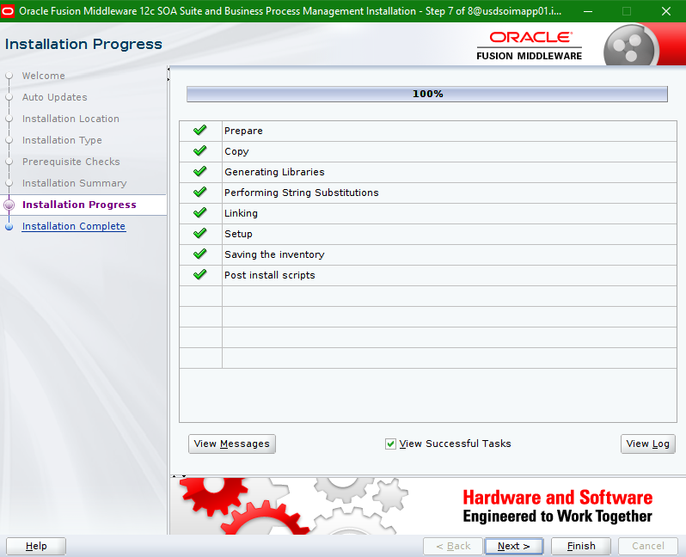

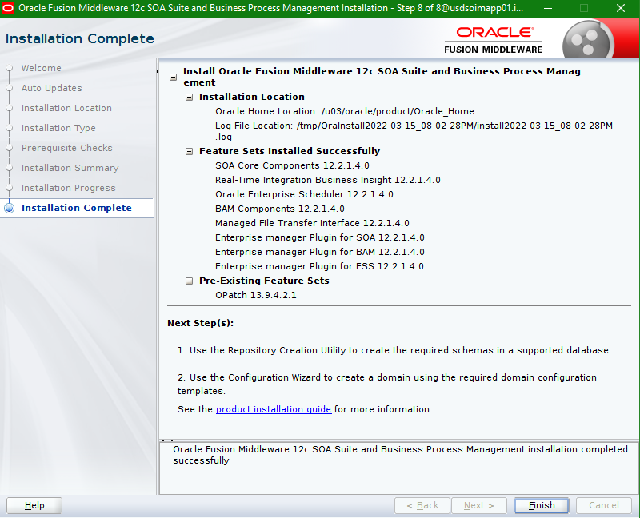

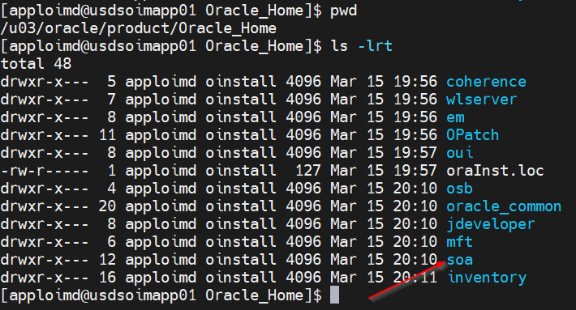

## Install OIM 12c

* Run the below command from the location “/u03”.

**/u03/oracle/java/bin/java -jar fmw_12.2.1.4.0_idm.jar**



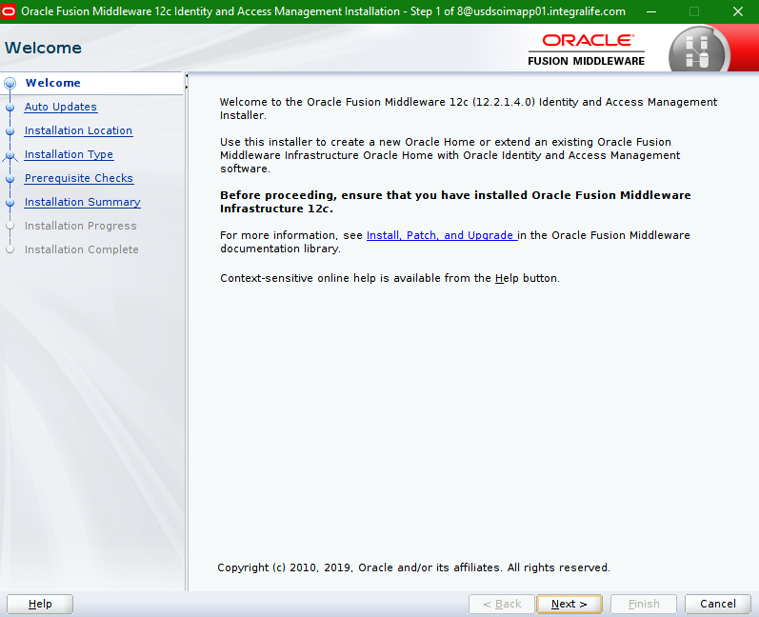

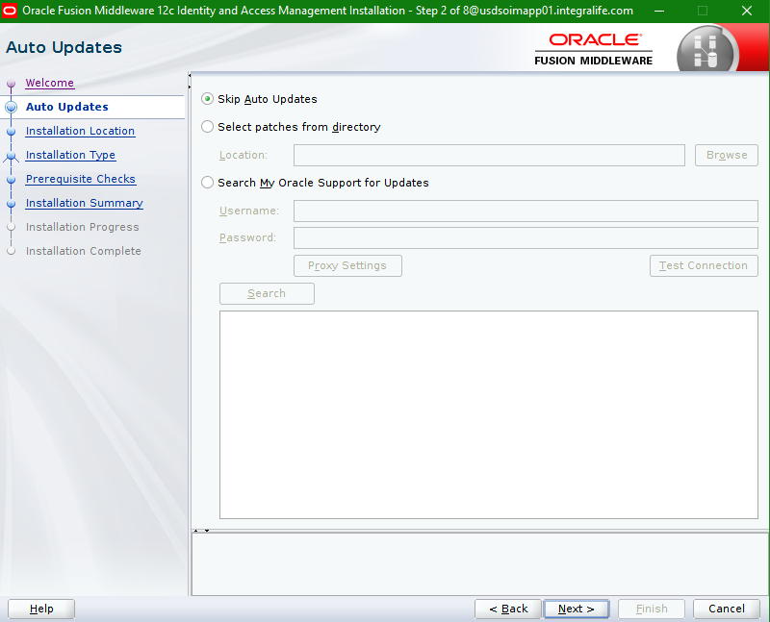

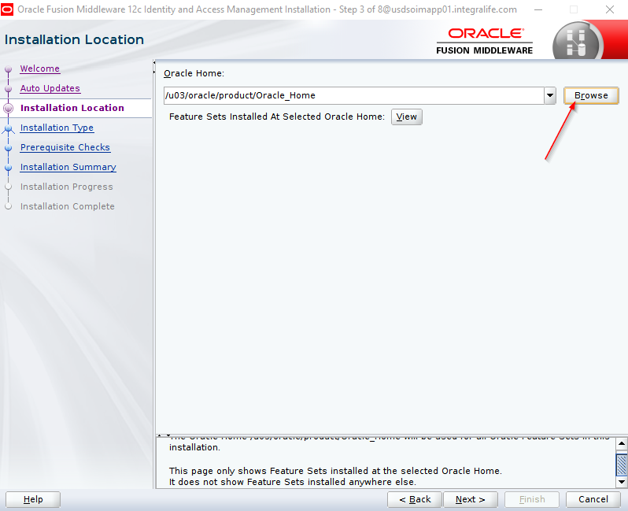

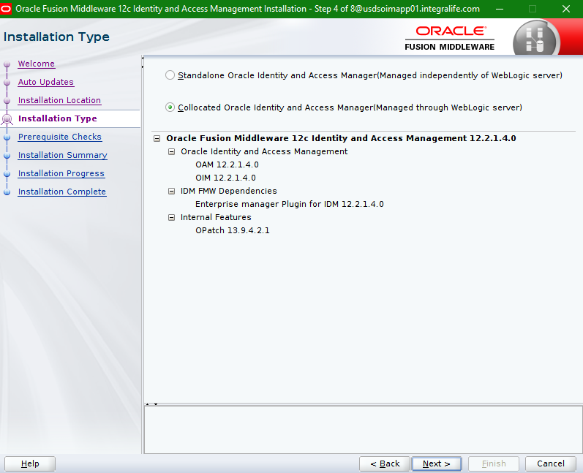

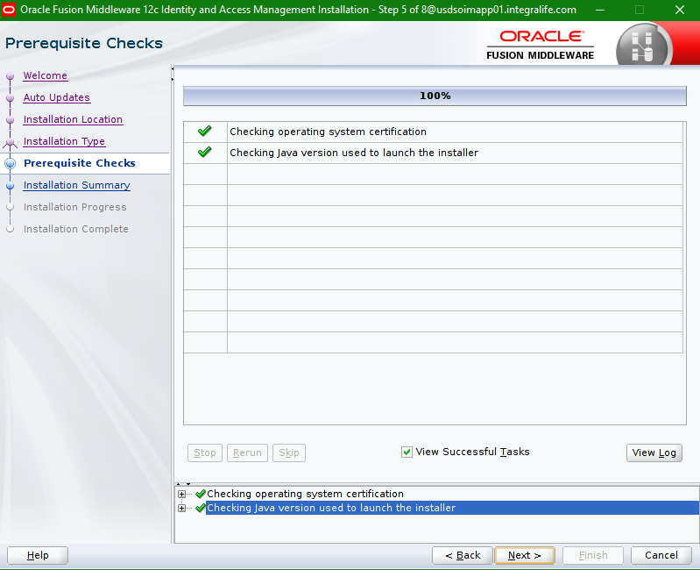

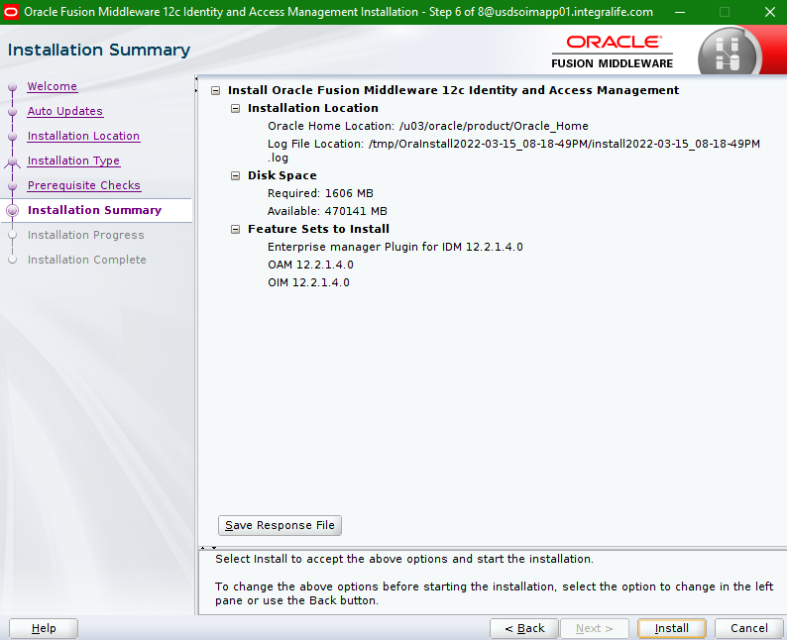

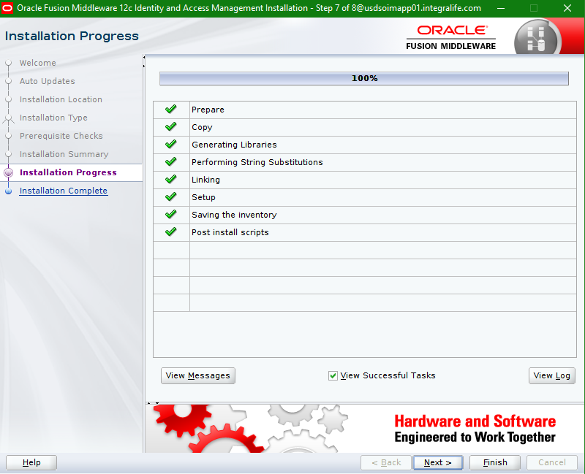

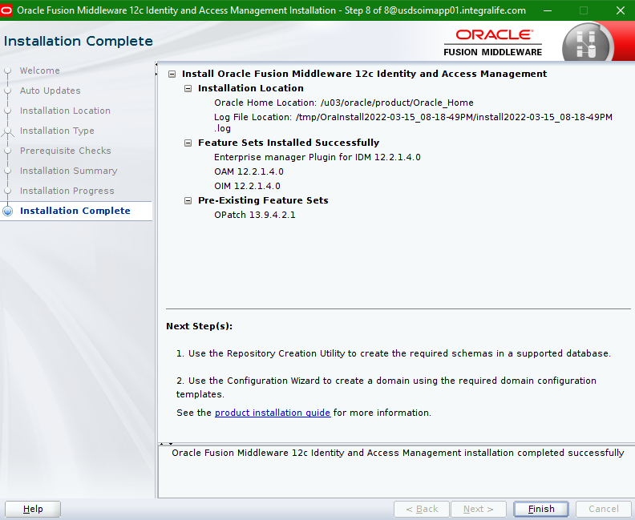

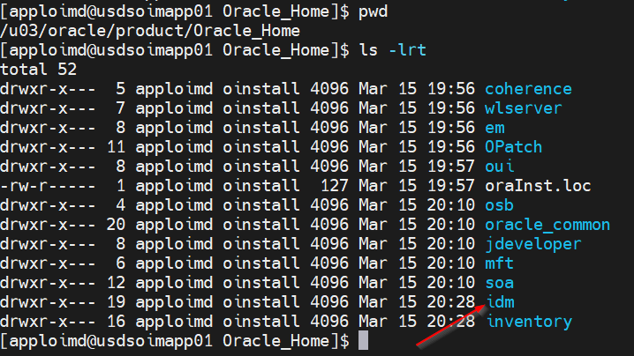

## 12c Schema Creation (RCU)

* Set the Java class path to new JAVA_HOME i.e., “/u03/oracle/java/bin” using below commands.

**export JAVA_HOME=/u03/oracle/java/**

**export PATH=$JAVA_HOME/bin:$PATH**

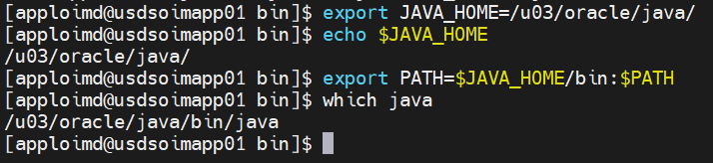

* Run the **./rcu** command from the location “/u03/oracle/product/Oracle_Home/oracle_common/bin”

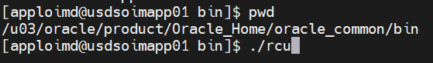

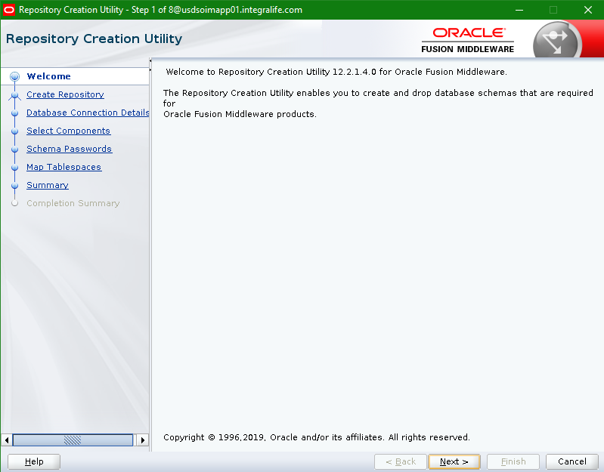

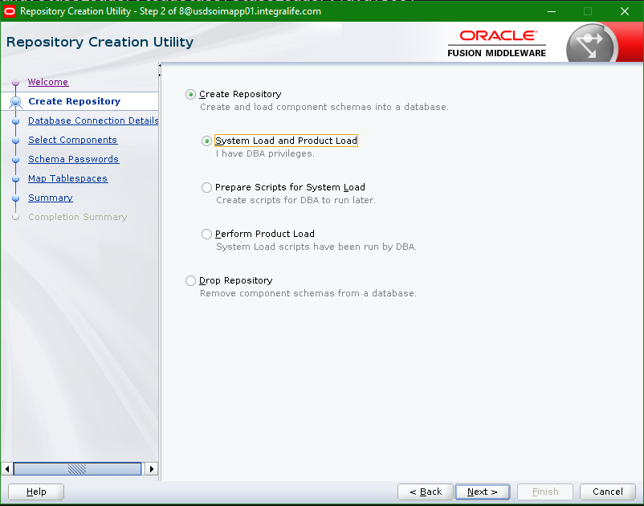

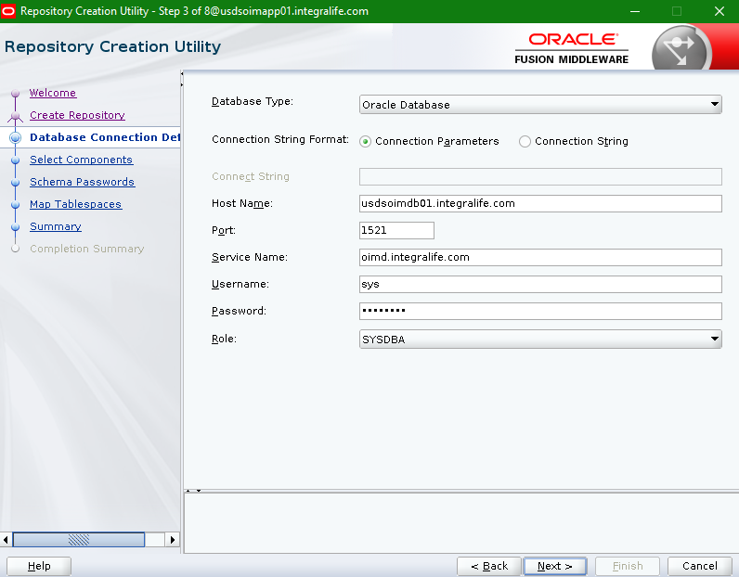

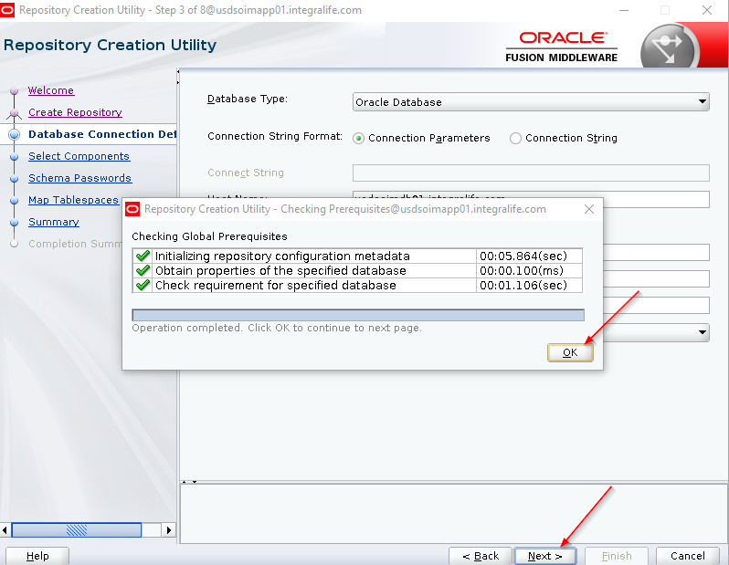

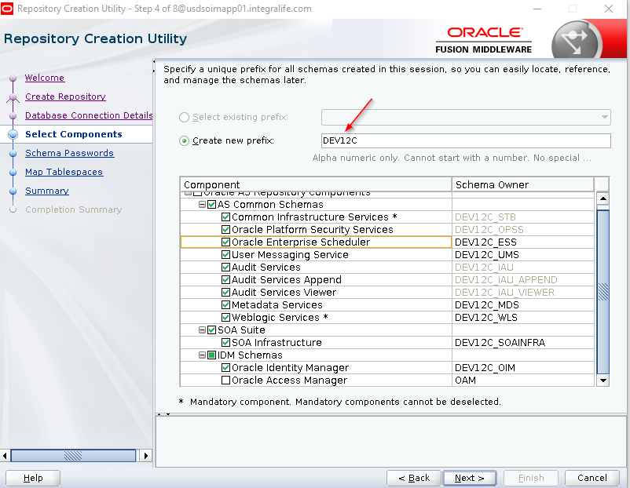

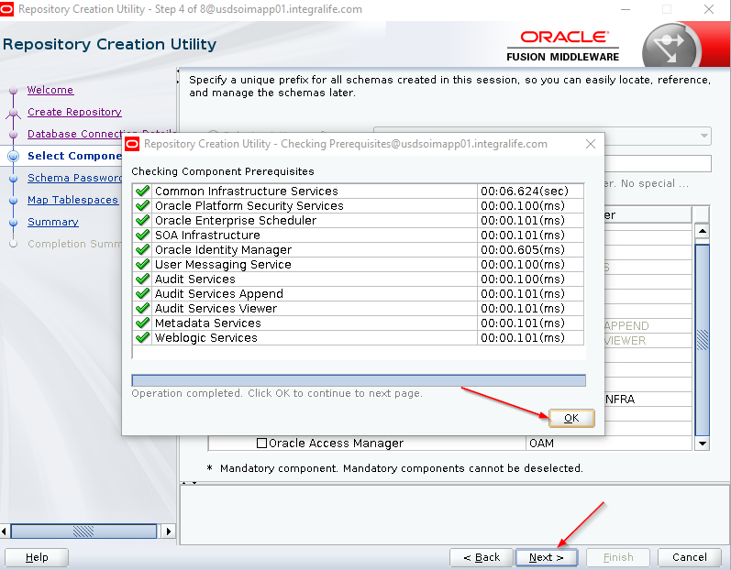

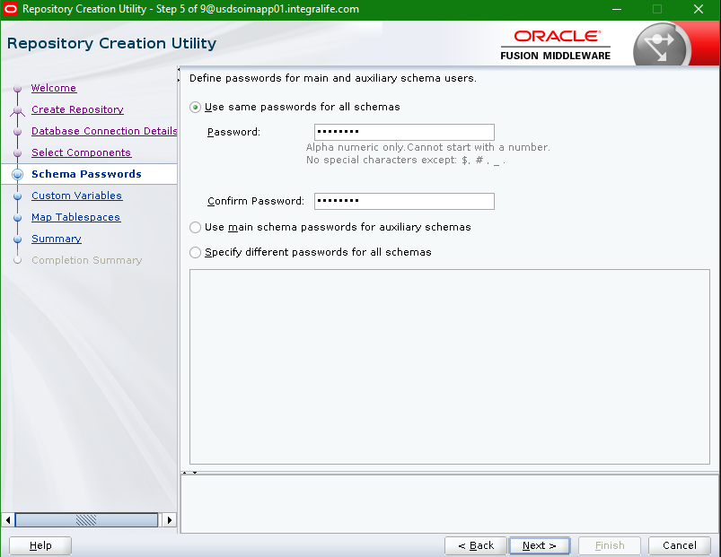

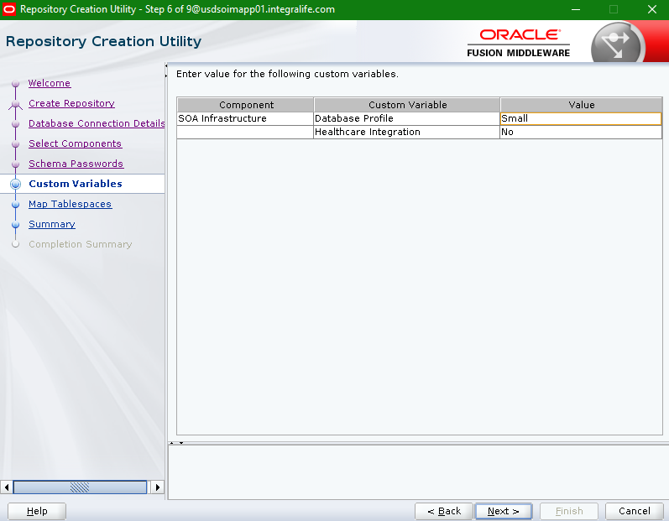

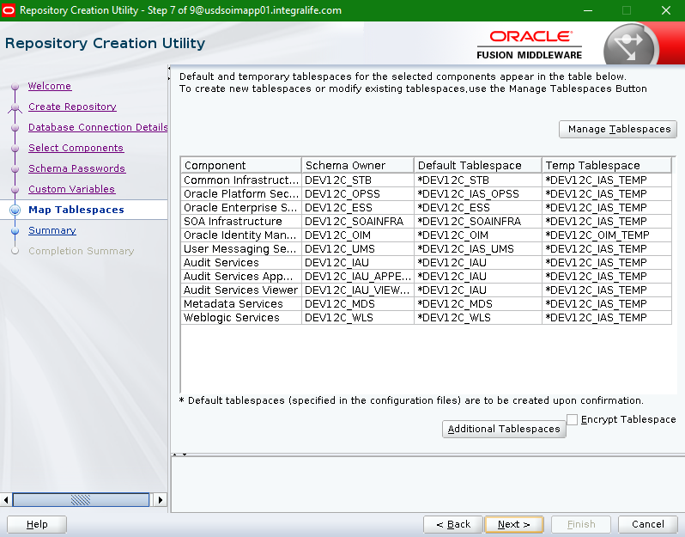

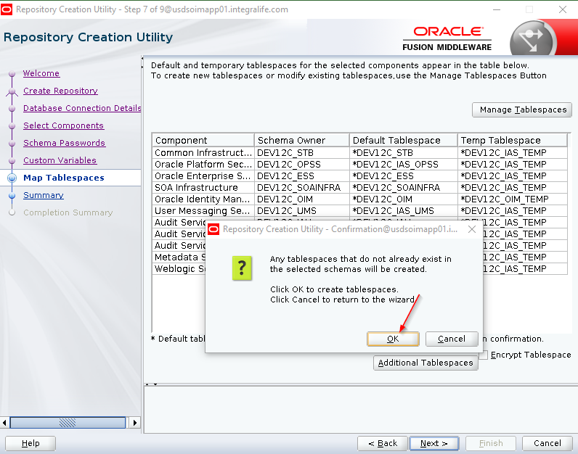

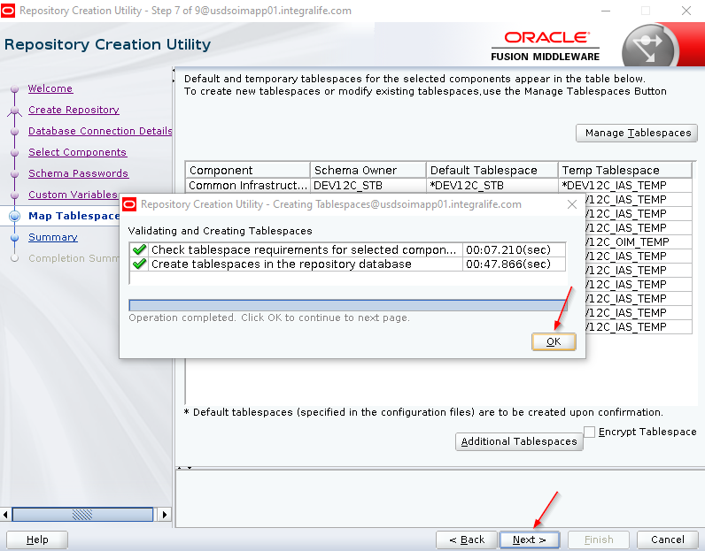

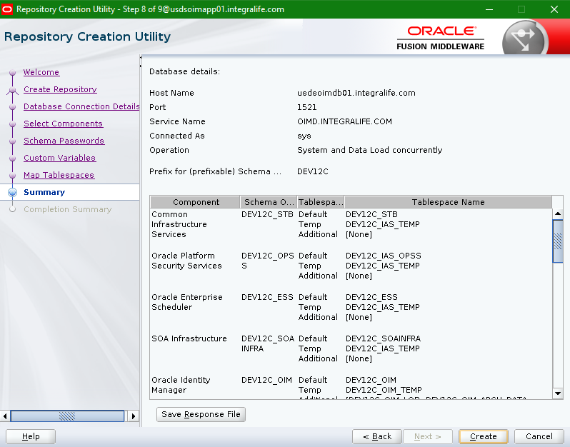

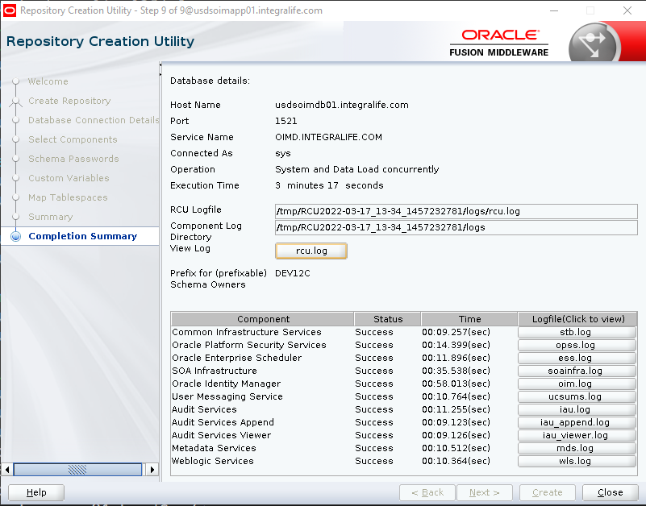

* Login into the database using SYS account and run the below SQL Query and verify the newly created database schemas.

**select username,account_status,expiry_date,created from dba_users;**

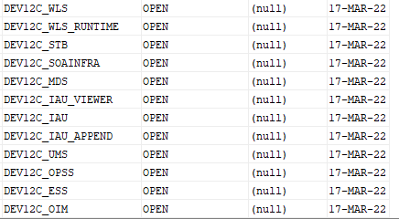

## WebLogic Domain Configuration

* Go to the location “/u03/oracle/product/Oracle_Home/oracle_common/common/bin” and ./config.sh script to create the WebLogic domain.

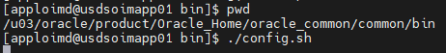

* Provide the domain location as “/u03/oracle/config/domains/oimdomain”

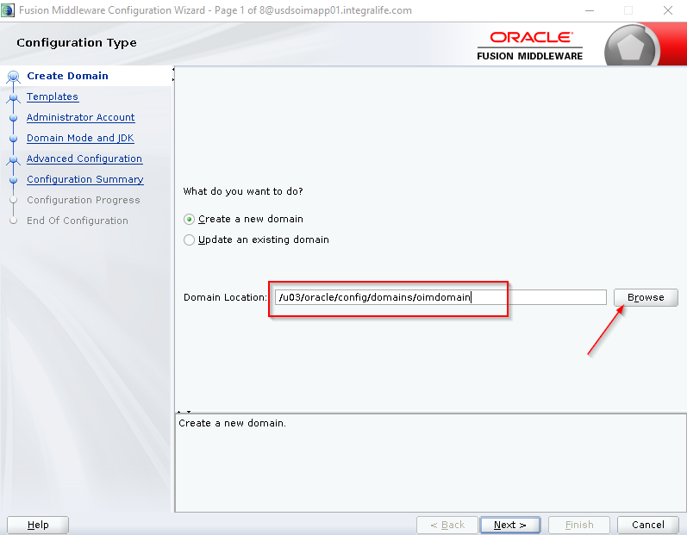

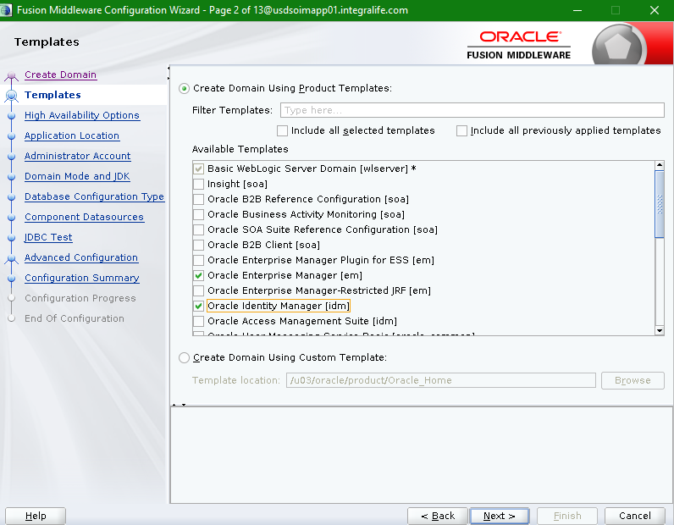

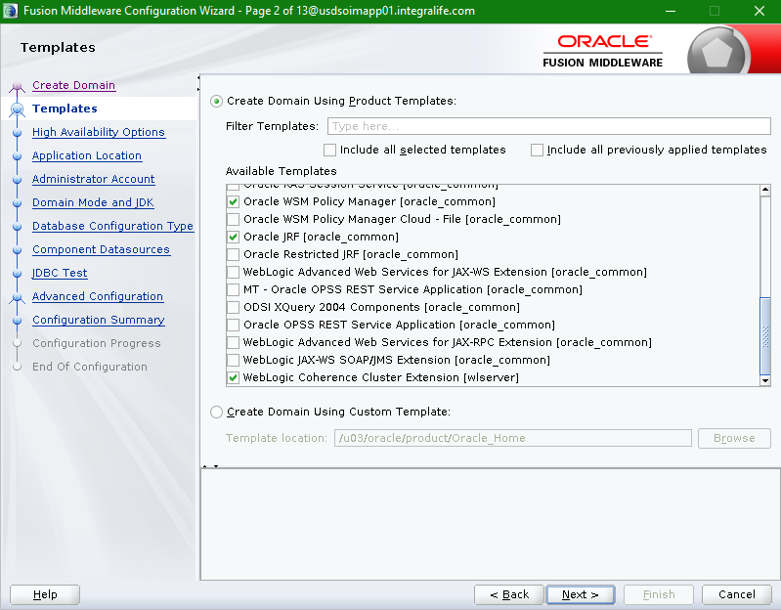

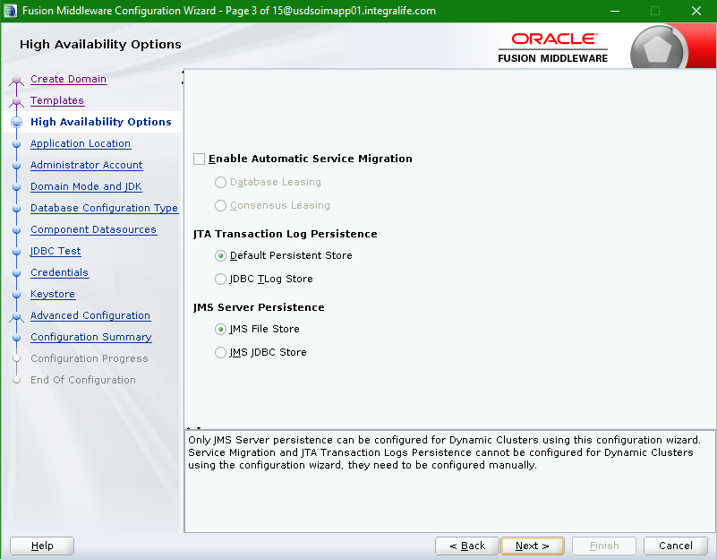

* Provide application location as “/u03/oracle/config/applications/oimdomain”.

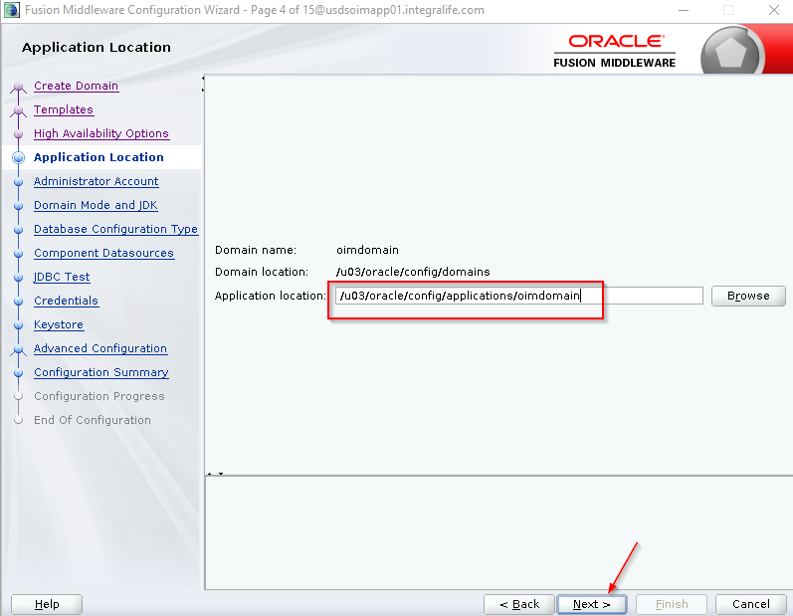

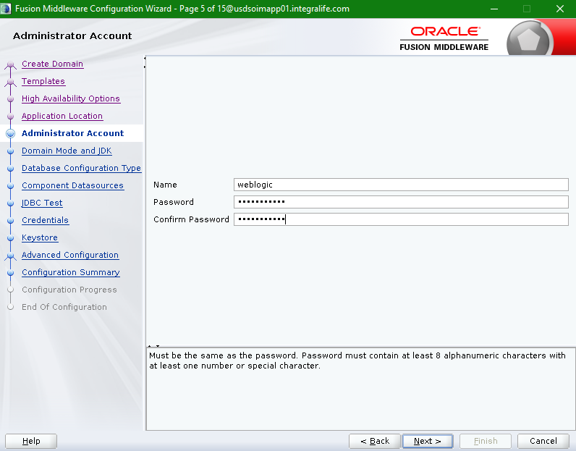

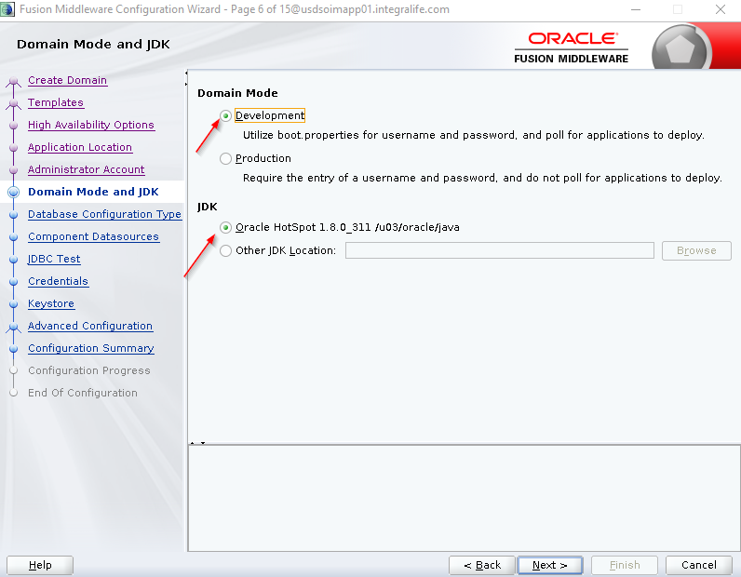

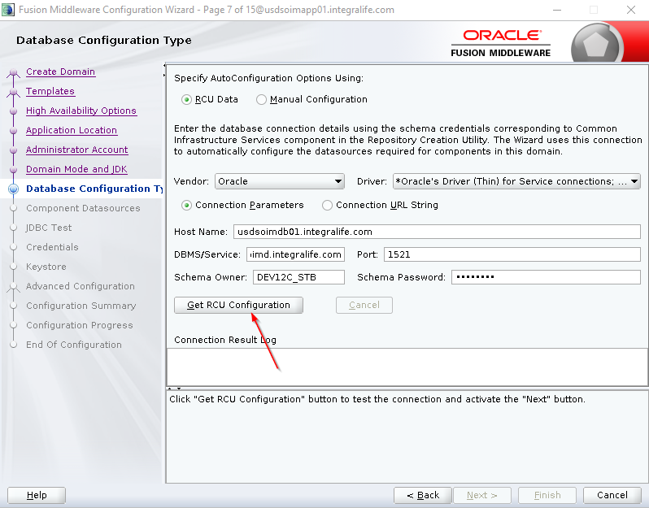

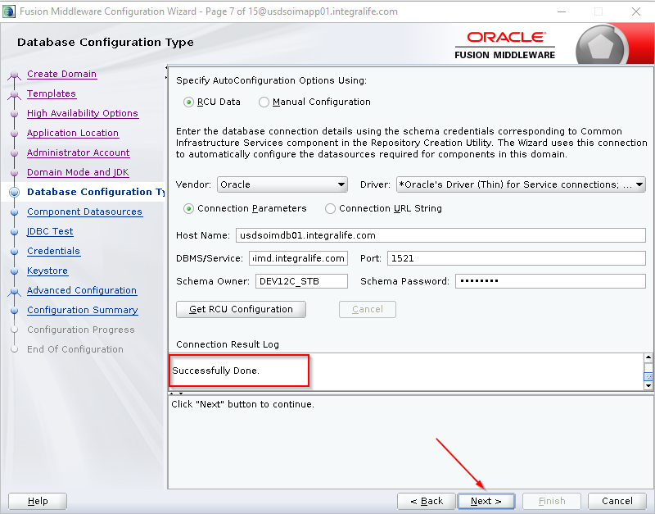

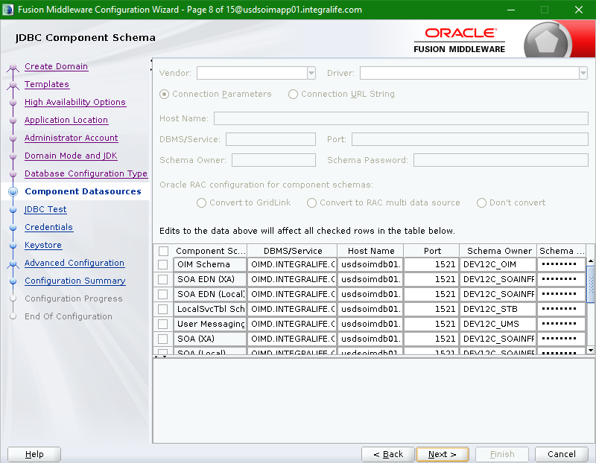

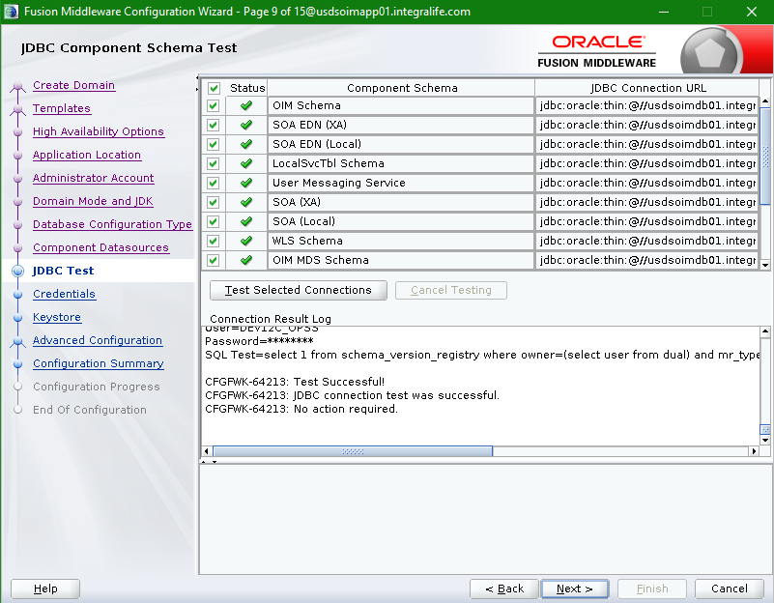

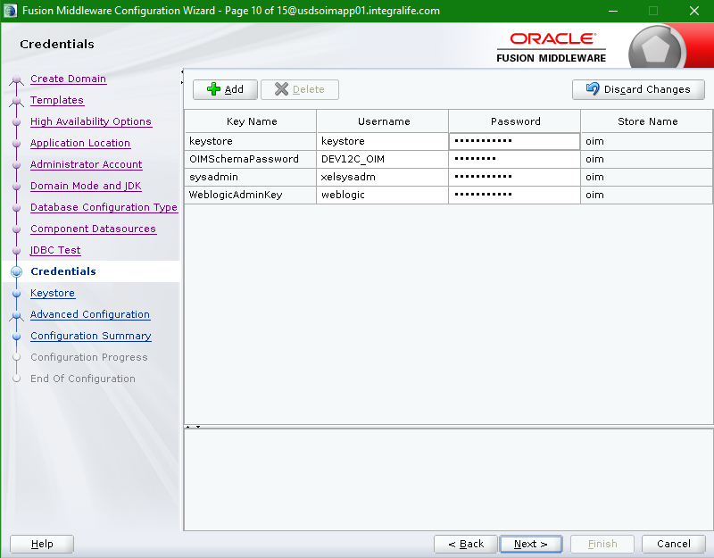

Note: keystore password provided same as weblogic password

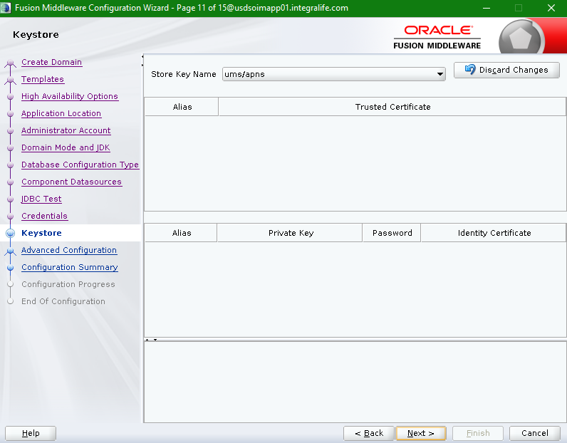

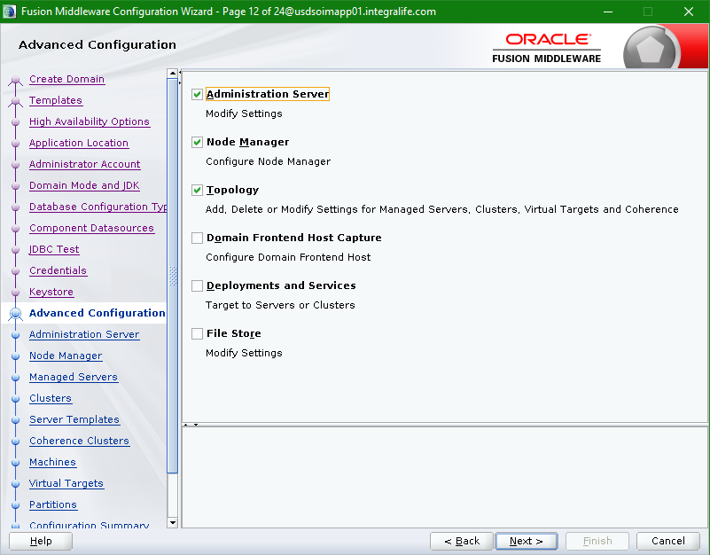

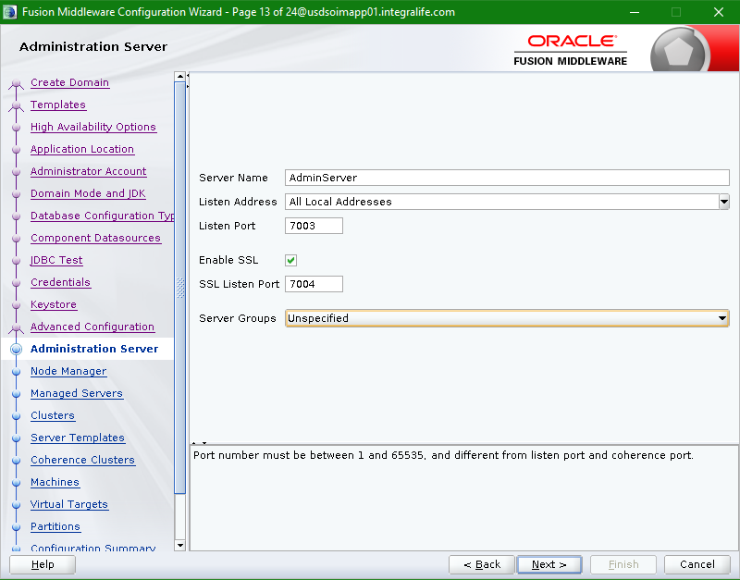

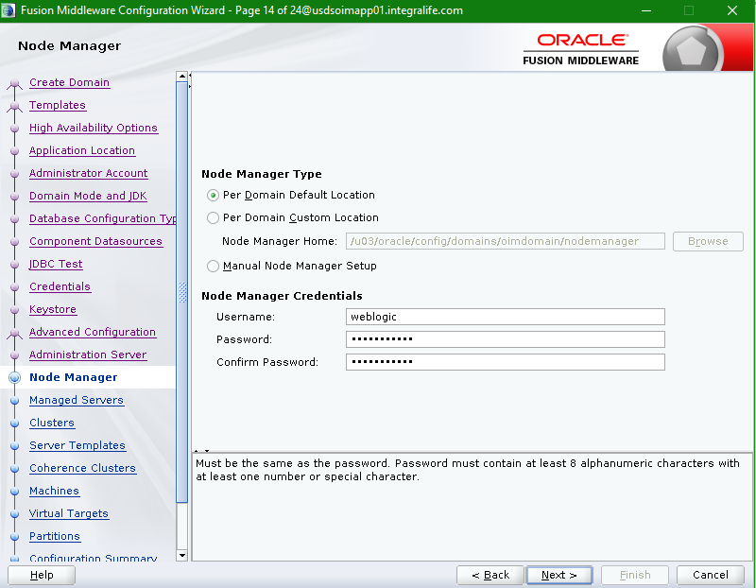

Note: Node Manager username as “weblogic” and password is same as weblogic admin user.

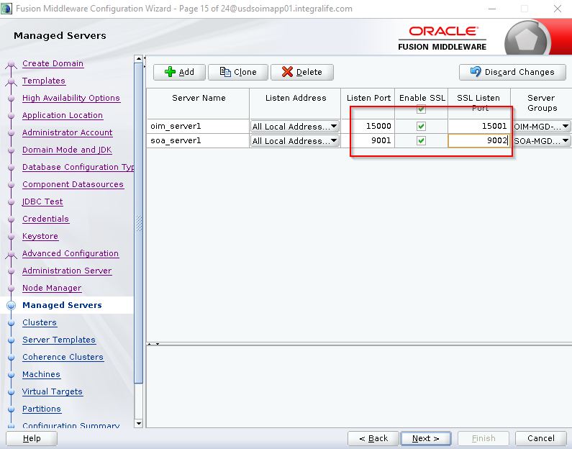

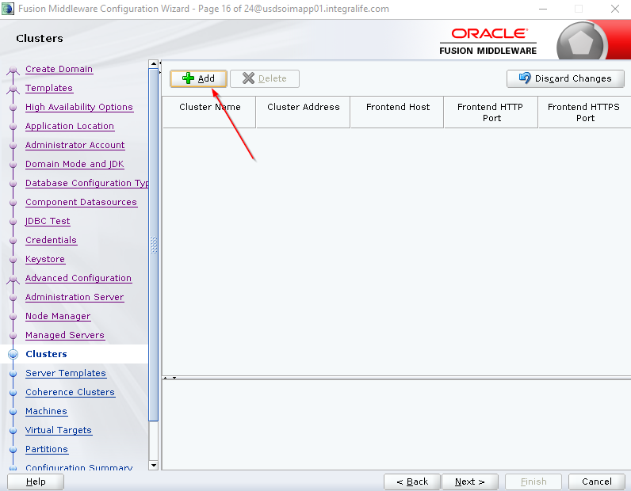

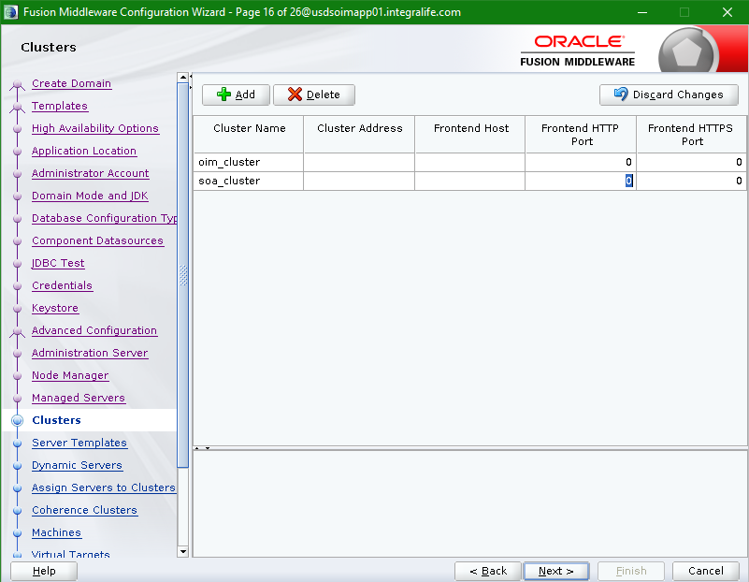

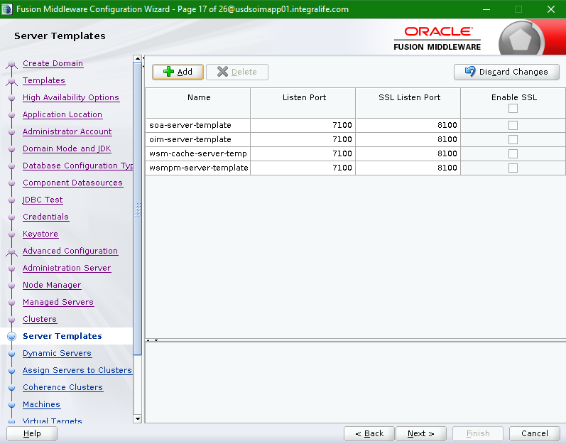

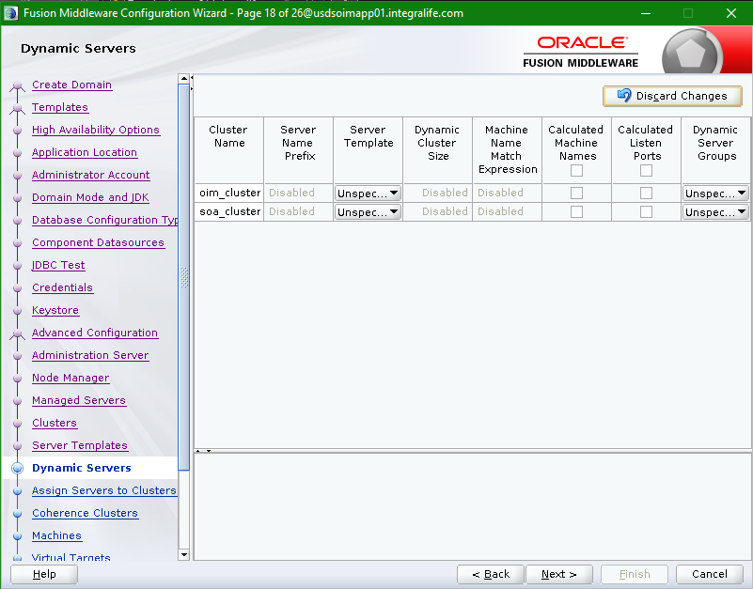

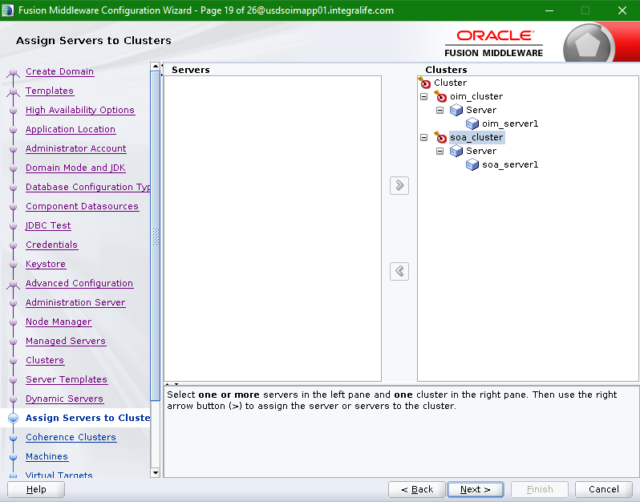

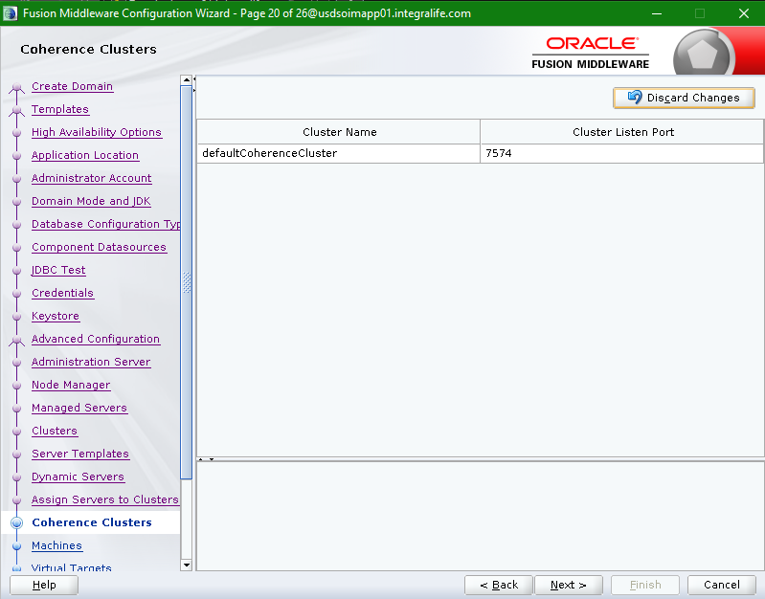

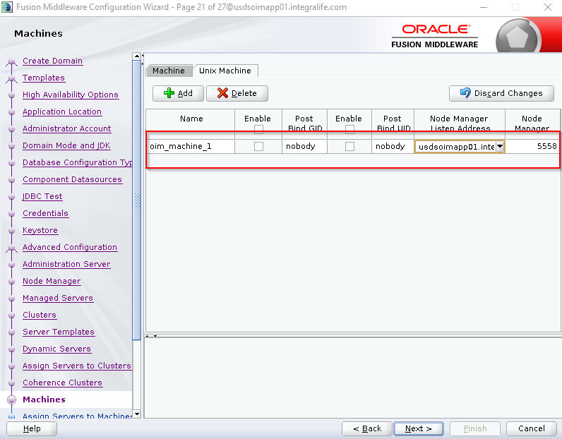

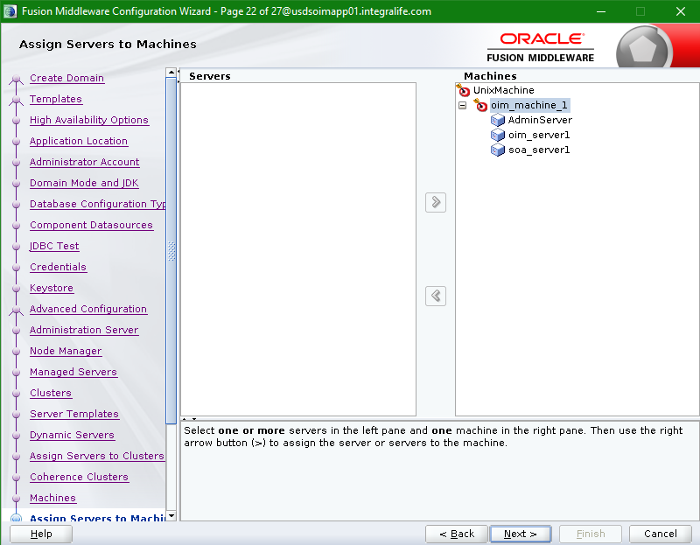

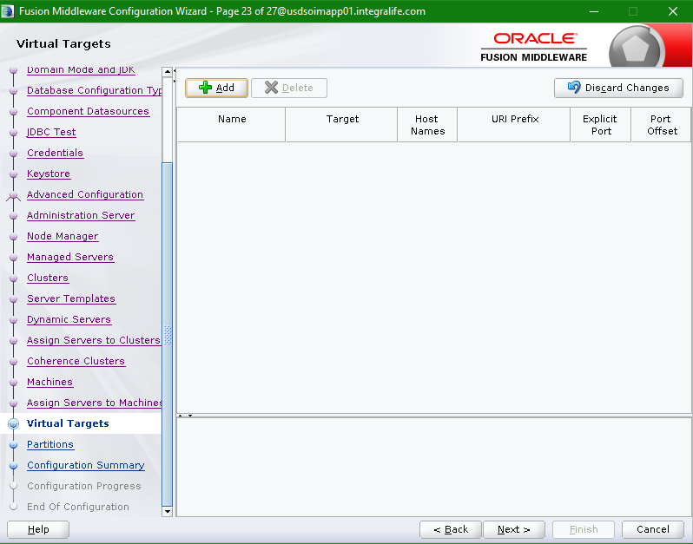

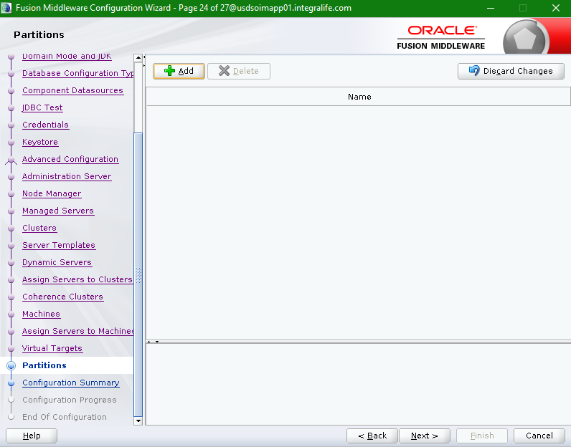

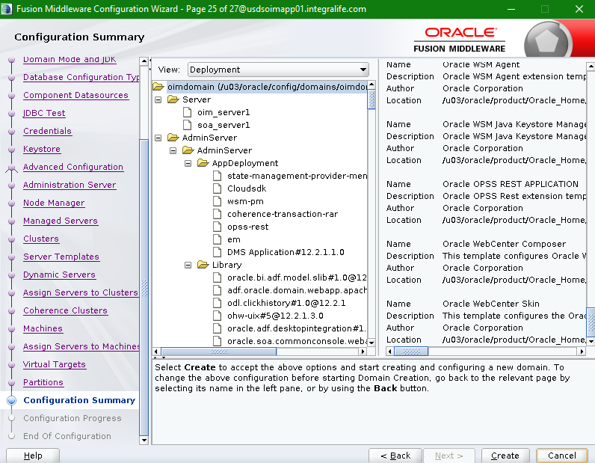

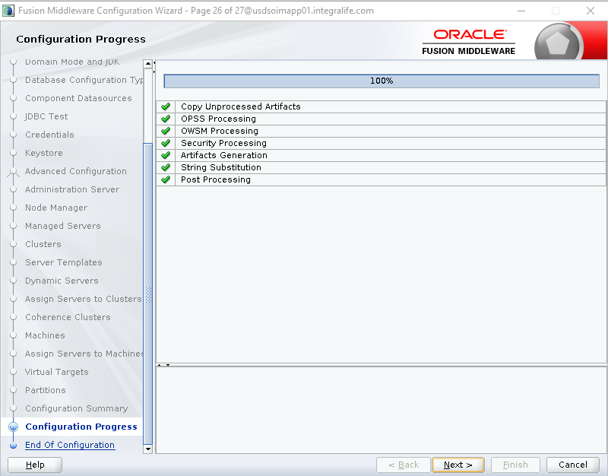

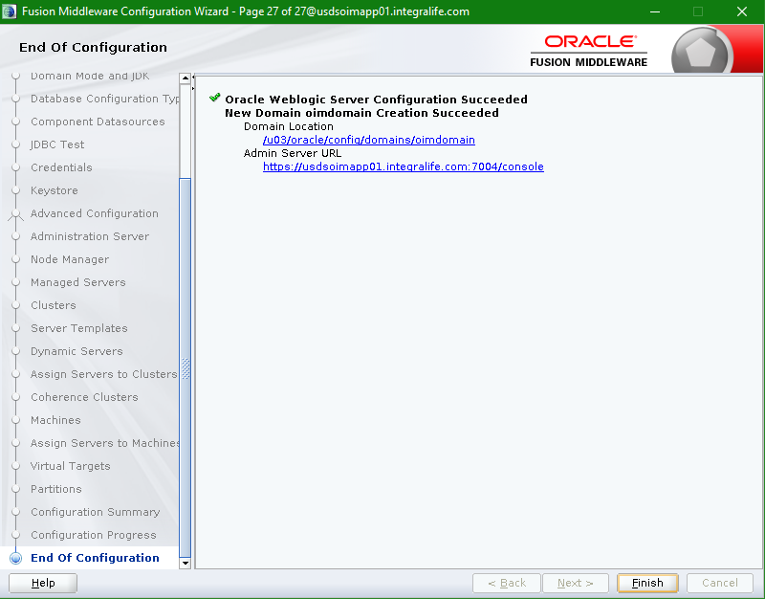

* Verify the domain configuration.

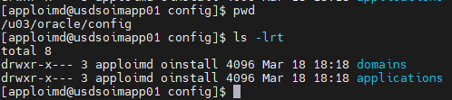

## Perform Offline Configuration

* Set the DOMAIN_HOME and JAVA_HOME to right values before running offline configuration script.

export DOMAIN _HOME= /u03/oracle/config/domains/oimdomain



export JAVA_HOME= /u03/oracle/java

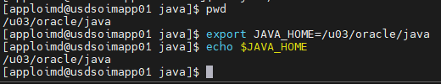

* Go to the location “/u03/oracle/product/Oracle_Home/idm/server/bin” and run the ./offlineConfigManager.sh script

Give the permission to the script.

chmod -R 775 offlineConfigManager.sh

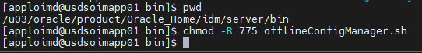

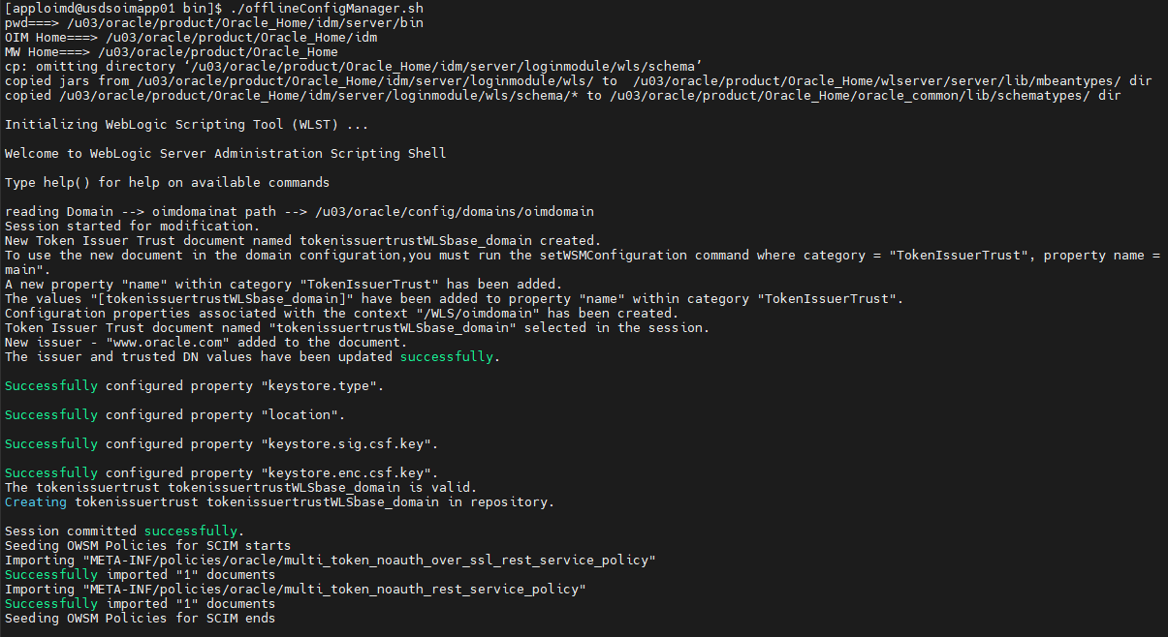

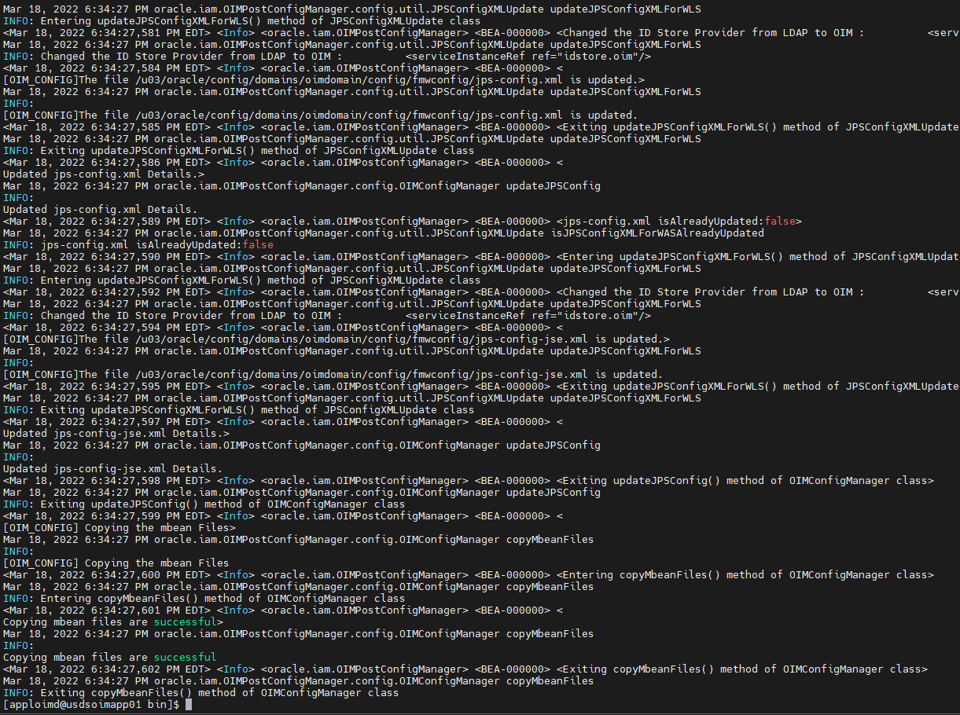

## Run Node Manager

* Verify the Node Manager propertied form the location “/u03/oracle/config/domains/oimdomain/nodemanager”.

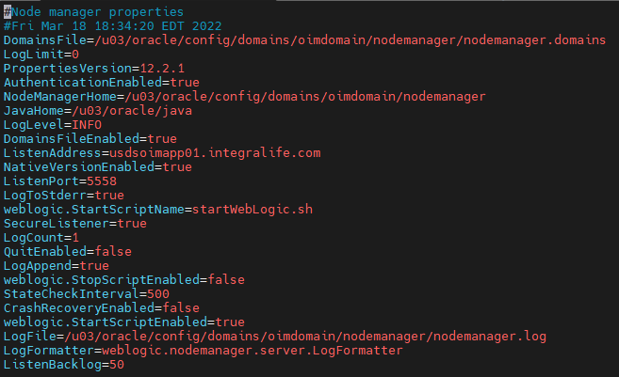

* Run the Node Manager from the location “/u03/oracle/config/domains/oimdomain/bin” using below command.

nohup ./startNodeManager.sh &

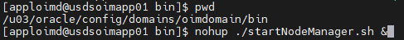

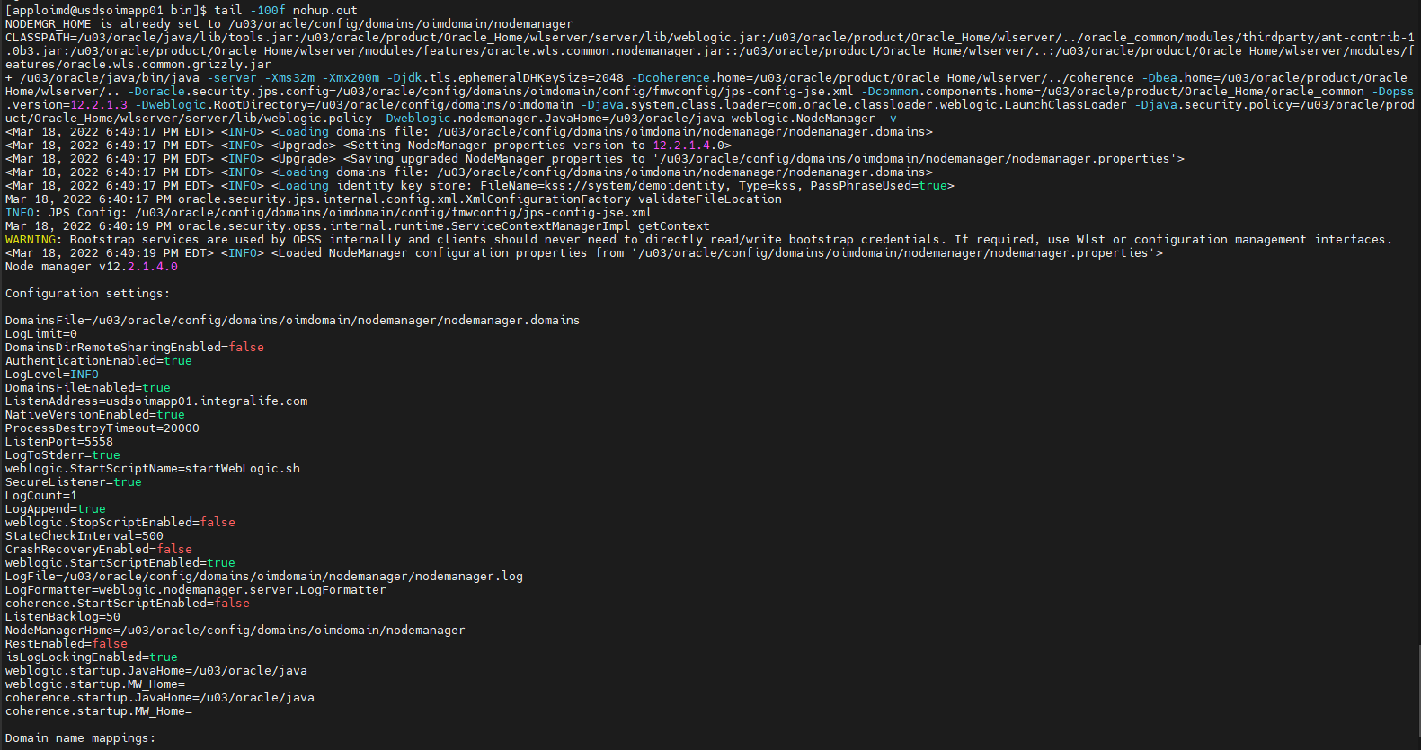

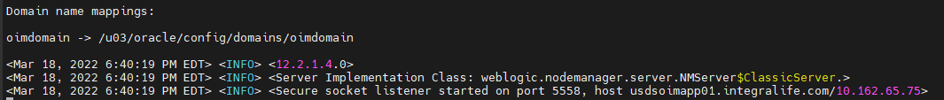

## Run WebLogic Server

* Go to the location “/u03/oracle/config/domains/oimdomain/bin” and run the below command to start the WebLogic server.

**nohup ./startWebLogic.sh &**

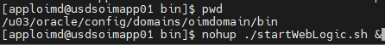

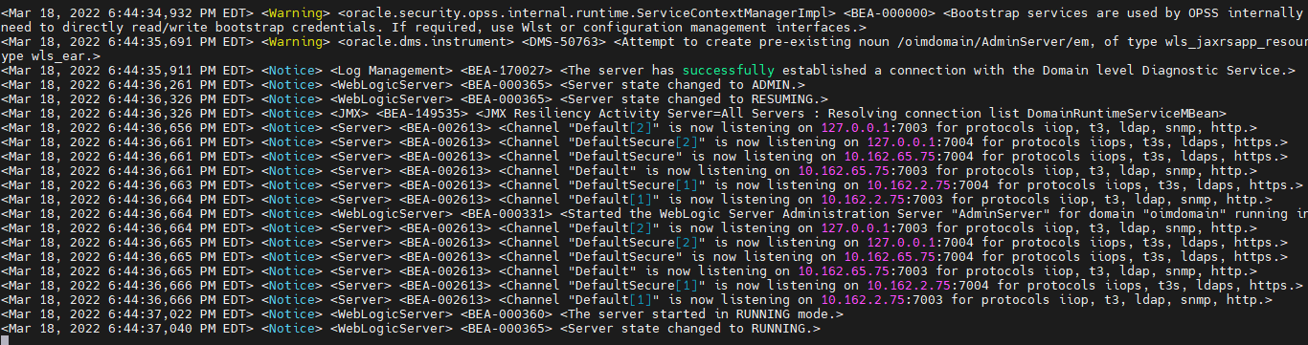

## Create Boot configuration to start the managed servers

* Create the “**security**” directory in the following locations.

/u03/oracle/config/domains/oimdomain/servers/oim_server1

/u03/oracle/config/domains/oimdomain/servers/soa_server1

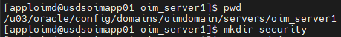

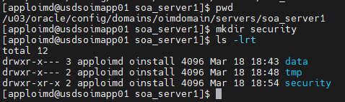

Copy the boot.property file from **/u03/oracle/config/domains/oimdomain/servers/AdminServer/security** to **/u03/oracle/config/domains/oimdomain/servers/oim_server1/security** and

**/u03/oracle/config/domains/oimdomain/servers/soa_server1/security**

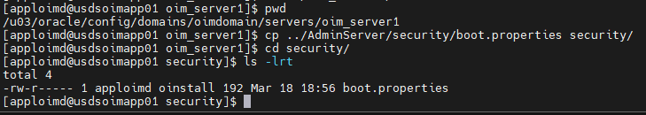

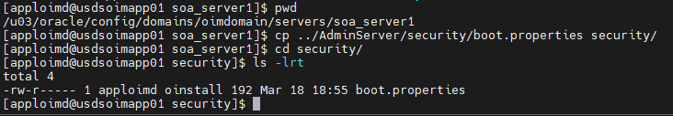

Open the boot.propertiy file from oim_server1/security and soa_server1/security and provide the weblogic username and password.

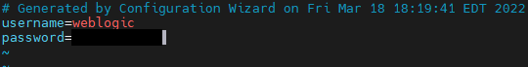

## Start SOA Managed Server

* Update WebLogic URL to non-ssl url in **setDomainEnv.sh** from the location “/u03/oracle/config/domains/oimdomain/bin”.

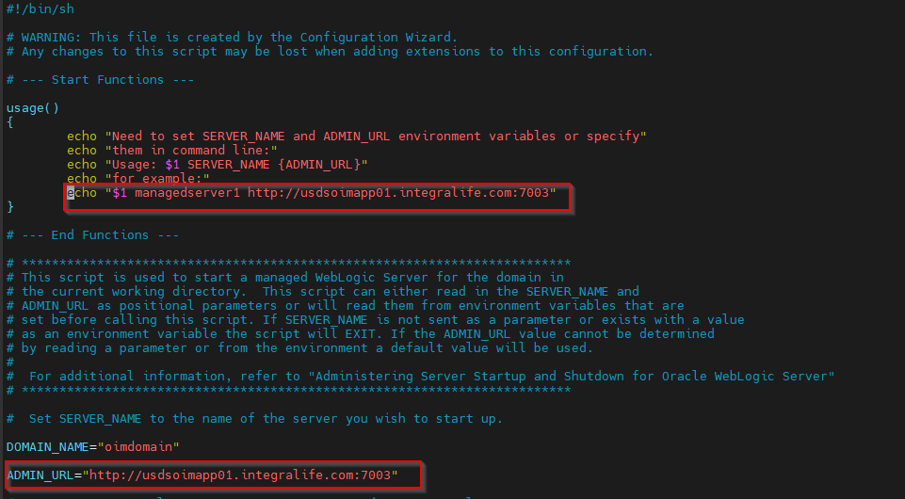

* Go to the location “/u03/oracle/config/domains/oimdomain/bin” and run the below command to start the SOA Managed server.

**nohup ./startManagedWebLogic.sh soa_server1 &**



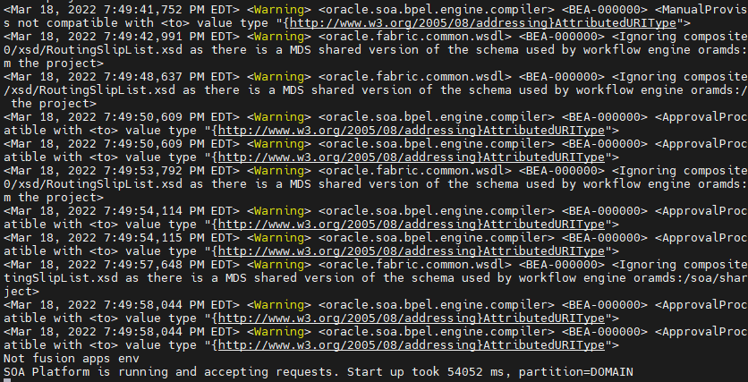

## Start OIM Managed Server

* Go to the location “/u03/oracle/config/domains/oimdomain/bin” and run the below command to start the OIM Managed server.

**nohup ./startManagedWebLogic.sh oim_server1 &**

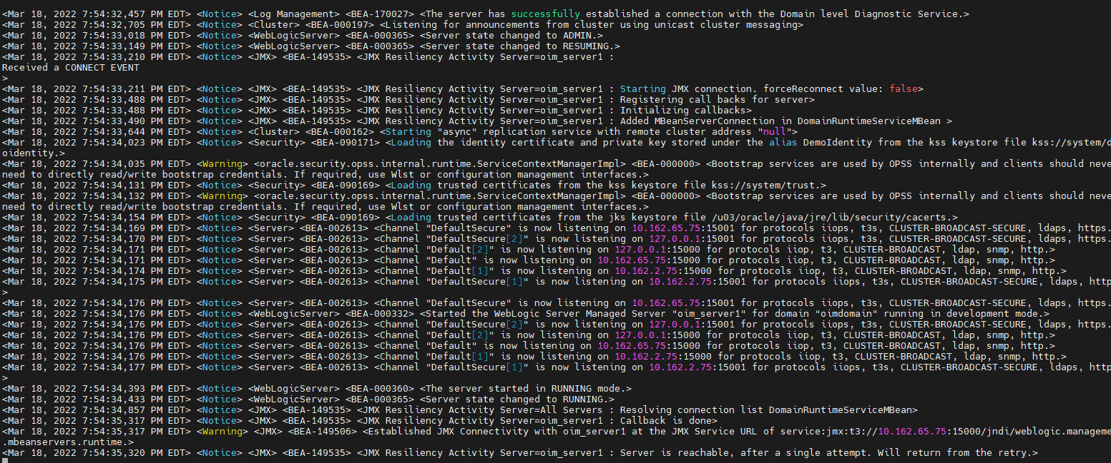

* Login into the WebLogic console and verify the server’s state.

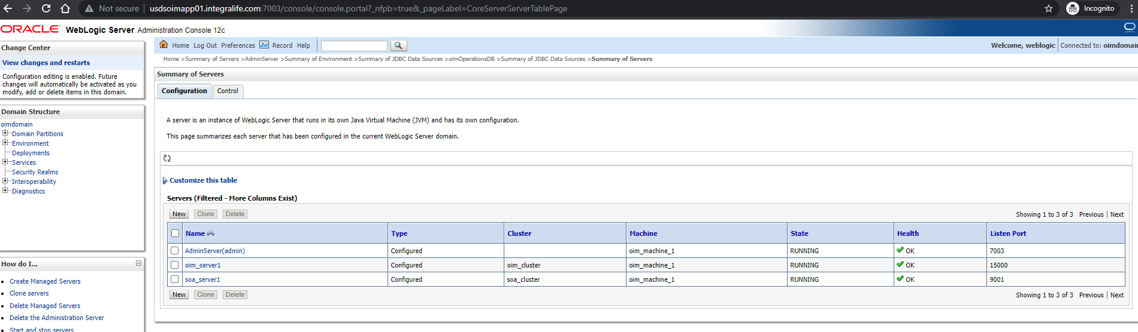

## SOA-OIM Integration

* Login into EM console

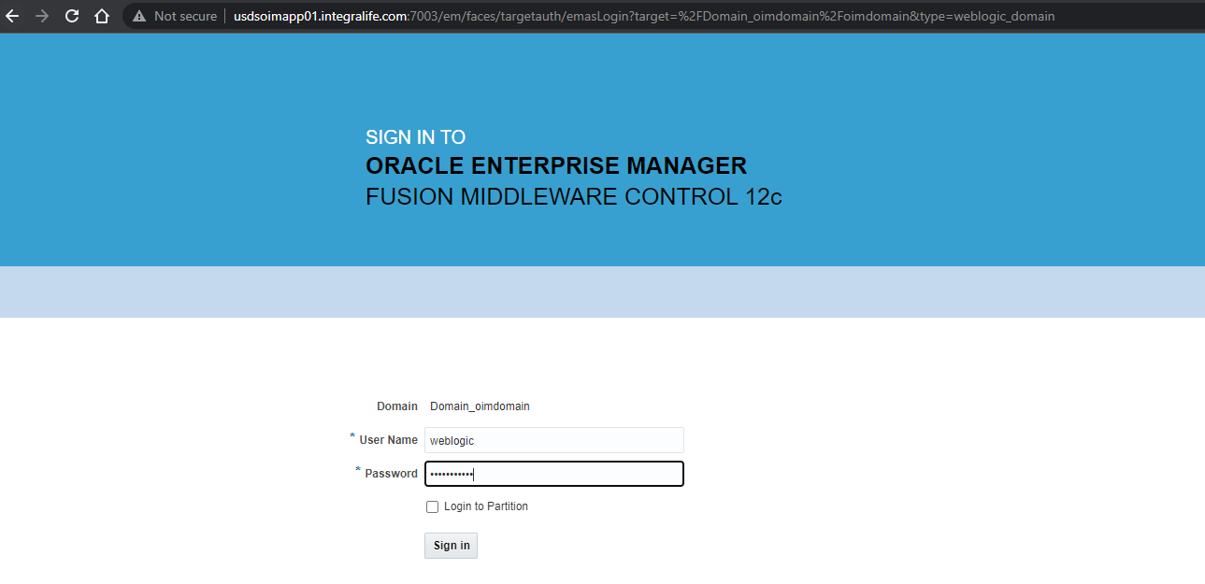

* Right click on oimdomain and select System MBean Browser.

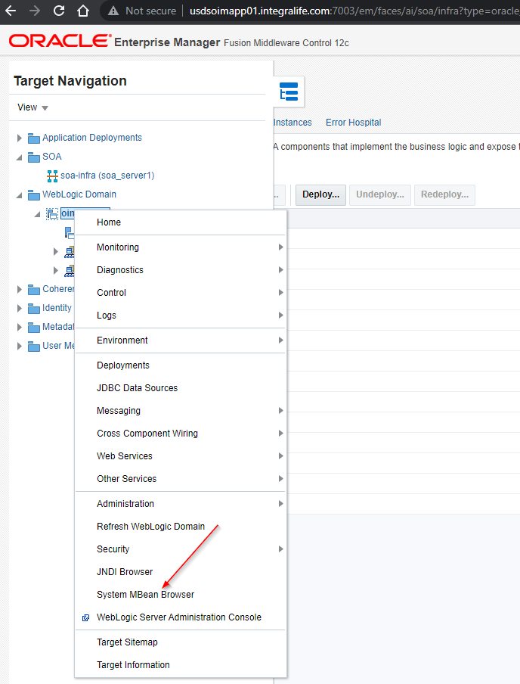

* Search with “OIMSOAIntegrationMBean”

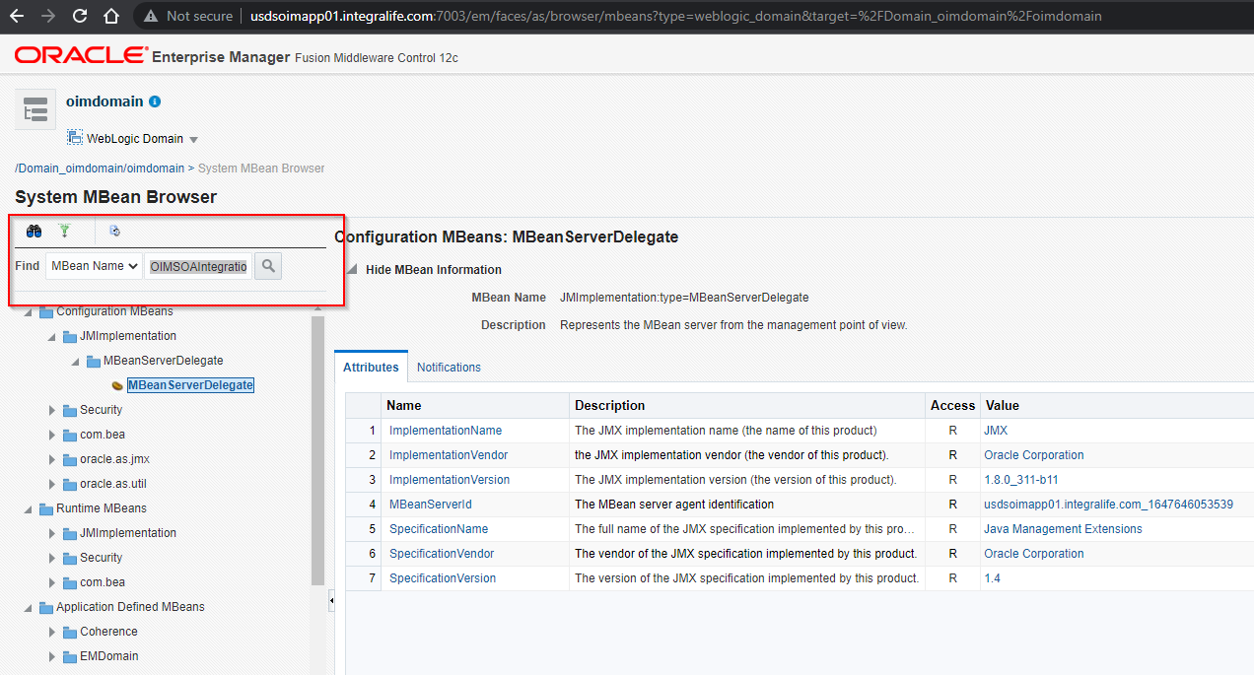

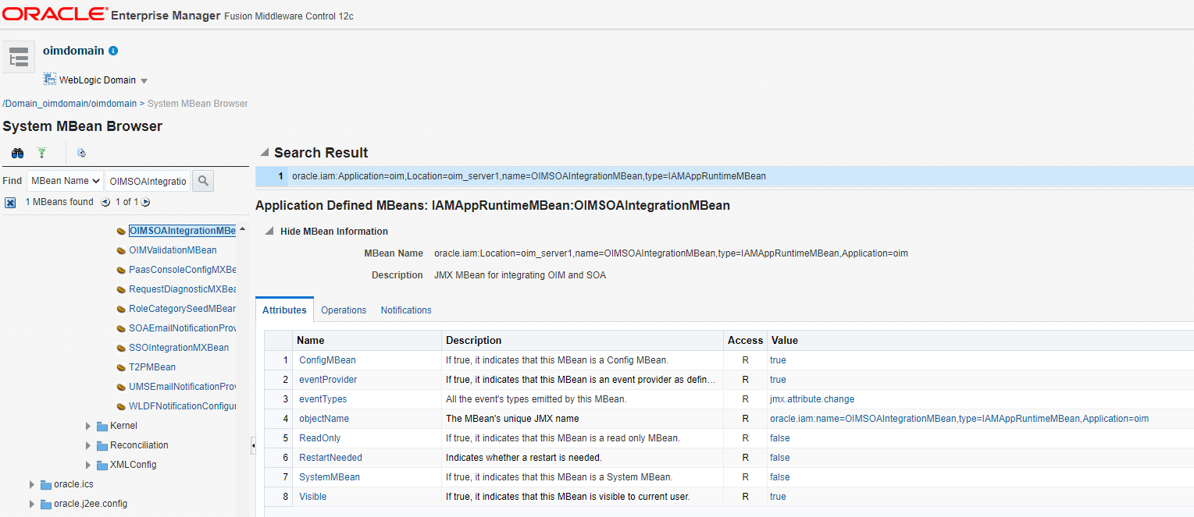

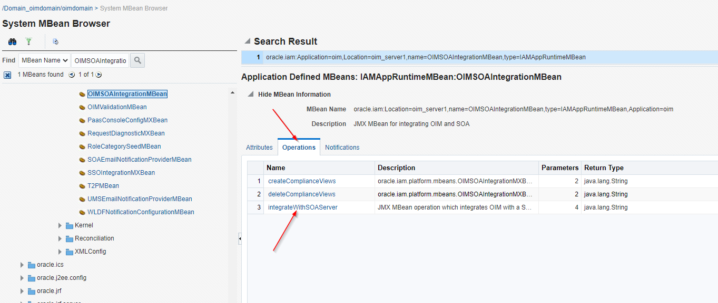

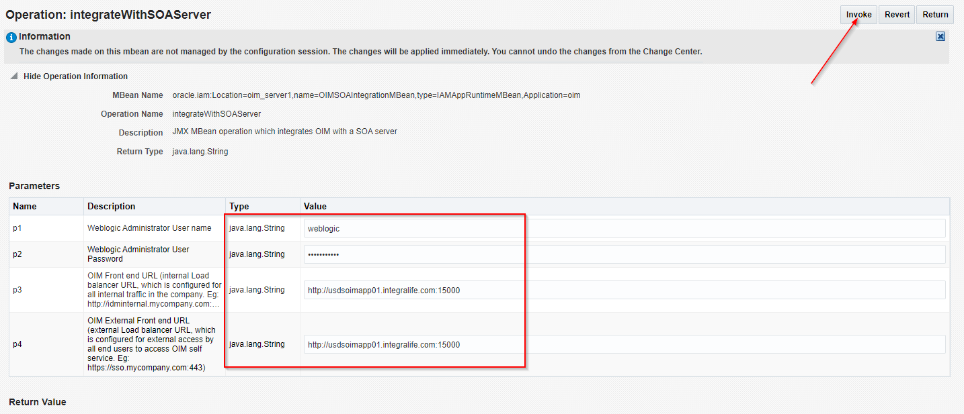

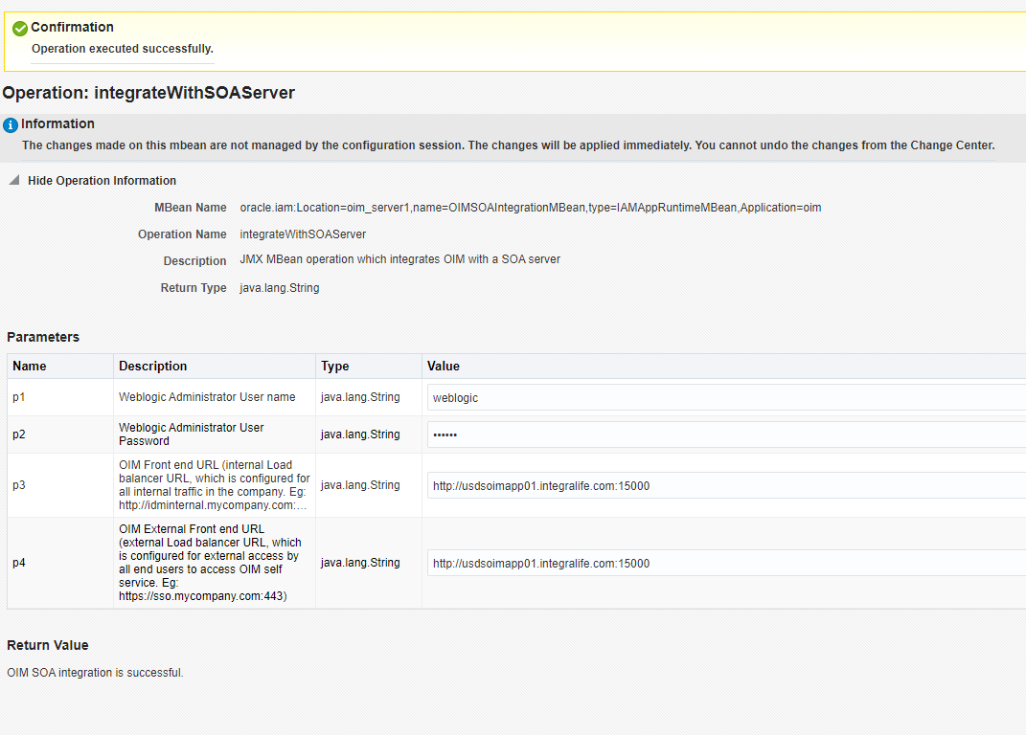

## Verify the Bootstrap Report

* Download and open the “BootStrapReportPreStart_xxxxxxx.html” from the location “/u03/oracle/config/domains/oimdomain/servers/oim_server1/logs/” and verify the bootstrap report.

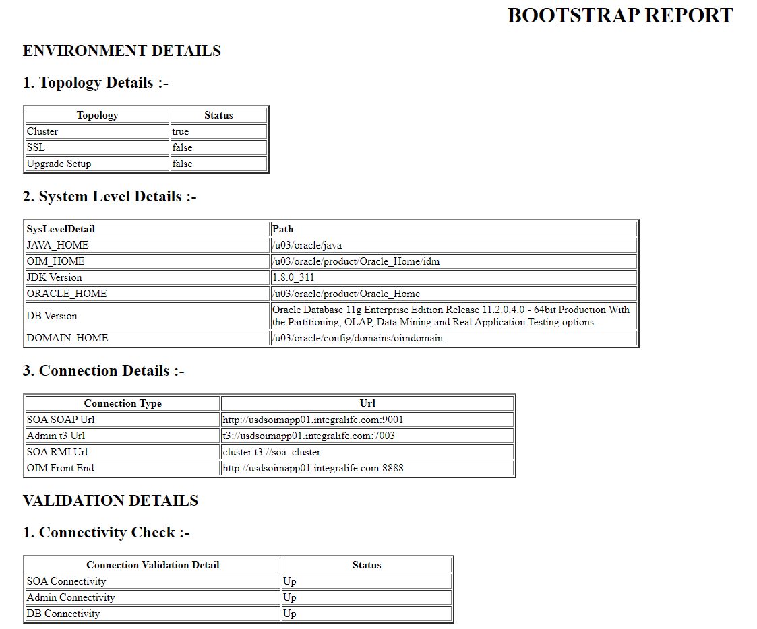

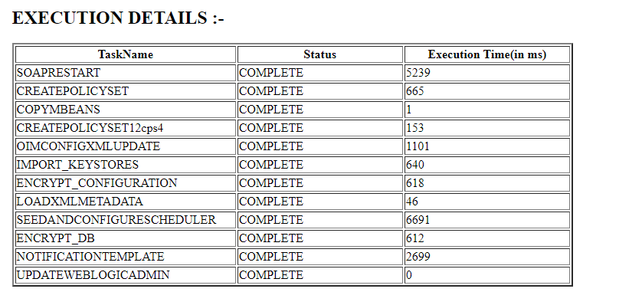

## Configure Design Console

* Go to the location “/u03/oracle/product/Oracle_Home/idm/designconsole/config” and open the file “xlconfig.xml”, update the OIM URL and Port number and save.

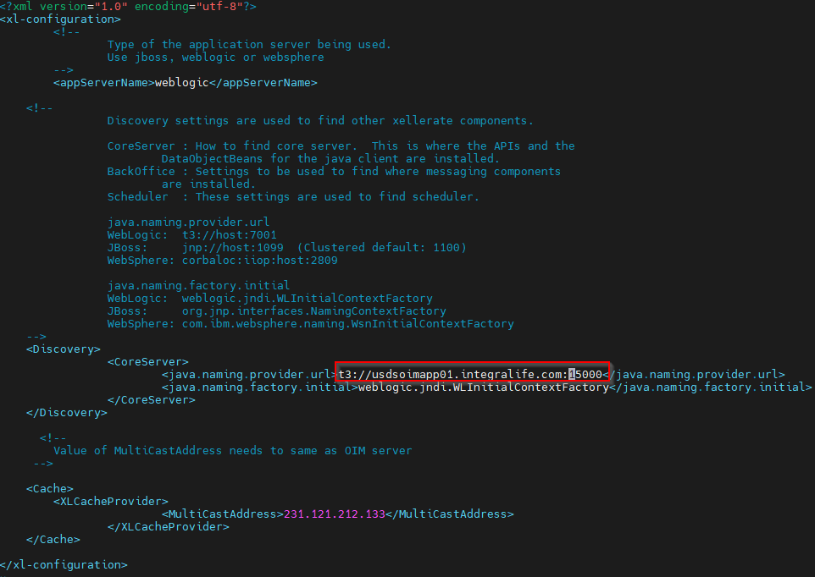

* Set the JAVA_HOME.

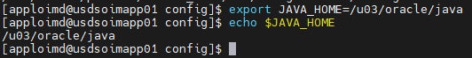

* Run the below command from the location “/u03/oracle/product/Oracle_Home/idm/designconsole” to access the design console.

**./xlclient.sh**

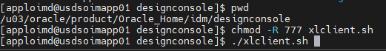

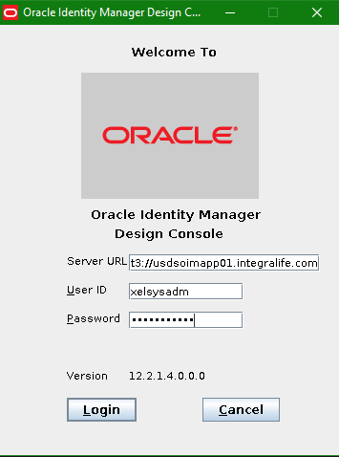

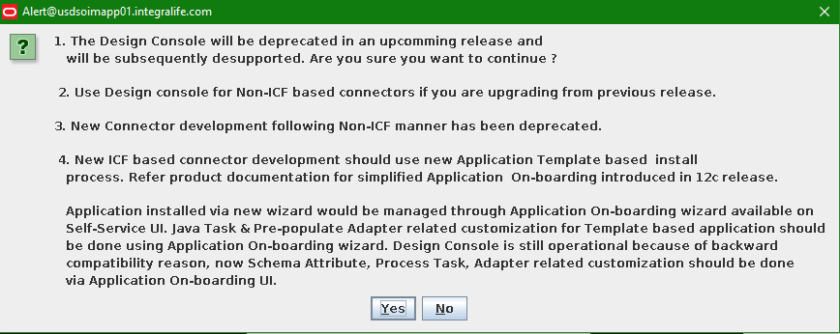

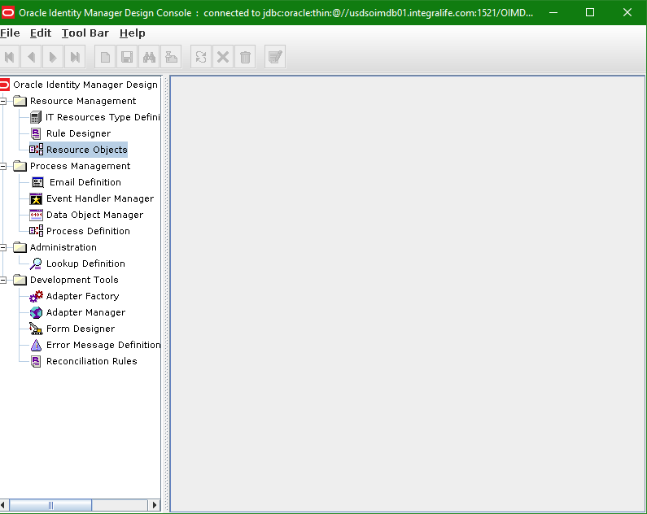

# Performance Tuning

## Tuning Application Cache

* Create a new directory as “mdsexport” in the location “/u03”.

**cd /u03**

**mkdir mdsexport**

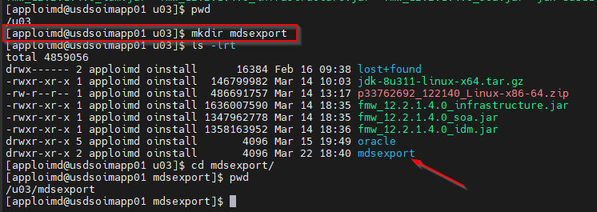

* Login in the EM Console and click on “**System MBean Browser**” under WebLogic Domain.

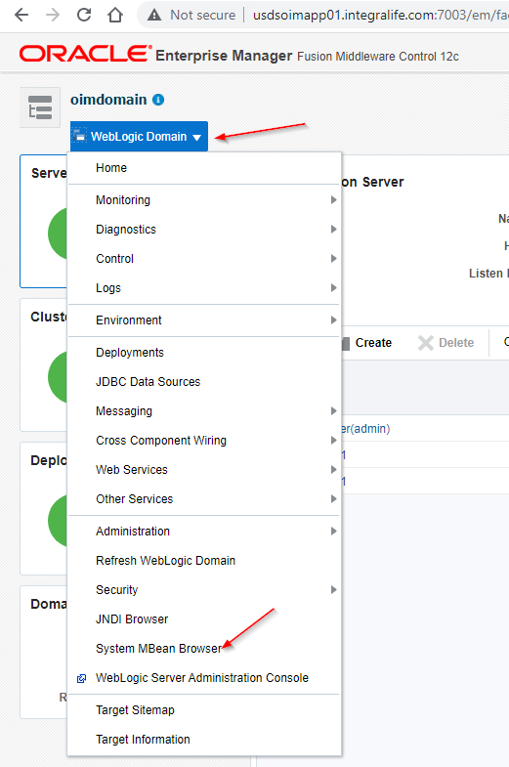

* Go to the below location to export the OIM metadata.

System MBean Browser 🡺 Application Defined MBeans 🡺oracle.mds.lcm 🡺Server: oim_server1 🡺Application: oim 🡺MDSAppRuntime 🡺 MDSAppRunTime

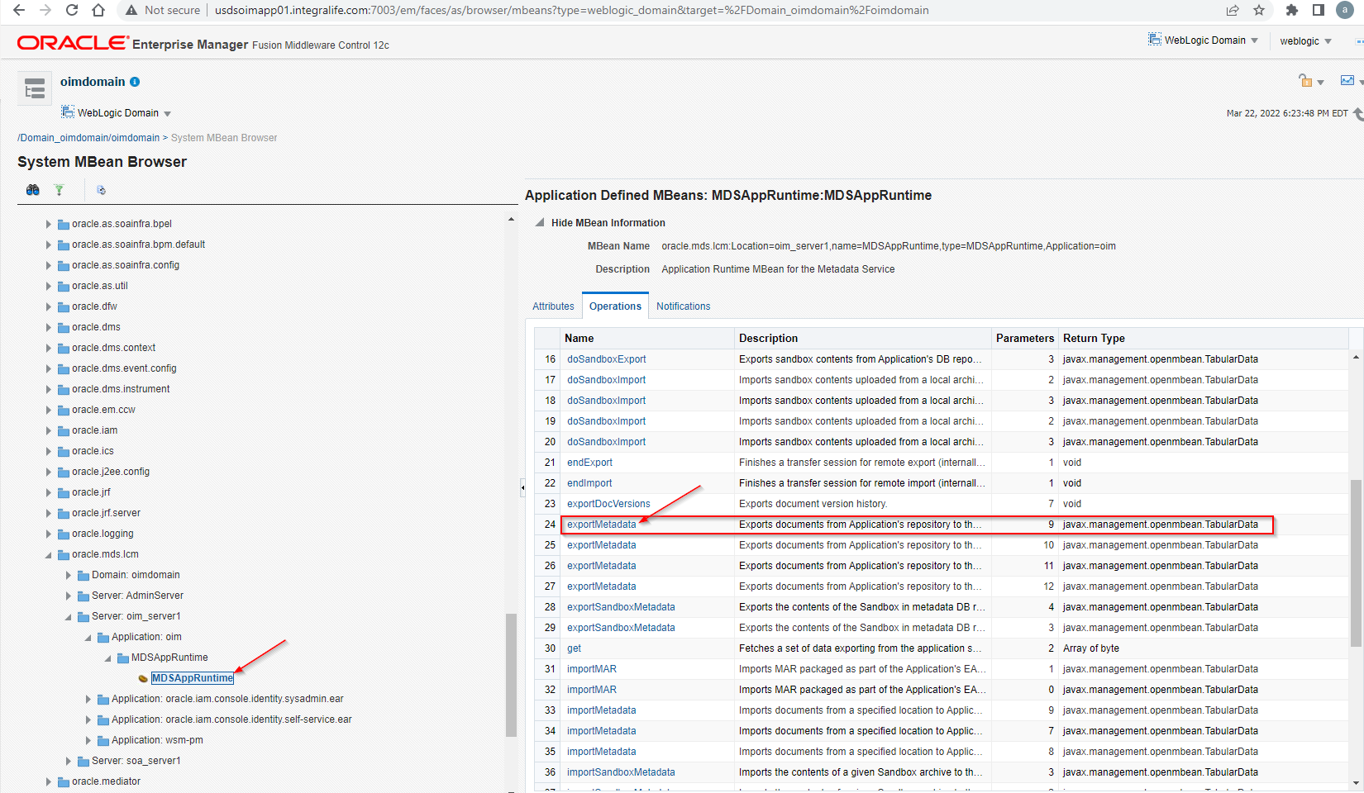

* Provide the “**toLocation**” as **“/u03/mdsexport”** and click on Invoke button.

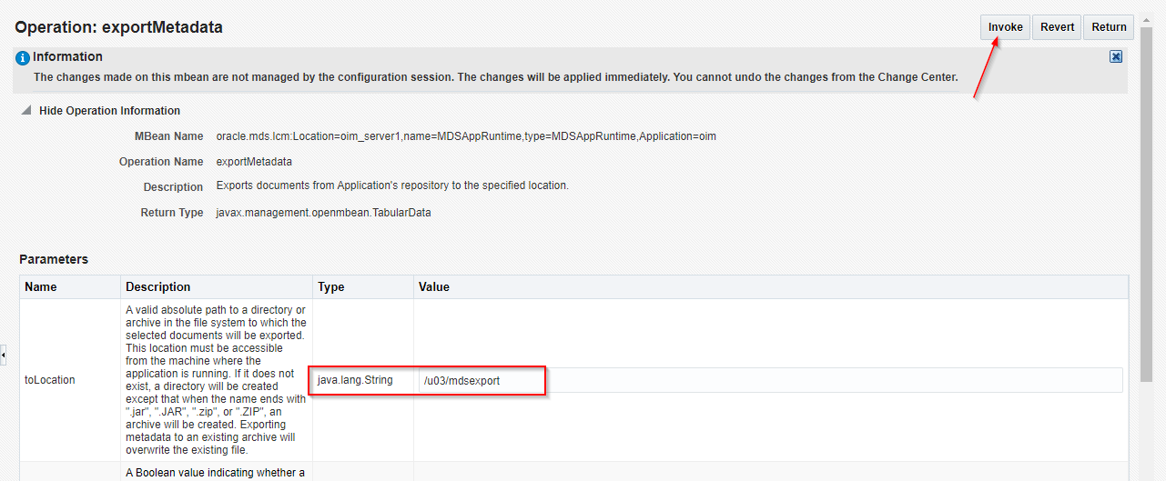

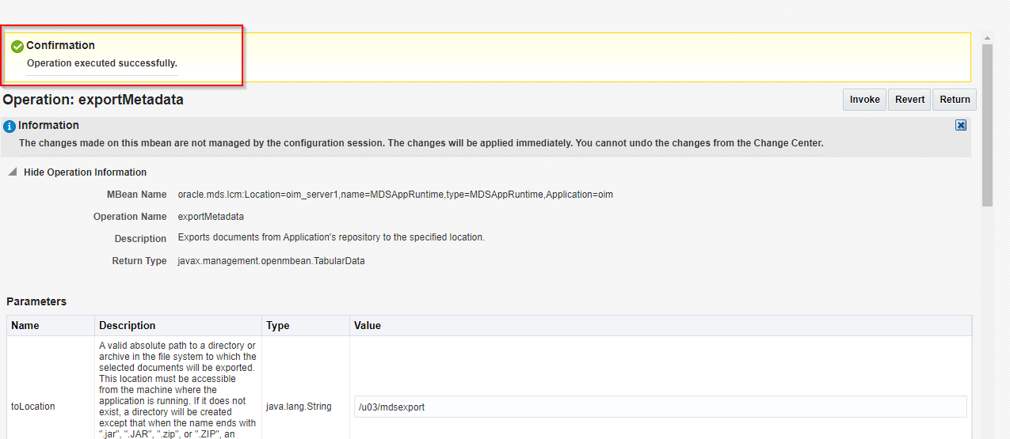

* Go to the location **“/u03/mdexport”** in linux box and verify the MDS files.

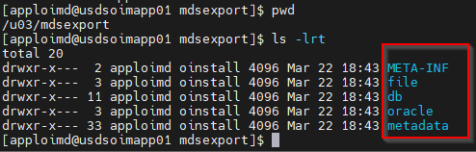

* Create new directory as “mdsimport/db” in the location “/u03”.

**mkdir -p mdsimport/db**

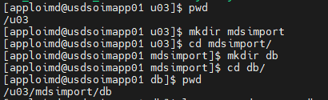

* Copy “**oim-config.xml”** file from the location **“/u03/mdsexport/db”** to **“/u03/mdsimport/db”**.

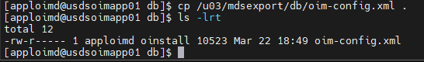

* Open the “oim-config.xml” file from “/u03/mdsimport/db” and enable the cache for all the cache config except the following and save.

**threadLocalCacheEnabled=false**

**StoredProcAPI=false**

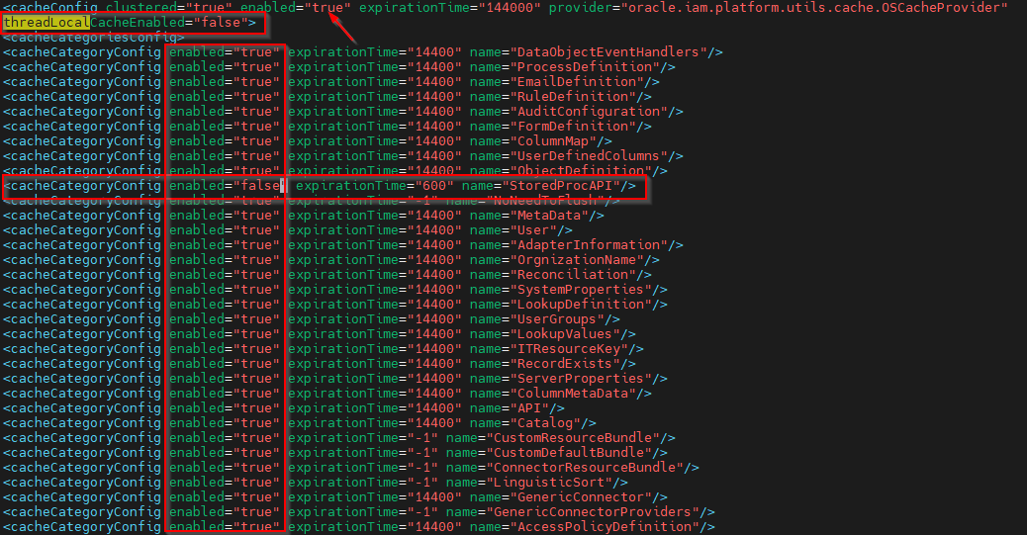

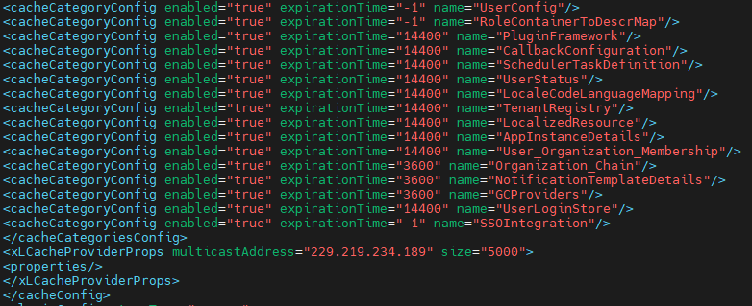

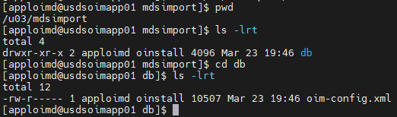

* Login into the EM console and open the “System MBean Browser” under “WebLogic Domain” and go the below location.

System MBean Browser 🡺 Application Defined MBeans 🡺oracle.mds.lcm 🡺Server: oim_server1 🡺Application: oim 🡺MDSAppRuntime 🡺 MDSAppRunTime

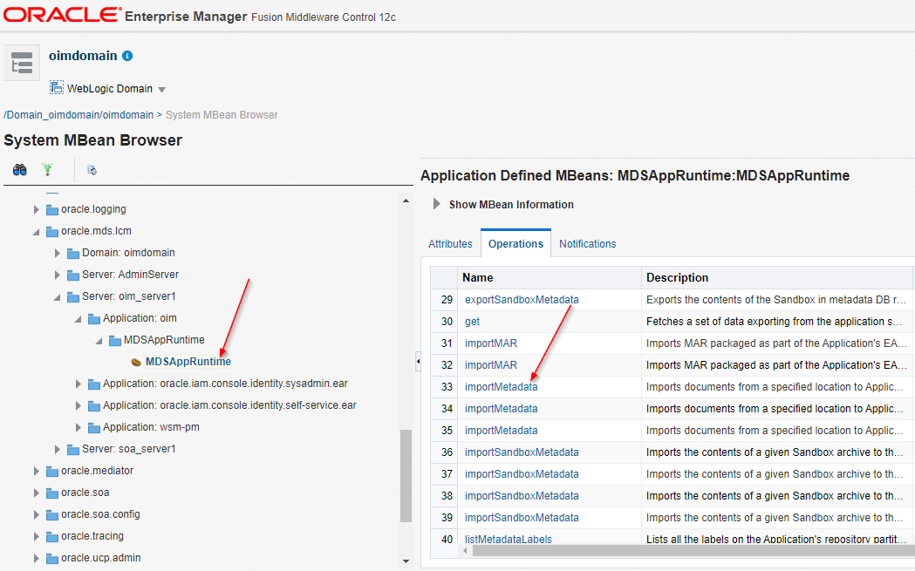

* Provide the **fromLocation** as “**/u03/mdsimport**” and click on “**invoke**” button.

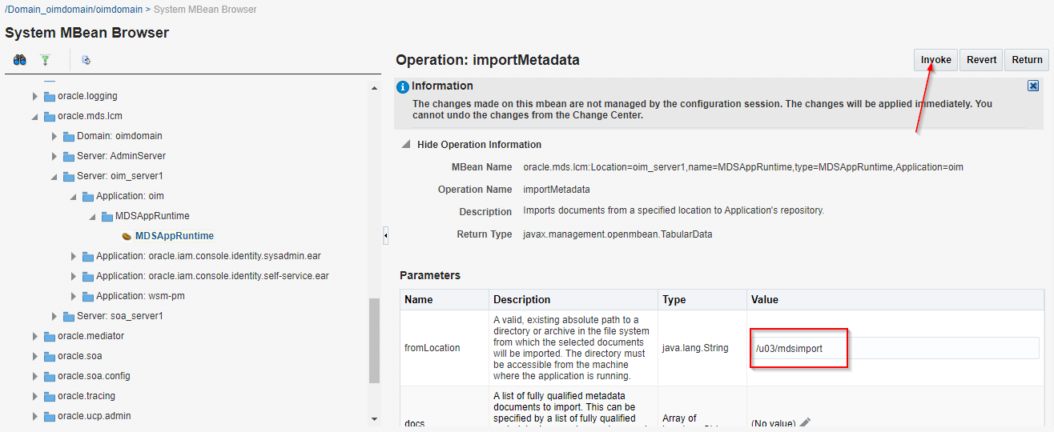

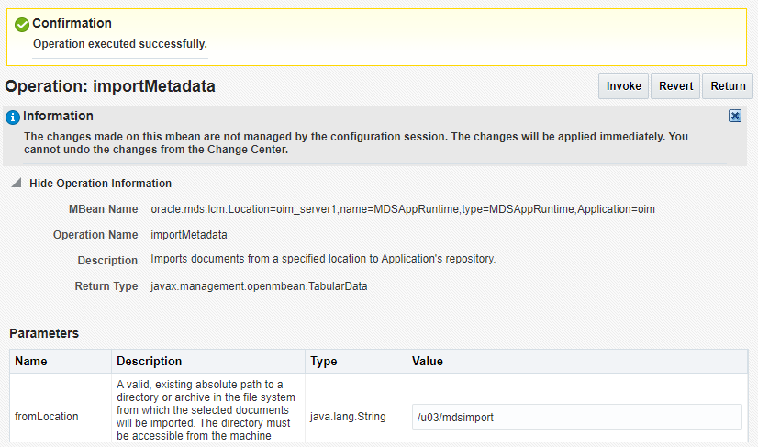

* To validate the changes, export the MDS again and verify the oim-config.xml file. Take the backup of existing **mdsexport** directory from the location **“/u03”** and perform the “MDS Export Step again”.

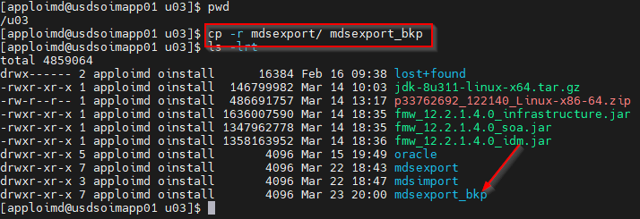

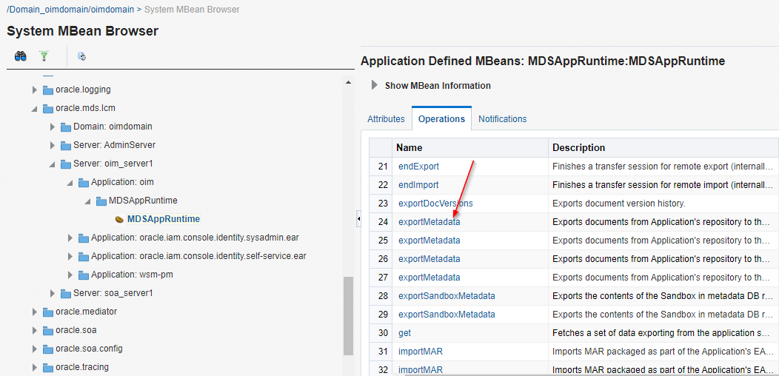

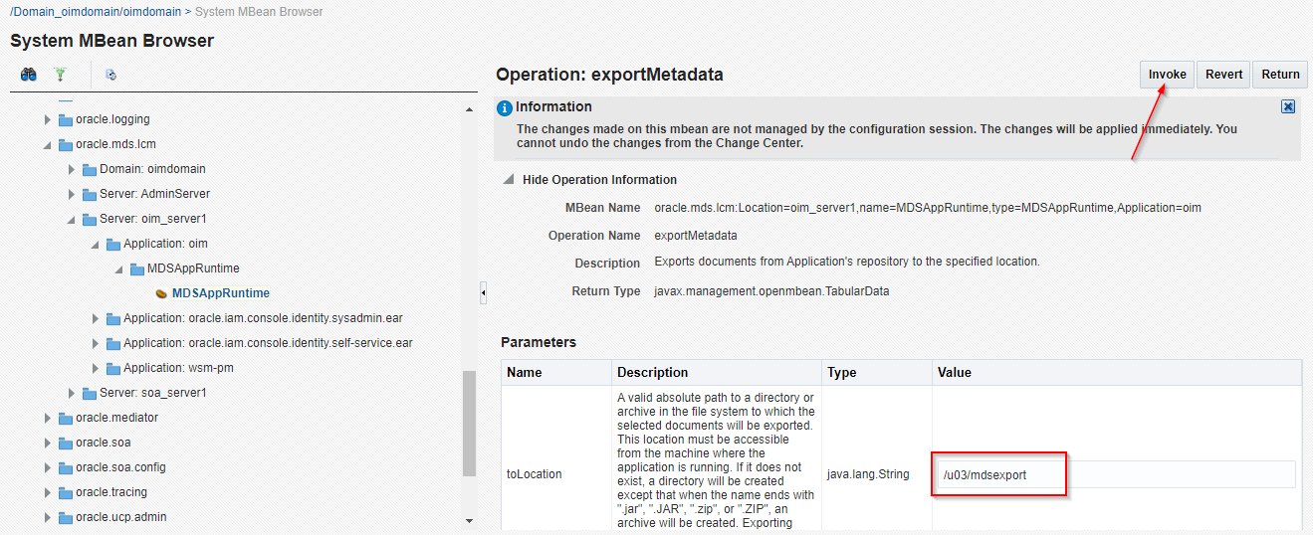

* Go to the location **“/u03/mdsexport/db”** and open the **oim-config.xml** file and verify the changes.

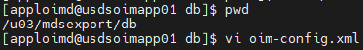

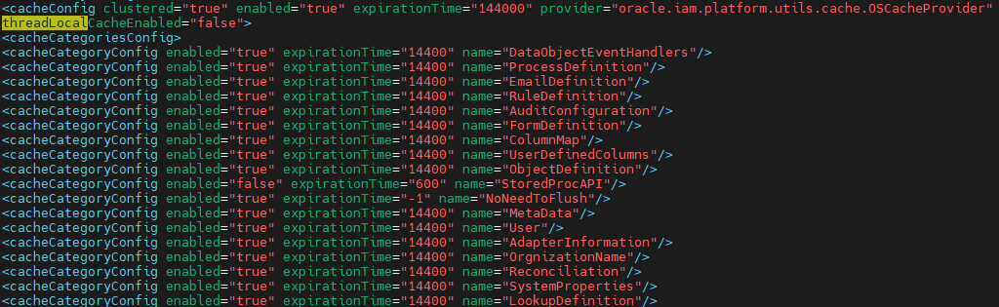

## Tuning JVM Memory Settings

* Go to the location **“/u03/oracle/config/domains/oimdomain/bin”** and open the **“setStartupEnv.sh”** file.

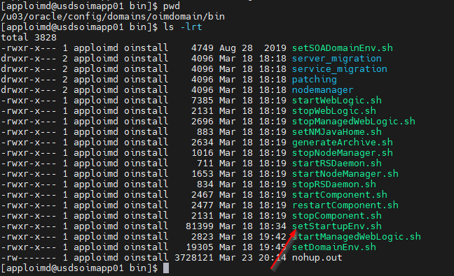

* Set the Java heap memory values as below for the section **“OIM-MGD-SVRS”** and save the file.

**Xms – 4096**

**Xmx - 8192**

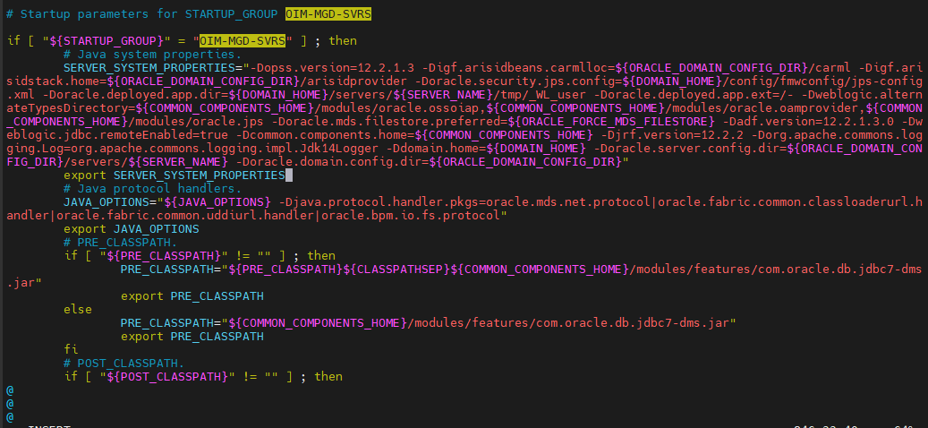

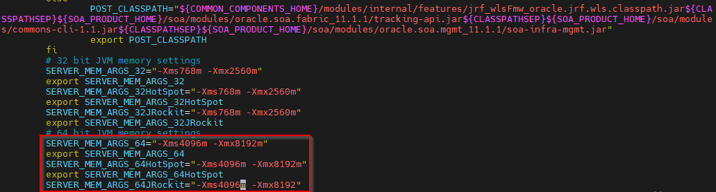

* Set the Java heap memory values as below for the section **“STARTUP_GROUP SOA-MGD-SVRS”** and save the file.

**Xms – 4096**

**Xmx - 8192**

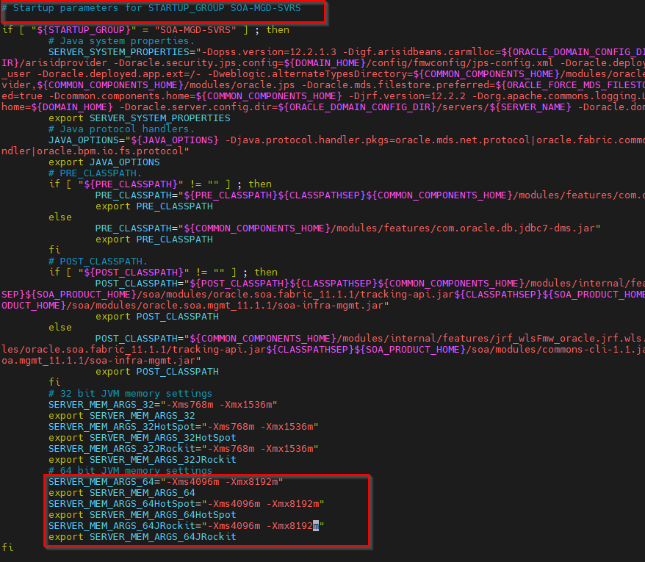

* Set the Java heap memory values as below for the section **“STARTUP_GROUP AdminServerStartupGroup”** and save the file.

**Xms – 1024**

**Xmx - 2048**

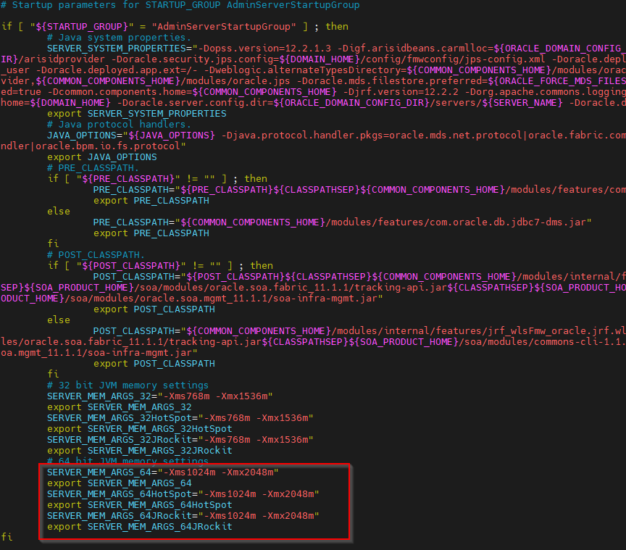

## Tuning the JDBC Connection Pool

* Login into WebLogic console click on **“Data Sources”** and open the following data sources and increase the connection pooling **“Maximum Capacity”** as below.

**ApplicationDB - 250**

**oimOperationsDB - 250**

**oimJMSStoreDS – 50**

**Note: For above data sources make sure “Inactive Connection Time Out” is set to 300 and “Seconds to Trust Idle Pool Connection” as 30**

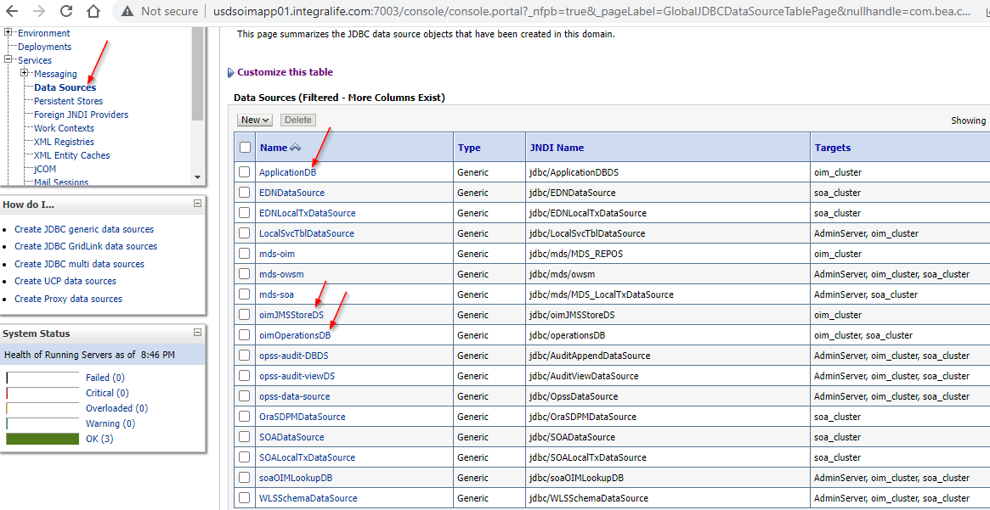

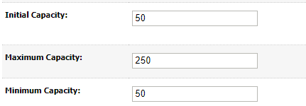

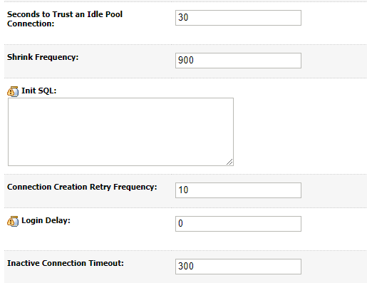

## Increase Thread Count for OIG Access Policy Job

* Login into OIM System administration console and open the Scheduler link.

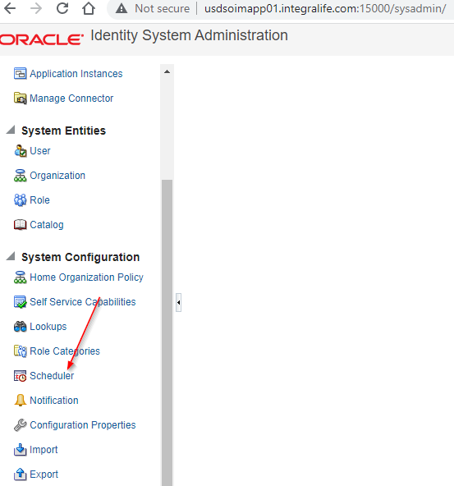

* Open “Evaluate User Policies” schedule job and update the “Number of Threads” scheduler parameter as 20 and click on Apply button.  
  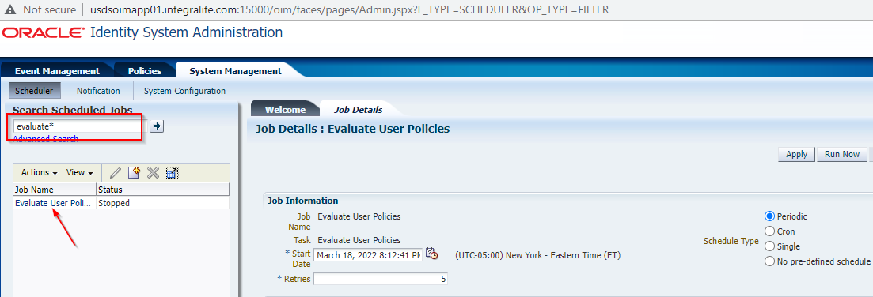

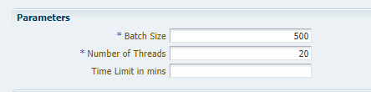

## Tuning OIG Work Manager

* Login into the WebLogic console and verify the Max Thread Constraint value for the following Work Managers.

|  |  |
| --- | --- |
| **Work Manager Name** | **Recommended Value** |
| OIMMDBWorkManager | 80 |
| OIMAuditWorkManager | 5 |
| OIMWorkManager | 10 - 15 |
| OIMUIWorkManager | 20 |

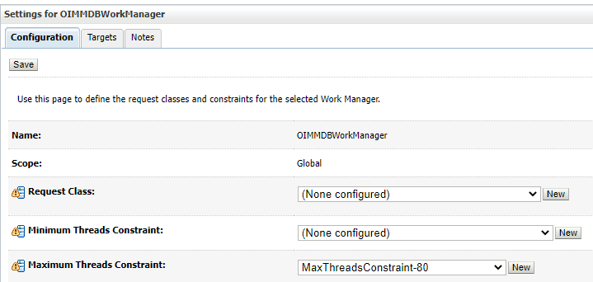

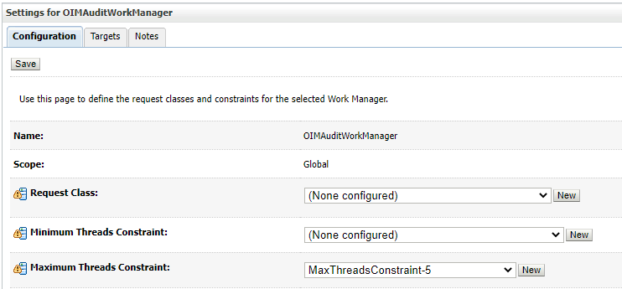

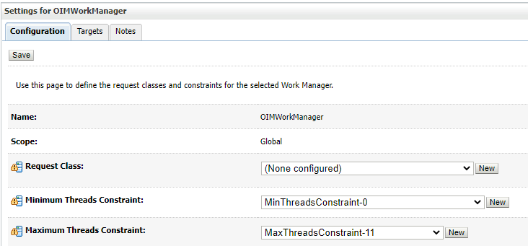

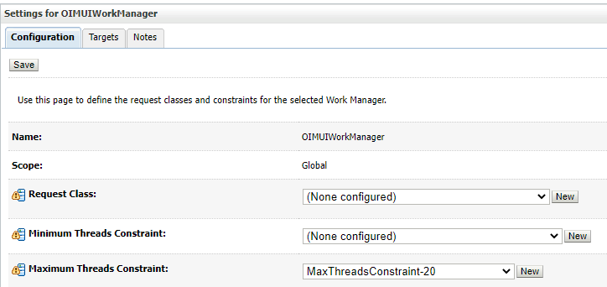

## JMS Tuning

* Login into the WebLogic console and open the JMS Servers under Services.

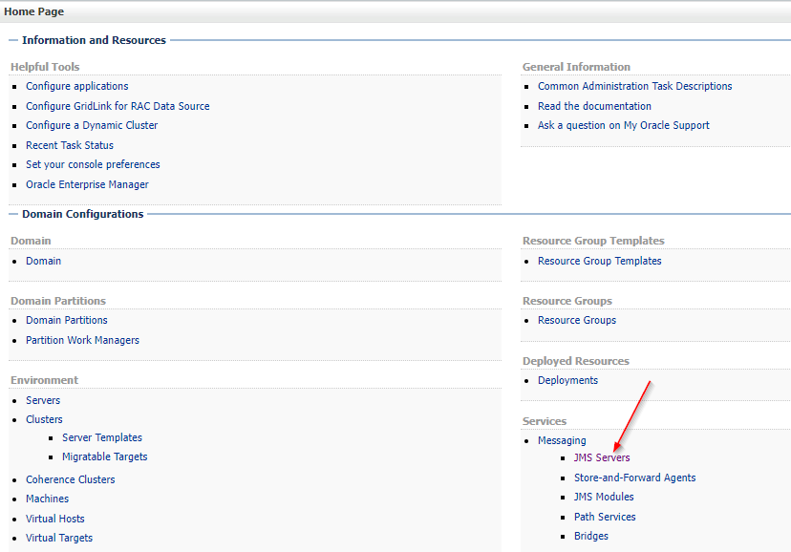

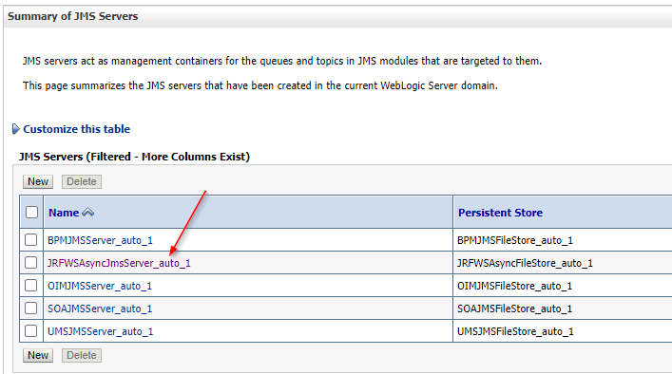

* Update the “**Message Buffer Size”** value as 1073741824(bytes). Default value is -1.

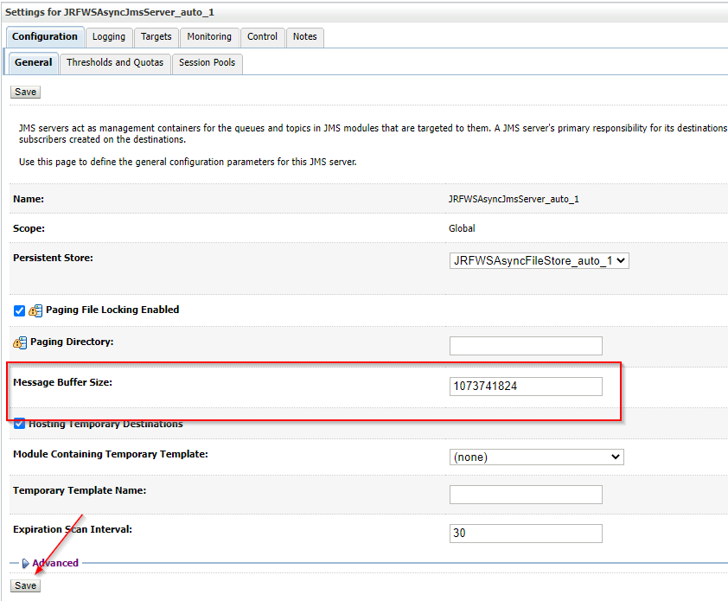

* Increase **Messages Maximum** value to 1000000 for **Thresholds and Quotas**. Default value is 20000.

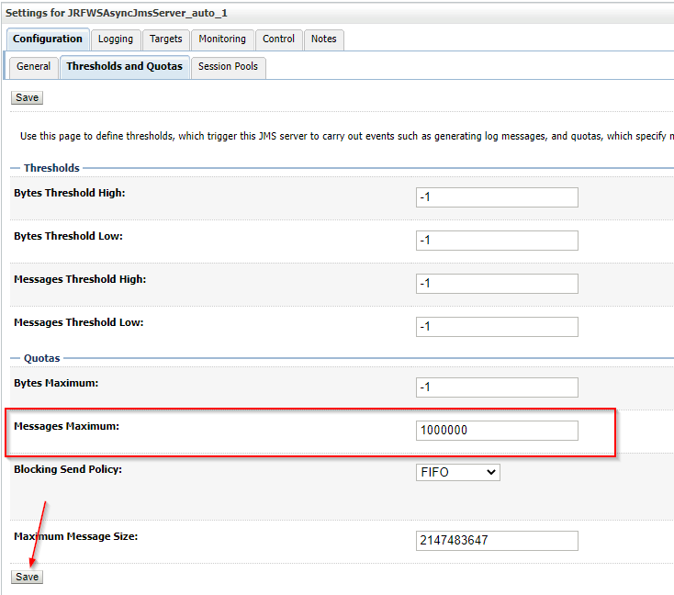

## Restart Servers

* Restart the servers in following order.

1. OIM Server
2. SOA Server
3. WebLogic Server

* Login into the WebLogic console

Servers🡺 select oim_server1 🡺 Force shutdown now.

Servers🡺 select soa_server1 🡺 Force shutdown now.

Servers 🡺 select AdminServer 🡺 Force shutdown now.

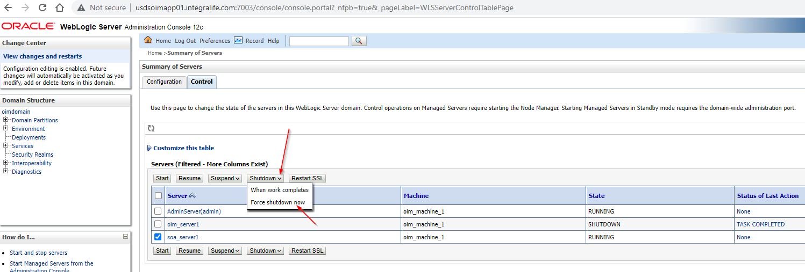

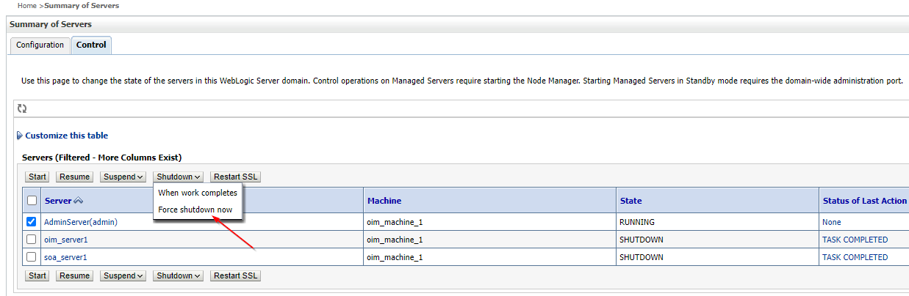

* Login into the Linux box and start the WebLogic server using below command from the location “/u03/oracle/config/domains/oimdomain/bin”.

**nohup ./startWebLogic.sh &**

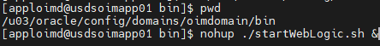

* Login into WebLogic console and start the SOA and OIM servers.

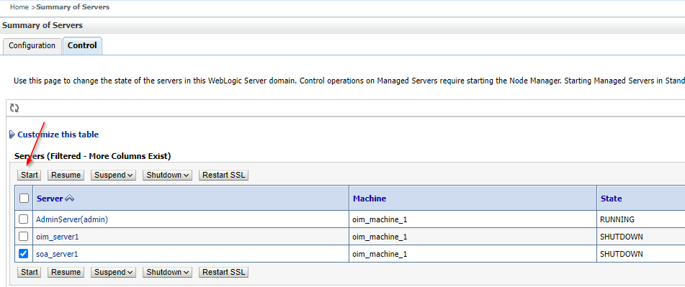

# Apply Bundle Patches

* Stop all the servers(SOA, OIM, and WebLogic)
* **Take the complete backup of database and MW_HOME, DOMAIN_HOME**
* Create a directory PATCH_TOP in the location “/u03”.

**mkdir PATCH_TOP**

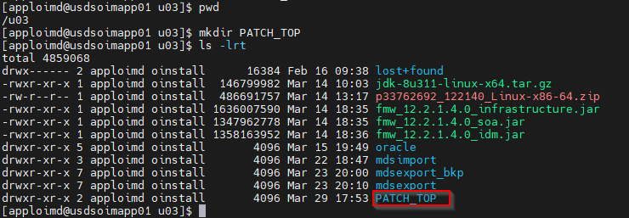

* Copy “**p33762692_122140_Linux-x86-64.zip**” file from “/u03/” to “/u03/PATCH_TOP” and unzip the file.

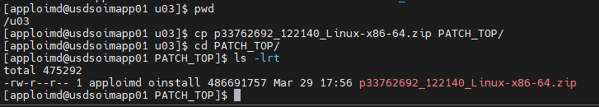



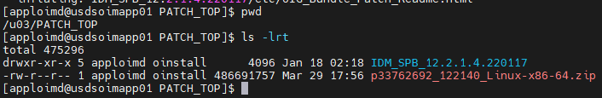

* Take the backup of Oracle_Home and Config directories before applying the patches. Create a directory “backups/backup_03292022” in the location “/u03”.

**mkdir -p backups/backup_03292022**

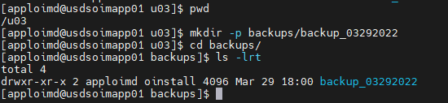

* Go to the location “/u03/backups/backup_03292022” and run the below commands.

**cp -r /u03/oracle/product/Oracle_Home/ .**

**cp -r /u03/oracle/config/ .**

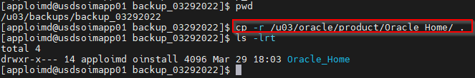

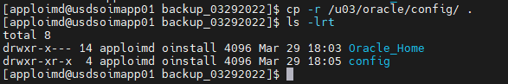

* Create “**oraInventory**” directory in the location “/u03”.

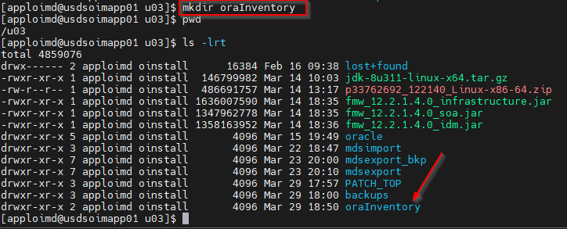

* Go to the location **“/u03/oracle/product/Oracle_Home”** and open the file **“oraInst.loc”** and update the **“inventory_loc”** value as **“/u03/oraInventory”** and save.

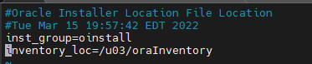

* Make sure /etc/oraInst.loc file is same as $ORACLE_HOME/oraInst.loc.

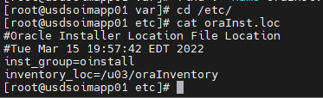

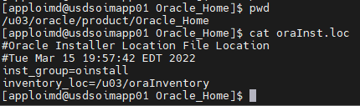

## Apply OPATCH 13.9.4.2.8

* Verify the Opatch version before applying the patch.

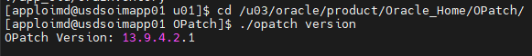

* Copy p28186730_139428_Generic.zip from the location “/u03” to **/u03/PATCH_TOP** and unzip.





* Set the JAVA_HOME as “/u03/oracle/java/bin” using below command.

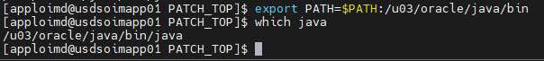

* Run the below command to install the patch.

**java -jar /u03/PATCH_TOP/6880880/opatch_generic.jar -silent oracle_home=/u03/oracle/product/Oracle_Home**



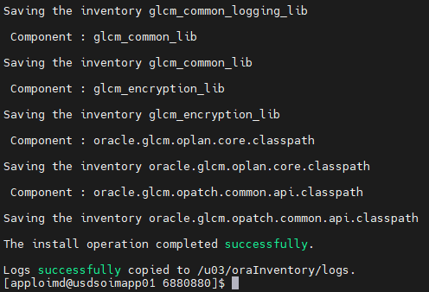

* Go to the location “oracle/product/Oracle_Home/OPatch/” and verify the opatch version using below command.

**./opatch version**

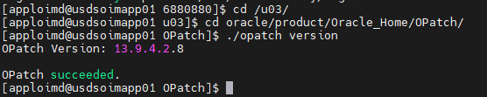

* Run below command to validate the opatch inventory.

**./opatch lsinventory**

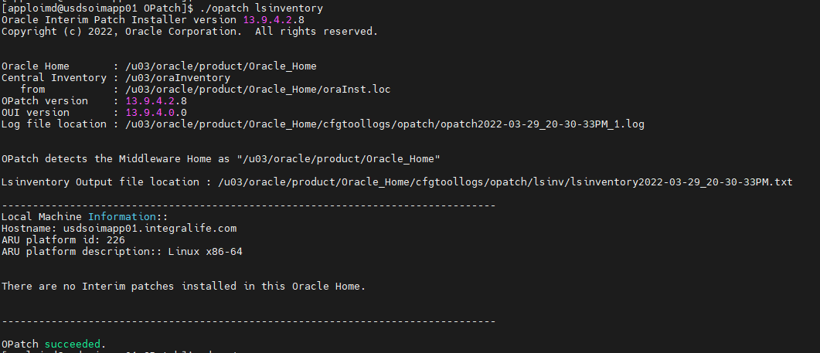

## Apply SOA Bundle Patch

* Patch Number – 33965482
* Set the ORACLE_HOME and JAVA_HOME using below commands.

**JAVA_HOME:**export JAVA_HOME=/u03/oracle/java

export PATH=$JAVA_HOME/bin:$PATH

**ORACLE_HOME**

export ORACLE_HOME=/u03/oracle/product/Oracle_Home

* Apply the patch using below command from the location “/u03/PATCH_TOP/IDM_SPB_12.2.1.4.220418/binary_patches/soa/generic/33965482”

**/u03/oracle/product/Oracle_Home/OPatch/opatch apply**



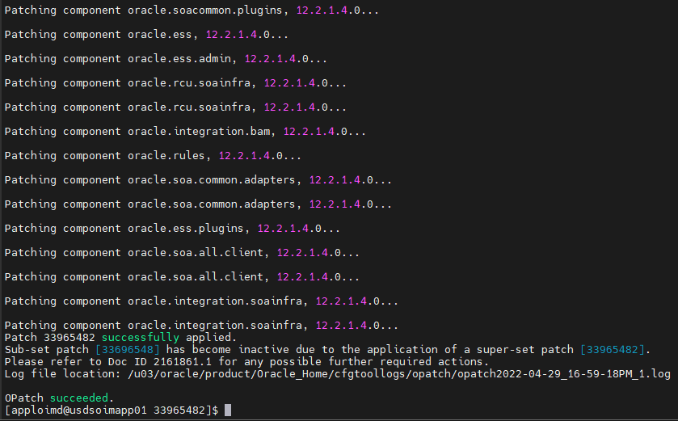

* Go to the location **“/u03/oracle/product/Oracle_Home/soa/common/sql/soainfra/sql/oracle/122140/”** and copy the **soa_purge12 and verify12** directories to local machine.

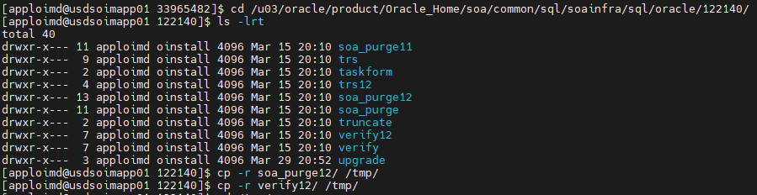

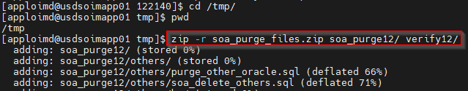

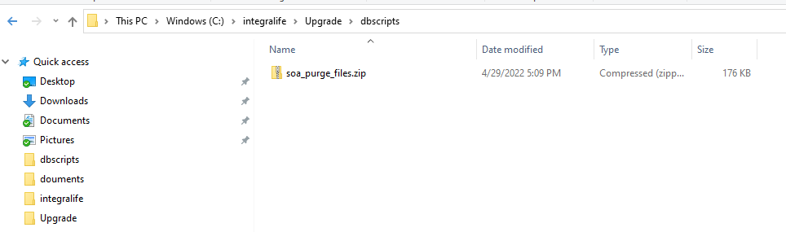

* Login into database machine and copy the **soa_purge_files.zip** to database machine **/tmp** directory and unzip.

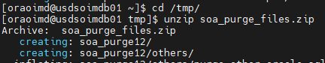

* Go to the directory **“/tmp/soa_purge12”** and connect to the **DEV12C_SOAINFRA** schema using SQLPLUS and execute the **soa_purge_scripts.sql** script.

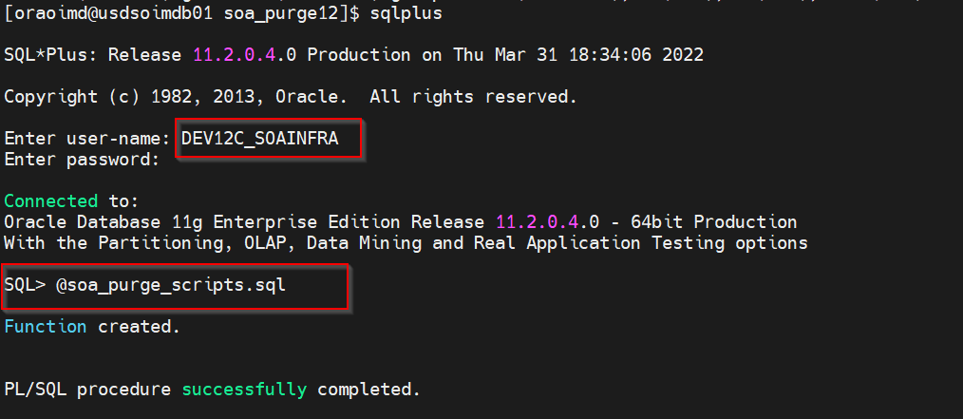

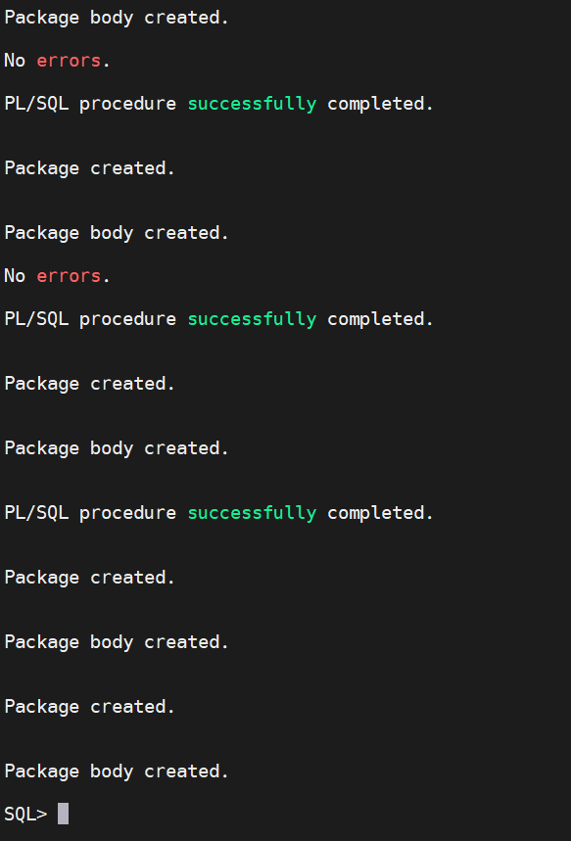

* Go to the directory **”** **/tmp/verify12”** and connect to the **DEV12C_SOAINFRA** schema using SQLPLUS and execute the **soa_verify_scripts.sql** script.

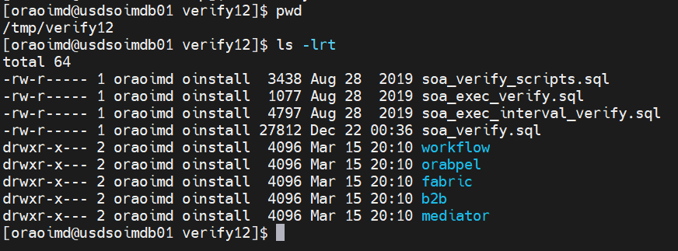

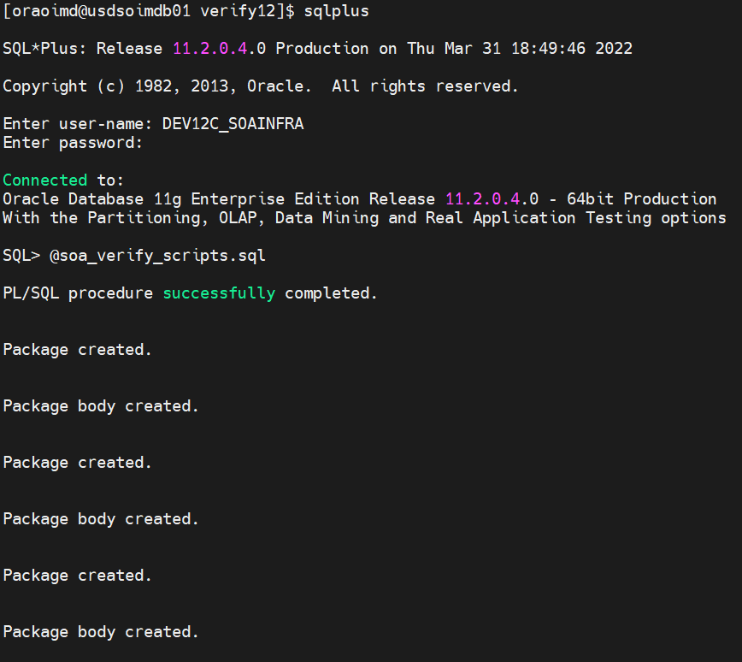

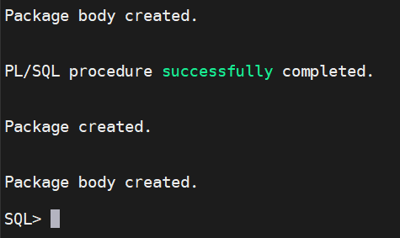

* Go to the location in database machine **“/tmp/soa_purge12/soa”** and and connect to the **DEV12C_SOAINFRA** and execute **loadcompbasedpurgeprogram.sql** script using SQLPLUS.

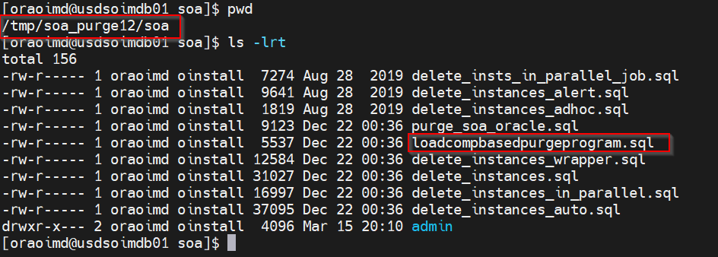

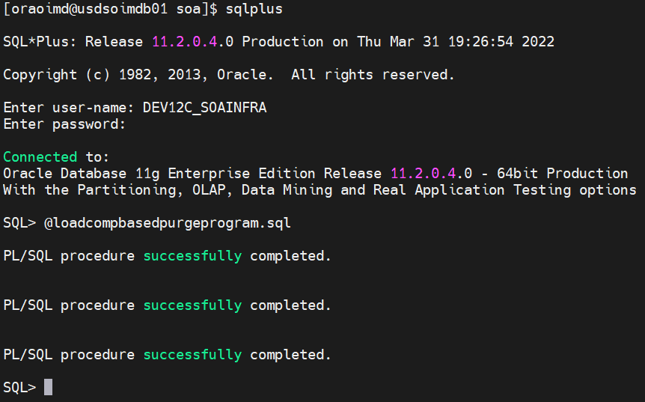

**Note: First we may get below errors during execution of loadcompbasedpurgeprogram.sql script.**

ERROR at line 1:  
ORA-27470: failed to re-enable "DEV12C_SOAINFRA.DELETE_INSTANCES_AUTO_PRG"  
after making requested change  
ORA-27456: not all arguments of program  
"DEV12C_SOAINFRA.DELETE_INSTANCES_AUTO_PRG" have been defined  
ORA-06512: at "SYS.DBMS_ISCHED", line 4467  
ORA-06512: at "SYS.DBMS_SCHEDULER", line 2851  
ORA-06512: at line 3

**Solution: Re-execute the Post Installation Step as per the Oracle doc (Doc ID 2765890.1)**

<https://support.oracle.com/epmos/faces/DocumentDisplay?_afrLoop=413270853440411&parent=EXTERNAL_SEARCH&sourceId=PROBLEM&id=2765890.1&_afrWindowMode=0&_adf.ctrl-state=lp56ic0nz_4>

* Go to the location **“/u03/oracle/product/Oracle_Home/soa/plugins/maven/com/oracle”** Cleanup PS3 maven plugin files shipped in 12.2.1.4 using following commands.

**rm -rf  */*/12.2.1-3-0/**

**rm -rf  */*/*/12.2.1-3-0/**

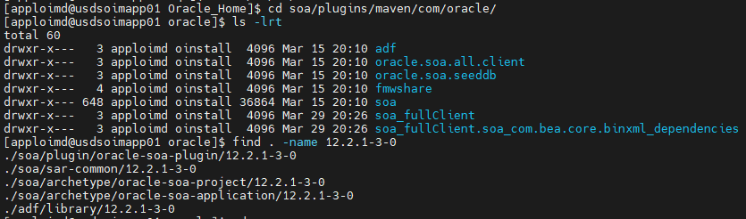

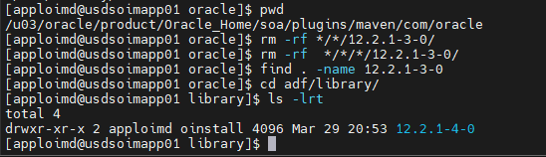

## Apply OIM Bundle Patch

* Stop all the Servers (SOA, OIM and WebLogic).
* Patch Number – 34066601
* Set the ORACLE_HOME and JAVA_HOME using below commands.

**JAVA_HOME:**export JAVA_HOME=/u03/oracle/java

export PATH=$JAVA_HOME/bin:$PATH

**ORACLE_HOME**

export ORACLE_HOME=/u03/oracle/product/Oracle_Home

* Apply the patch using below command from the location “/u03/PATCH_TOP/IDM_SPB_12.2.1.4.220418/binary_patches/oig/generic/34066601”

**/u03/oracle/product/Oracle_Home/OPatch/opatch apply**



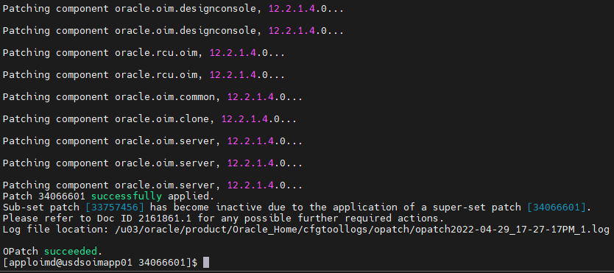

**Note:** OIM Opatch apply will take more time

* Verify the patch details by running the **opatch lsinventory** command from the location **“/u03/oracle/product/Oracle_Home/OPatch/”.**

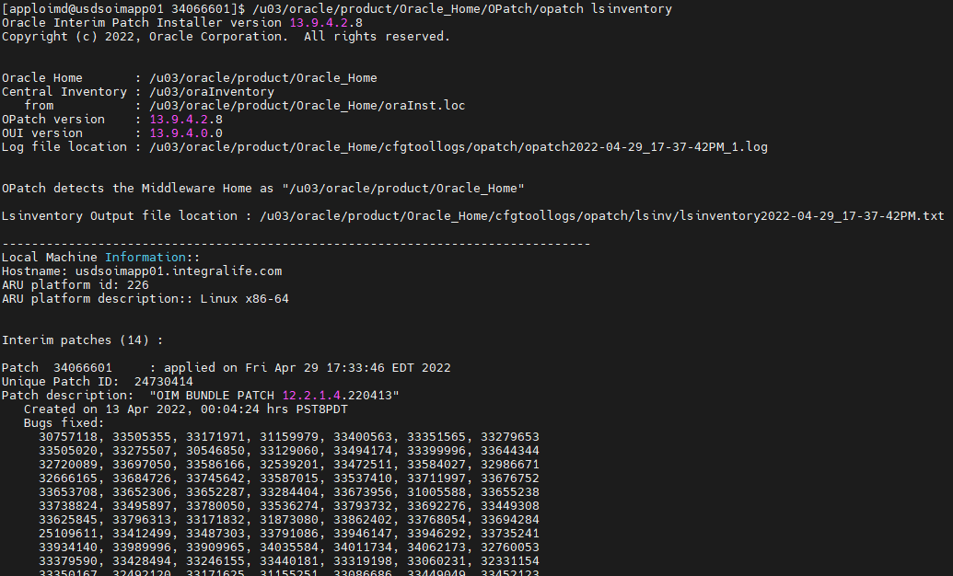

* Start all the servers(Node Manager, WebLogic, SOA and OIM).

Node Manager:

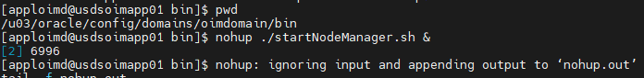

WebLogic:

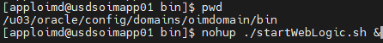

* Login into WebLogic console and start the SOA and OIM Managed Servers.

**Note: OIM and SOA servers will take more time to start after applying the patch first time.**

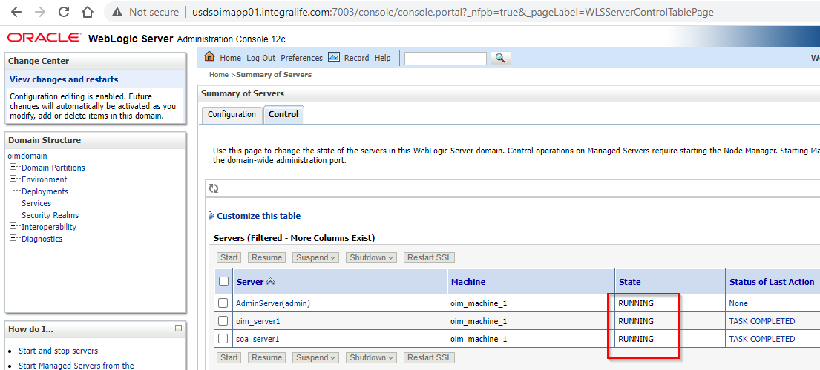

* Using a text editor, edit the file **patch_oim_wls.profile** located in the directory **$ORACLE_HOME/idm/server/bin/** directory and change the values accordingly as per the environment.

|  |  |
| --- | --- |
| **Parameter** | **Value** |
| ant_home | /u03/oracle/product/Oracle_Home/oracle_common/modules/thirdparty/org.apache.ant/1.10.5.0.0/apache-ant-1.10.5 |
| java_home | /u03/oracle/java |
| mw_home | /u03/oracle/product/Oracle_Home |
| oim_oracle_home | /u03/oracle/product/Oracle_Home/idm |
| soa_home | /u03/oracle/product/Oracle_Home/soa |
| weblogic.server.dir | /u03/oracle/product/Oracle_Home/wlserver |
| domain_home | /u03/oracle/config/domains/oimdomain |
| weblogic_user | weblogic |
| weblogic_password | ****** |
| soa_host | usdsoimapp01.integralife.com |
| soa_port | 9001 |
| operationsDB.user | DEV12C_OIM |
| OIM.DBPassword | ****** |
| operationsDB.host | usdsoimdb01.integralife.com |
| operationsDB.serviceName | oimd.integralife.com |
| operationsDB.port | 1521 |
| mdsDB.user | DEV12C_MDS |
| mdsDB.password | ****** |
| mdsDB.host | usdsoimdb01.integralife.com |
| mdsDB.port | 1521 |
| mdsDB.serviceName | oimd.integralife.com |
| oim_username | xelsysadm |
| oim_password | ****** |
| oim_serverurl | t3://usdsoimapp01.integralife.com:15000 |
| wls_serverurl | t3://usdsoimapp01.integralife.com:7003 |

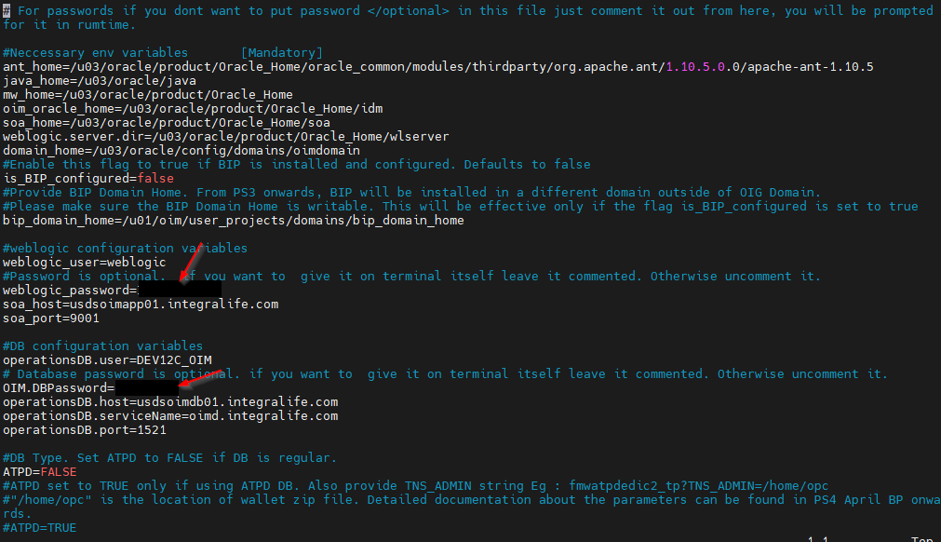

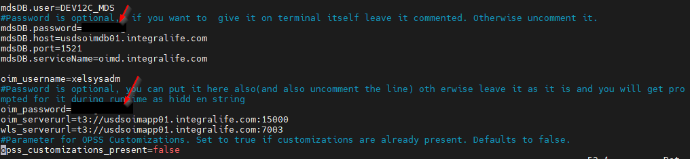

* **Make sure that the WebLogic Admin Server, SOA Managed Servers, and Oracle Identity** **Governance Managed Server are running before running the patch_oim_wls.sh script.**
* Set JAVA_HOME environment variable using below commands.

**export JAVA_HOME=/u03/oracle/java**

**export PATH=$JAVA_HOME/bin:$PATH**

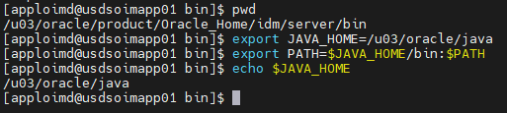

* Give the permissions to **“patch_oim_wls.sh”** script and execute.

**./patch_oim_wls.sh**

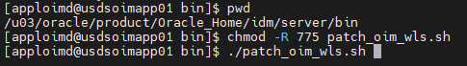

* To verify that the **patch_oim_wls** script has completed successfully, check the $ORACLE_HOME/idm/server/bin/patch_oim_wls.log log file.

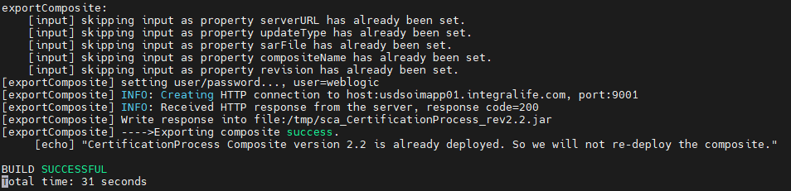

**Note: If any errors observed in the log file with .sql file execution errors, re-run the patch_oim_wls.sh script file**

* Stop OIM,SOA and WebLogic servers from WebLogic console.

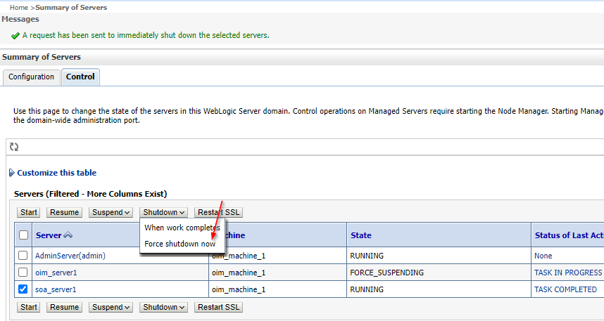

* Remove the **tmp** and **cache** directories from all the servers.

OIM: /u03/oracle/config/domains/oimdomain/servers/oim_server1/

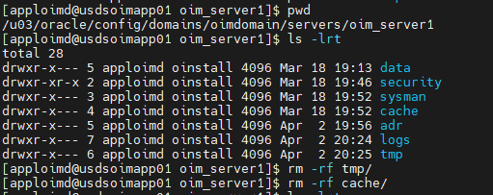

SOA: /u03/oracle/config/domains/oimdomain/servers/soa_server1

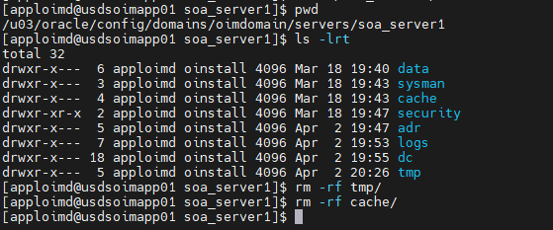

WebLogic: /u03/oracle/config/domains/oimdomain/servers/AdminServer

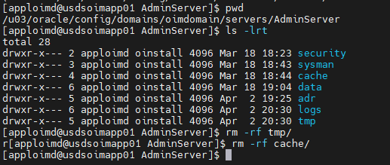

## Apply WebLogic Patch

* Set the ORACLE_HOME and JAVA_HOME using below commands.

**JAVA_HOME:**export JAVA_HOME=/u03/oracle/java

export PATH=$JAVA_HOME/bin:$PATH

**ORACLE_HOME**

export ORACLE_HOME=/u03/oracle/product/Oracle_Home

* Apply the patch using below command from the location “/u03/PATCH_TOP/IDM_SPB_12.2.1.4.220418/binary_patches/wls/generic/34012040”

**/u03/oracle/product/Oracle_Home/OPatch/opatch apply**



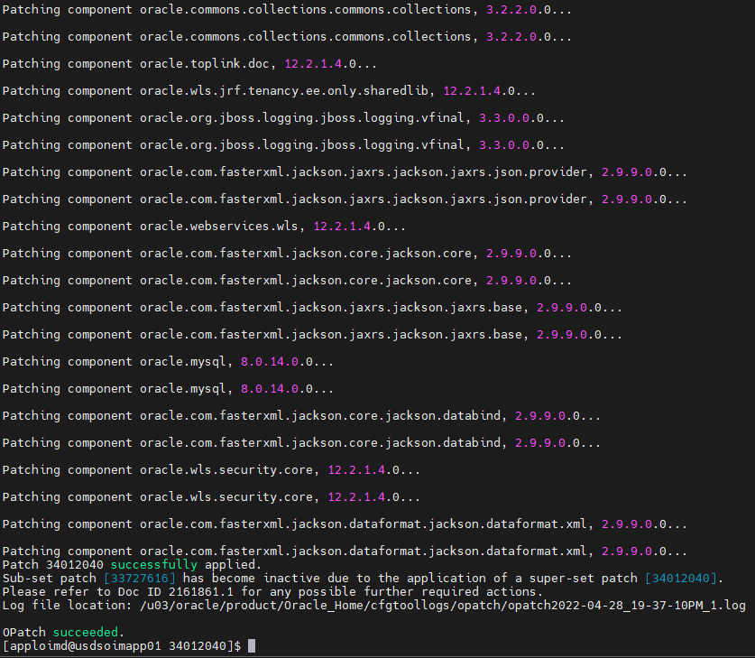

## Apply Patch 32647448

* Set the ORACLE_HOME and JAVA_HOME using below commands.

**JAVA_HOME:**export JAVA_HOME=/u03/oracle/java

export PATH=$JAVA_HOME/bin:$PATH

**ORACLE_HOME**

export ORACLE_HOME=/u03/oracle/product/Oracle_Home

* Apply the patch using below command from the location “/u03/PATCH_TOP/IDM_SPB_12.2.1.4.220418/binary_patches/wls/linux64/32647448”

**/u03/oracle/product/Oracle_Home/OPatch/opatch apply**



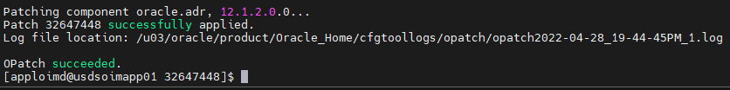

## Apply Coherence Patch

* Set the ORACLE_HOME and JAVA_HOME using below commands.

**JAVA_HOME:**export JAVA_HOME=/u03/oracle/java

export PATH=$JAVA_HOME/bin:$PATH

**ORACLE_HOME**

export ORACLE_HOME=/u03/oracle/product/Oracle_Home

* Apply the patch using below command from the location “/u03/PATCH_TOP/1221413”

**/u03/oracle/product/Oracle_Home/OPatch/opatch apply**



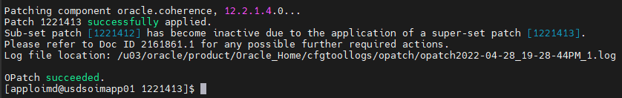

## Apply Third Party Bundle Patch

* Make Sure JAVA_HOME and ORACLE_HOME is set to the path.

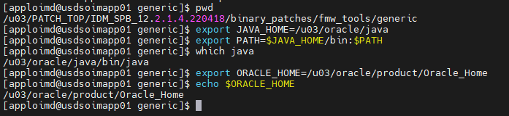

* Apply the patch using below command from the location “/u03/PATCH_TOP/IDM_SPB_12.2.1.4.220418/binary_patches/fmw_tools/generic/34044738”

**/u03/oracle/product/Oracle_Home/OPatch/opatch apply**



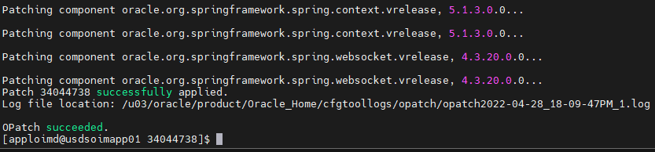

## Apply ADF Bundle Patch

* Set the ORACLE_HOME and JAVA_HOME using below commands.

**JAVA_HOME:**export JAVA_HOME=/u03/oracle/java

export PATH=$JAVA_HOME/bin:$PATH

**ORACLE_HOME**

export ORACLE_HOME=/u03/oracle/product/Oracle_Home

* Apply the patch using below command from the location “/u03/PATCH_TOP/IDM_SPB_12.2.1.4.220418/binary_patches/jdev/generic/33958532”

**/u03/oracle/product/Oracle_Home/OPatch/opatch apply**



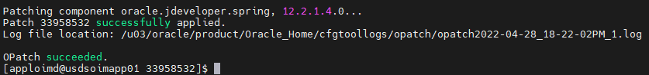

## Apply FMW Platform Patch

* Set the ORACLE_HOME and JAVA_HOME using below commands.

**JAVA_HOME:**export JAVA_HOME=/u03/oracle/java

export PATH=$JAVA_HOME/bin:$PATH

**ORACLE_HOME**

export ORACLE_HOME=/u03/oracle/product/Oracle_Home

* Apply the patch using below command from the location “/u03/PATCH_TOP/IDM_SPB_12.2.1.4.220418/binary_patches/fmw_platform/generic/33093748”

**/u03/oracle/product/Oracle_Home/OPatch/opatch apply**



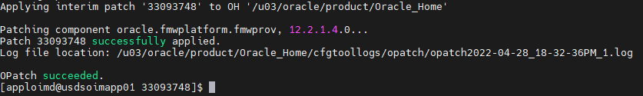

## Apply Patch 32720458

* Set the ORACLE_HOME and JAVA_HOME using below commands.

**JAVA_HOME:**export JAVA_HOME=/u03/oracle/java

export PATH=$JAVA_HOME/bin:$PATH

**ORACLE_HOME**

export ORACLE_HOME=/u03/oracle/product/Oracle_Home

* Apply the patch using below command from the location “/u03/PATCH_TOP/IDM_SPB_12.2.1.4.220418/binary_patches/jdbc/generic/32720458”

**/u03/oracle/product/Oracle_Home/OPatch/opatch apply**



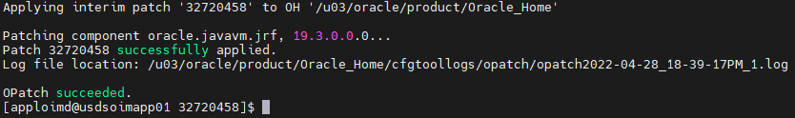

## Apply Patch 33618954

* Set the ORACLE_HOME and JAVA_HOME using below commands.

**JAVA_HOME:**export JAVA_HOME=/u03/oracle/java

export PATH=$JAVA_HOME/bin:$PATH

**ORACLE_HOME**

export ORACLE_HOME=/u03/oracle/product/Oracle_Home

* Apply the patch using below command from the location “/u03/PATCH_TOP/IDM_SPB_12.2.1.4.220418/binary_patches/owsm/generic/33618954”

**/u03/oracle/product/Oracle_Home/OPatch/opatch apply**



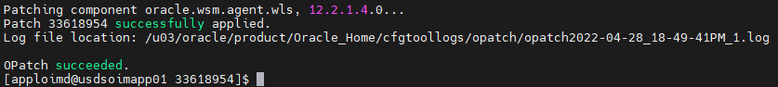

## Apply Patch 33546536

* Set the ORACLE_HOME and JAVA_HOME using below commands.

**JAVA_HOME:**export JAVA_HOME=/u03/oracle/java

export PATH=$JAVA_HOME/bin:$PATH

**ORACLE_HOME**

export ORACLE_HOME=/u03/oracle/product/Oracle_Home

* Apply the patch using below command from the location “/u03/PATCH_TOP/IDM_SPB_12.2.1.4.220418/binary_patches/owsm/generic/33546536”

**/u03/oracle/product/Oracle_Home/OPatch/opatch apply**



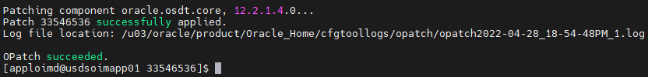

## Apply OPSS Patch

* Set the ORACLE_HOME and JAVA_HOME using below commands.

**JAVA_HOME:**export JAVA_HOME=/u03/oracle/java

export PATH=$JAVA_HOME/bin:$PATH

**ORACLE_HOME**

export ORACLE_HOME=/u03/oracle/product/Oracle_Home

* Apply the patch using below command from the location “/u03/PATCH_TOP/IDM_SPB_12.2.1.4.220418/binary_patches/opss/generic/33950717”

**/u03/oracle/product/Oracle_Home/OPatch/opatch apply**



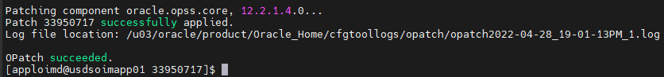

## Apply WebCenter Patch

* Set the ORACLE_HOME and JAVA_HOME using below commands.

**JAVA_HOME:**export JAVA_HOME=/u03/oracle/java

export PATH=$JAVA_HOME/bin:$PATH

**ORACLE_HOME**

export ORACLE_HOME=/u03/oracle/product/Oracle_Home

* Apply the patch using below command from the location “/u03/PATCH_TOP/IDM_SPB_12.2.1.4.220418/binary_patches/owcc/generic/33281560”

**/u03/oracle/product/Oracle_Home/OPatch/opatch apply**



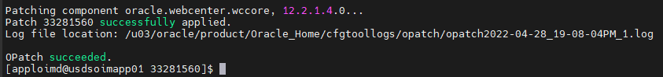

## Verify Opatch lsinventory

* Run the opatch lsinventory command to verify the patch details.

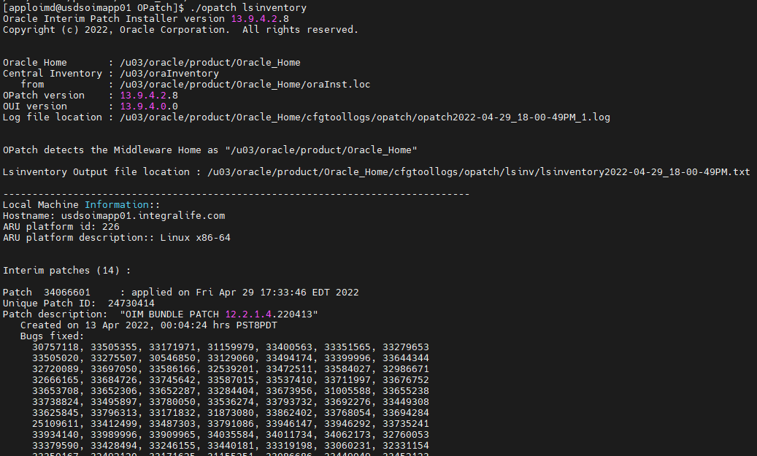

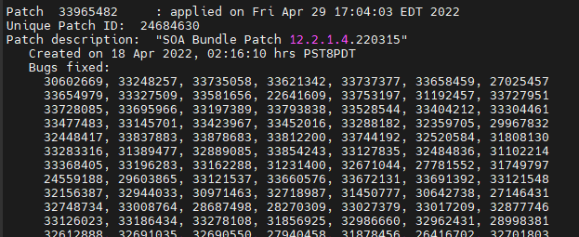

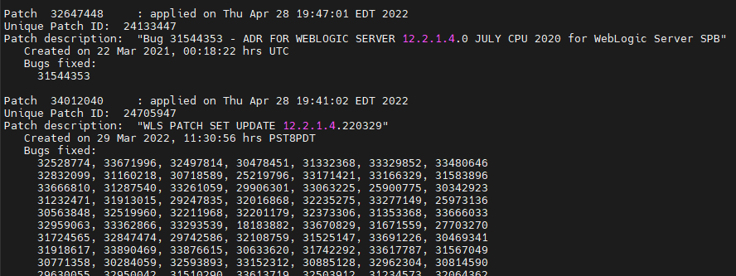

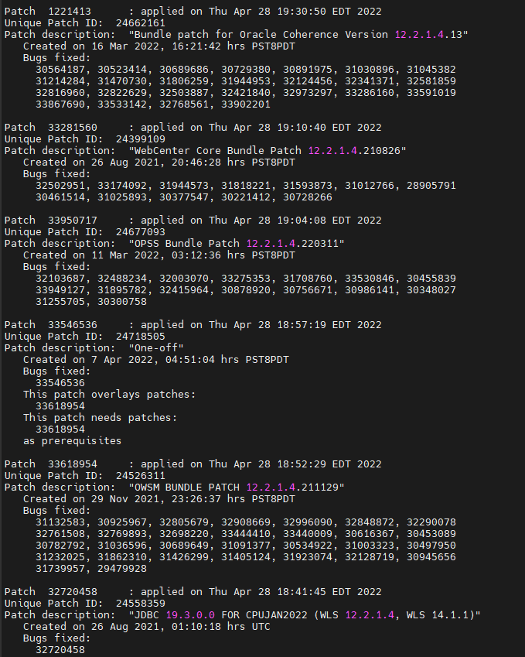

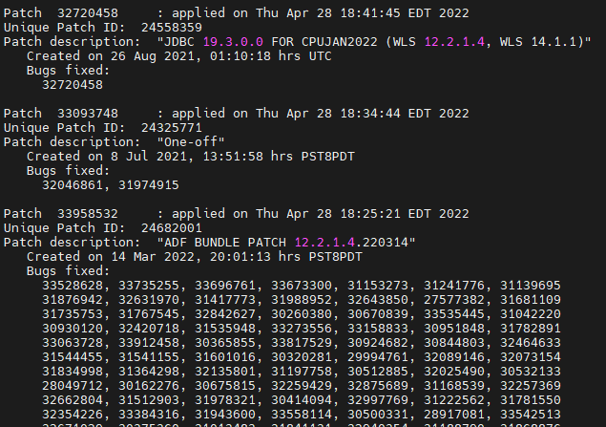

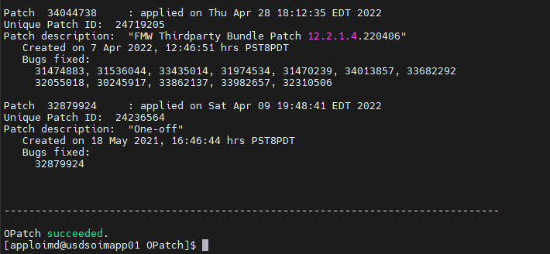

## Apply Upgrade Readiness Check Patch

**Note: This patch is required only if you encountered Result Set Last After Last Row issue during pre-upgrade readiness check.**

* This patch resolved the below issue during upgrade readiness check process.

**java.sql.SQLException: Result set after last row**

* Downloaded the patch **“p32879924_122140_Generic.zip”** file and copied in the location **“/u03/PATCH_TOP”**.

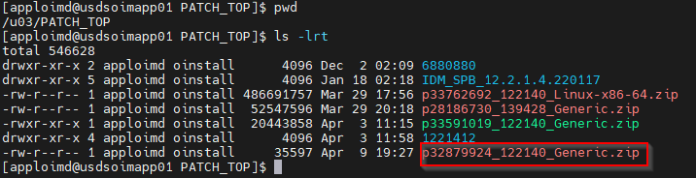

* Unzip **“p32879924_122140_Generic.zip”** file.
* Set the JAVA_HOME as “/u01/oracle/java” and add to class path.

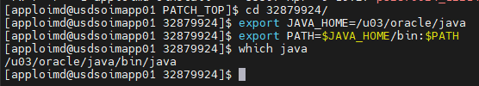

* Set the ORACLE_HOME as **“/u03/oracle/product/Oracle_Home”.**



* Run the below command from the location **“/u03/PATCH_TOP/32879924”** to apply the patch.

**/u03/oracle/product/Oracle_Home/OPatch/opatch apply**



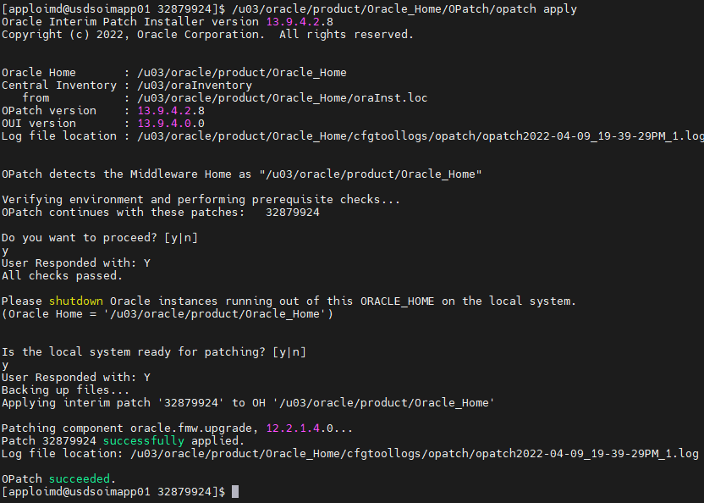

* Verify the **opatch lsinventory**.

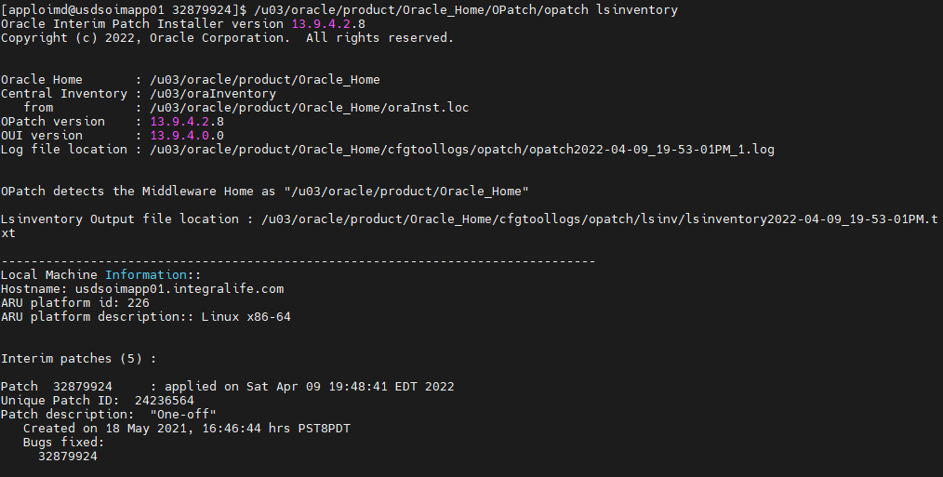

* Start all the servers(WebLogic, SOA and OIM).

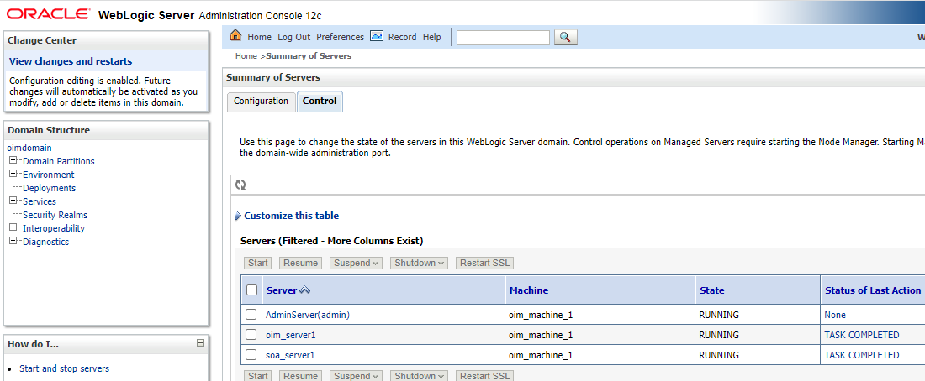

# Upgrade Oracle Identity Manager

## Stop OIM 11g Servers

* Ensure all the OIM 11g services are down before performing upgrade process.

## Backup

* Take the complete backup of Database 11g, 12c and $ORACLE_HOME, $DOMAIN_HOME for 12c.

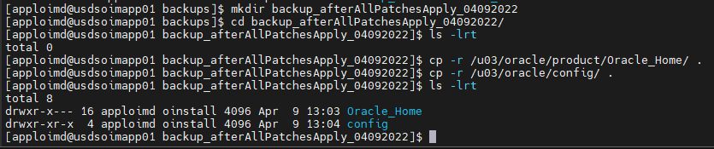

* Take the complete middleware backup of existing OIM 11g middleware.

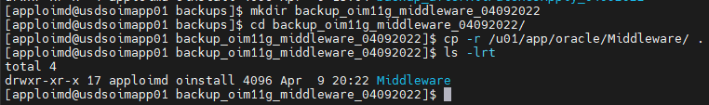

## Generating the Pre-Upgrade Report

* Download the pre-upgrade report utility **“12cPS4PreUpgradeReport.zip”** from Oracle Technology Network (OTN).
* Create a directory “**PreUpgradeReport**” in the location **“/u03”** in Admin Server host machine.

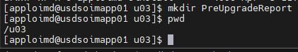

* Copy the downloaded “**12cPS4PreUpgradeReport.zip”** file to the location **“/u03/PreUpgradeReport”** and unzip**.**

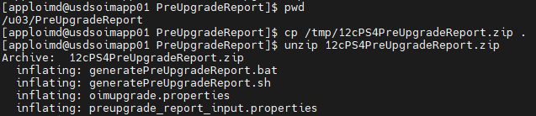

* Create a directory as **“OIM_PreUpgrade_Reports”** in the location **“/u03/PreUpgradeReport”** to store the generated pre-upgrade reports.

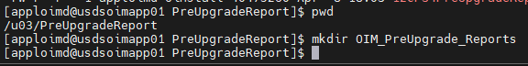

* Update the **preupgrade_report_input.properties** file with below values.

|  |  |
| --- | --- |
| **Parameter Name** | **Value** |
| oim.targetVersion | 12.2.1.4.0 |
| oim.jdbcurl | usdsoimdb01.integralife.com:1521/oimd.integralife.com |
| oim.oimschemaowner | DEV_OIM |
| oim.mdsjdbcurl | usdsoimdb01.integralife.com:1521/oimd.integralife.com |
| oim.mdsschemaowner | DEV_MDS |
| oim.databaseadminname | sys as sysdba |
| oim.outputreportfolder | /u03/PreUpgradeReport/OIM_PreUpgrade_Reports |
| oim.mwhome | /u01/app/oracle/Middleware |
| oim.oimhome | /u01/app/oracle/Middleware/Oracle_IDM1 |
| oim.javahome | /u03/oracle/java |
| oim.wlshome | /u01/app/oracle/Middleware/wlserver_10.3 |
| oim.domain | /u01/app/oracle/Middleware/user_projects/domains/oim |

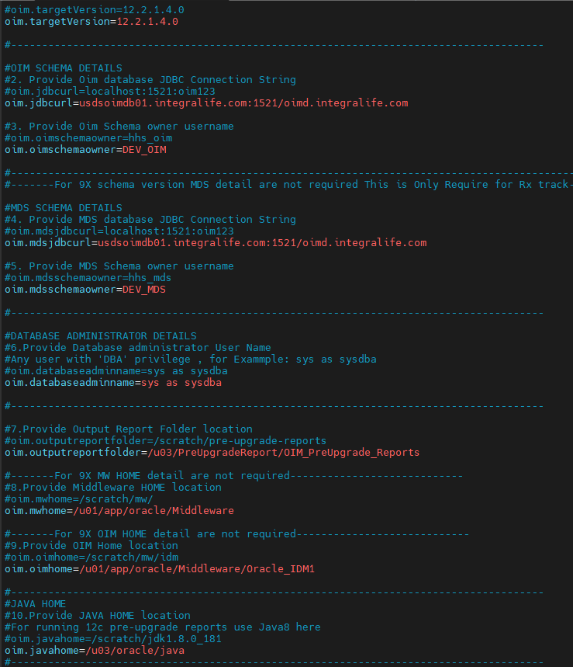

**:w**

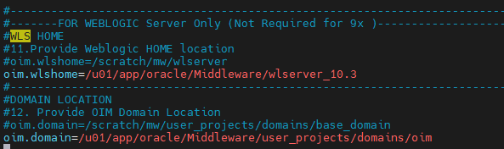

* Run the **“generatePreUpgradeReport.sh”** script from the location **“/u03/PreUpgradeReport”.**



* Provide OIM, MDS schema and SYS passwords.

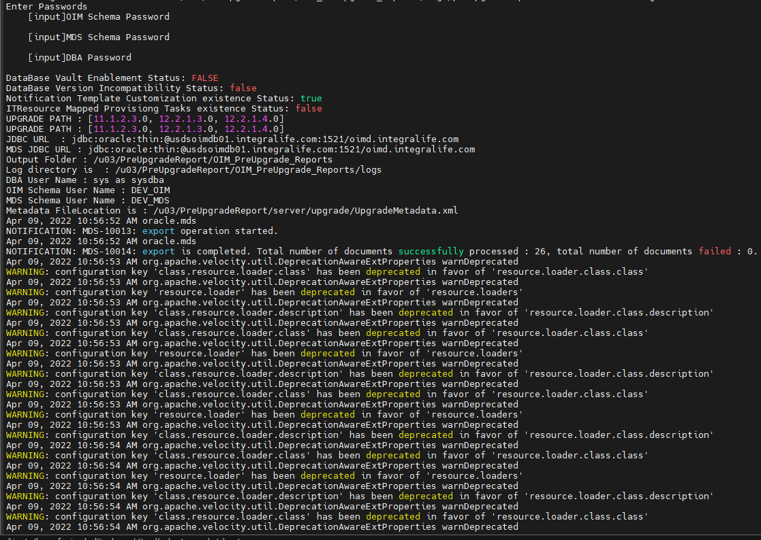

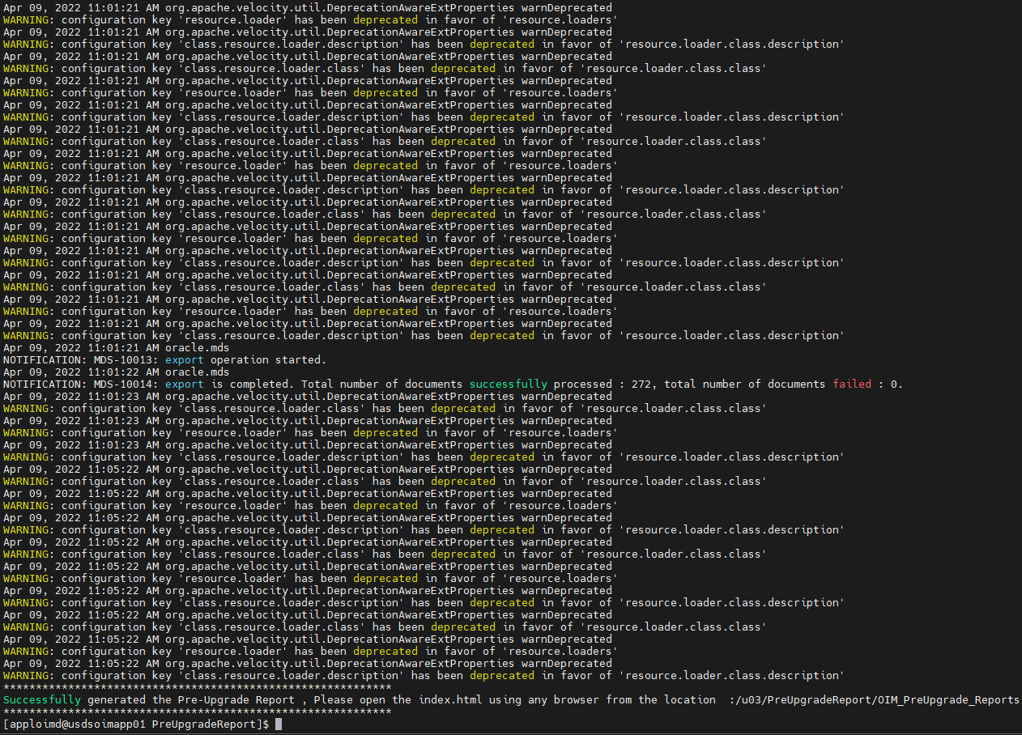

* Reports are generated as HTML pages in the location **“/u03/PreUpgradeReport/OIM_PreUpgrade_Reports”.** Copy “OIM_PreUpgrade_Reports” directory to your local machine and review each of the reports by opening index.html initially.

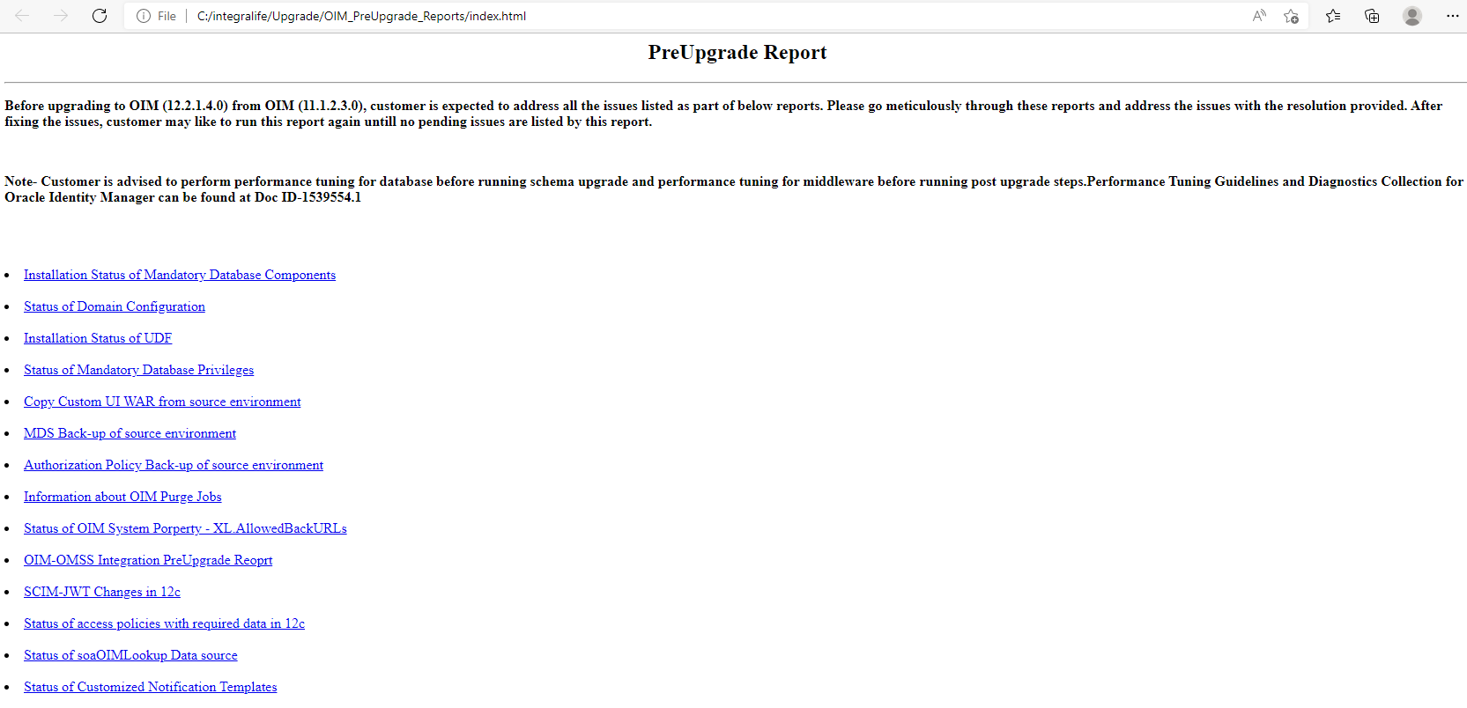

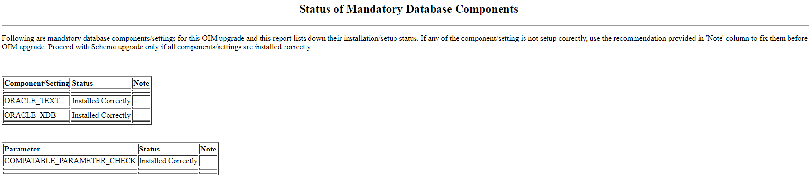

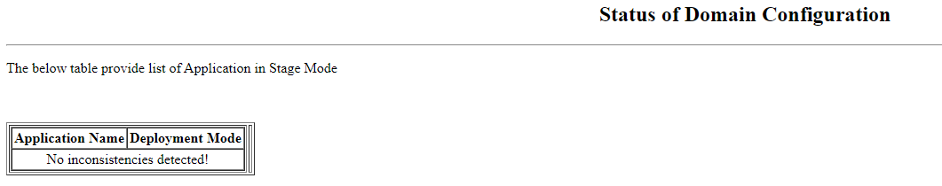

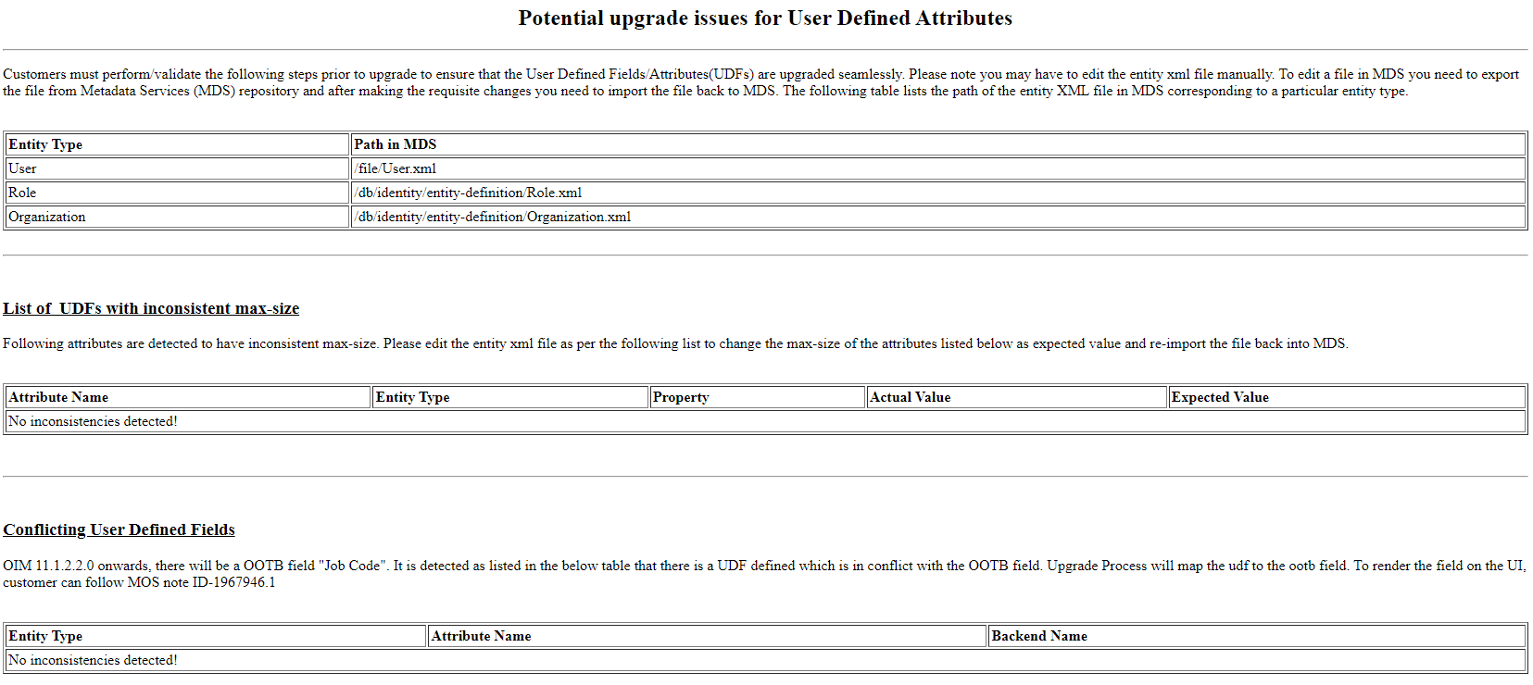

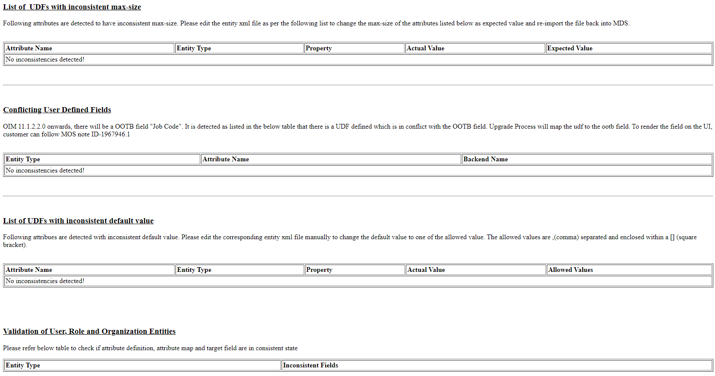

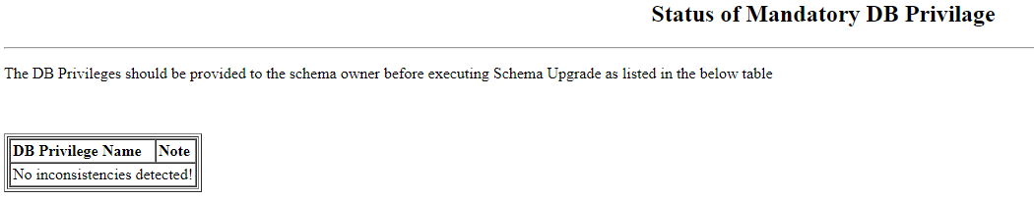

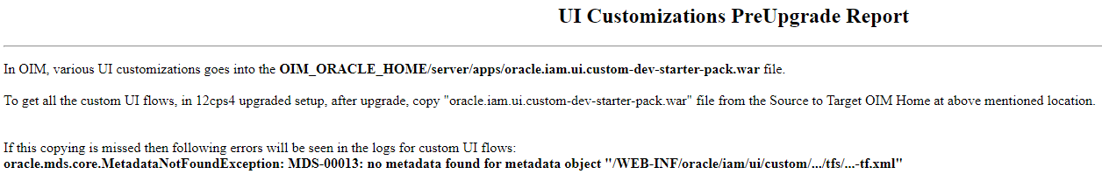

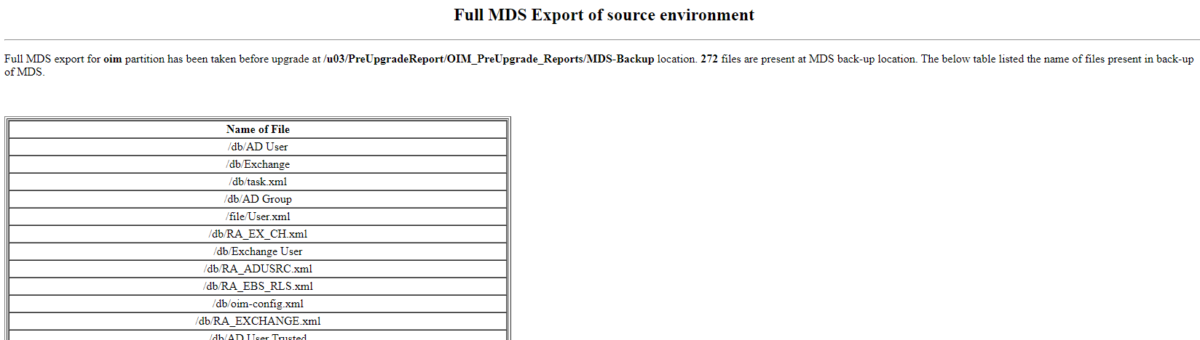

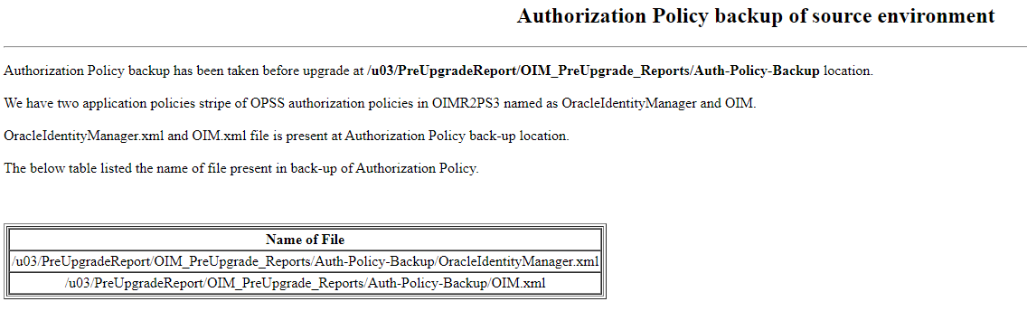

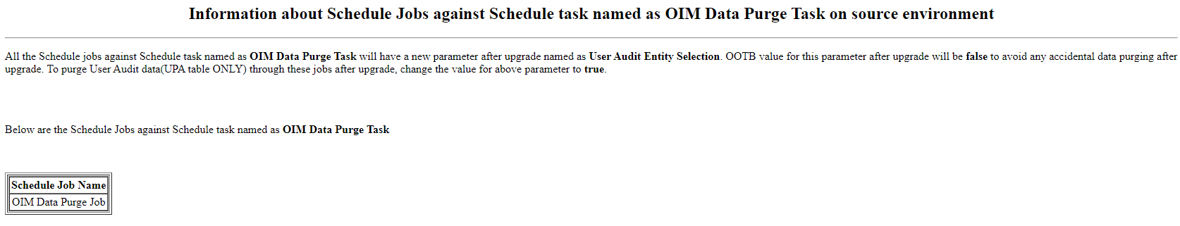

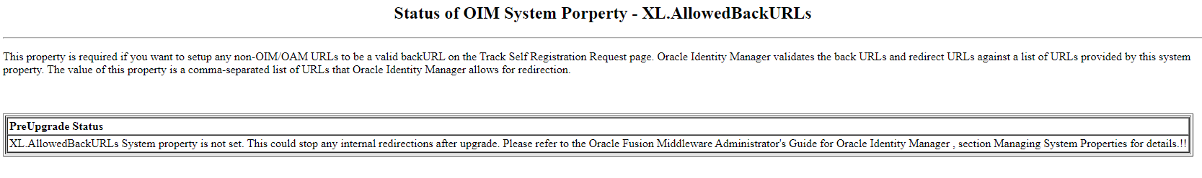

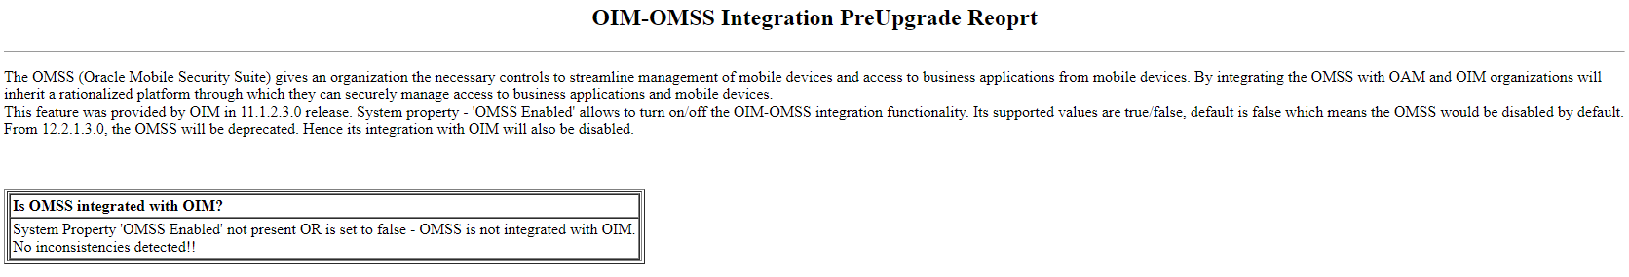

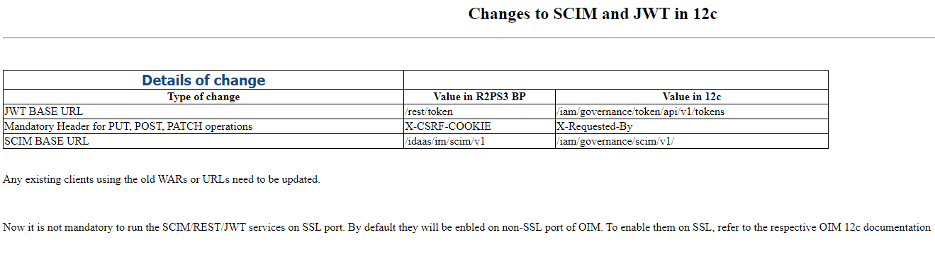

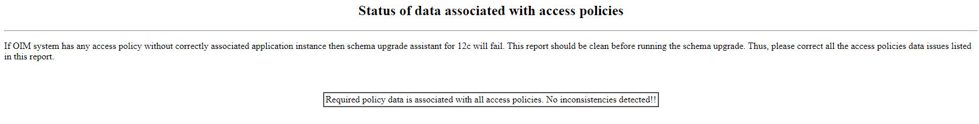

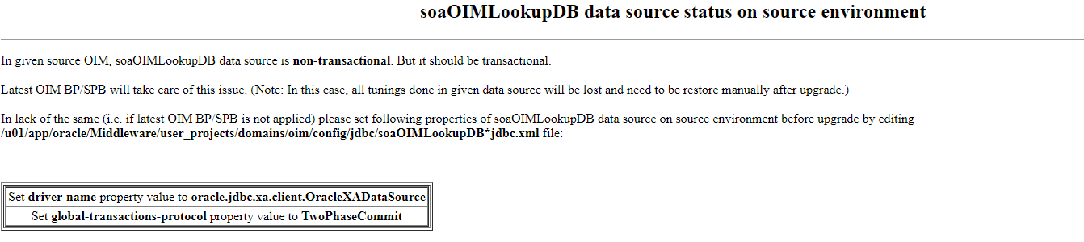

* Go to the existing OIM domain configuration location **“/u01/app/oracle/Middleware/user_projects/domains/oim/config/jdbc”** as recommended in above pre-upgrade report and update the below properties in file **“soaOIMLookupDB-*-jdbc.xml”** file and save.

**driver-name** - oracle.jdbc.xa.client.OracleXADataSource

**global-transactions-protocol** - TwoPhaseCommit

**Before:**

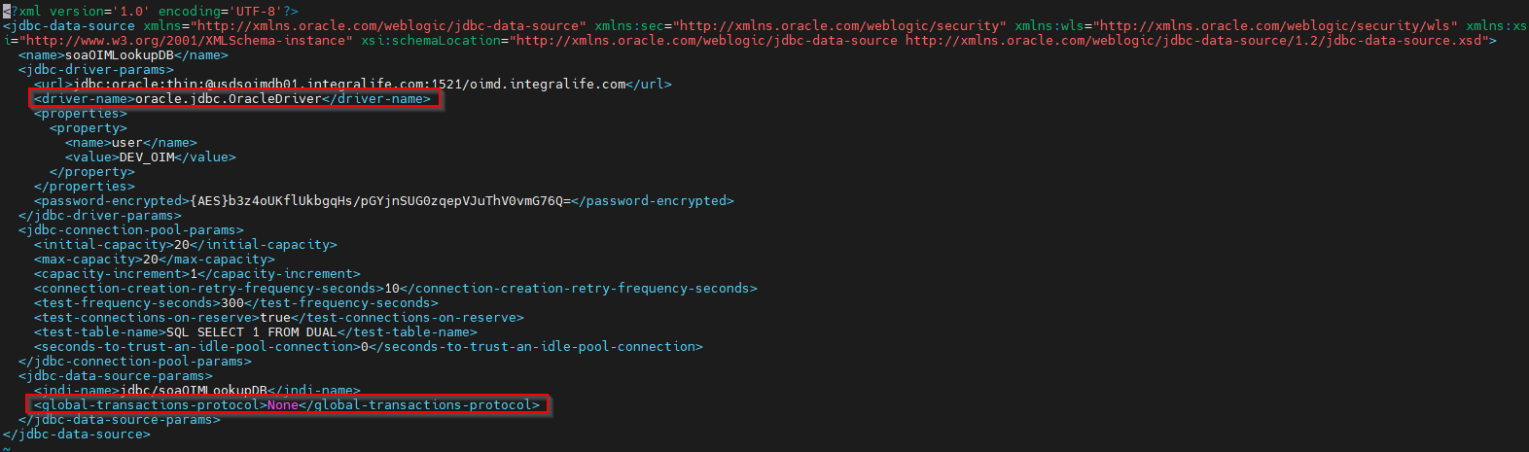

**After:**

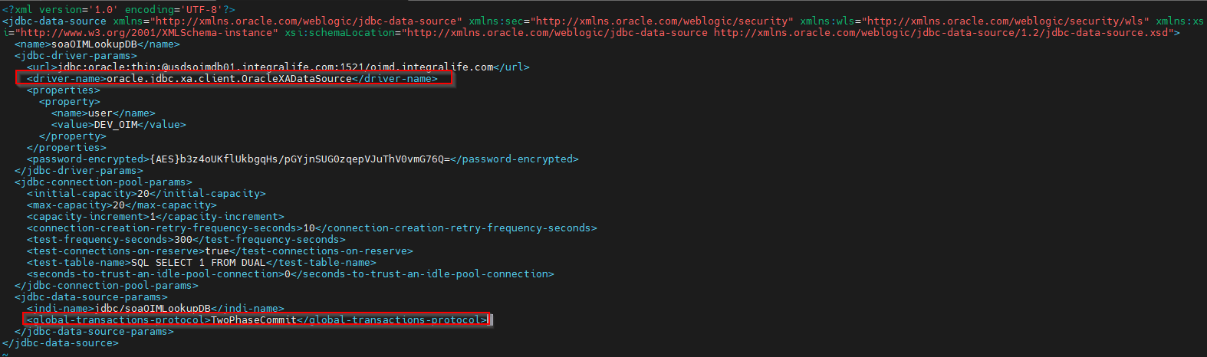

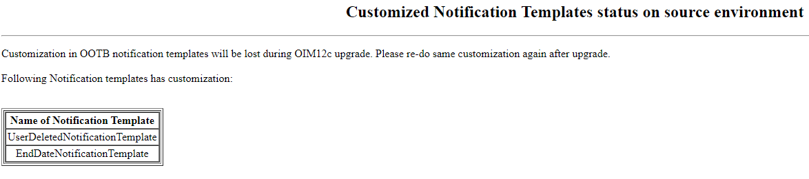

**Note: Export the above recommended notification templates from existing OIM 11g production environment and keep as backup.**

## Export OPSS Encryption Keys

* Ensure the encrypted OPSS is exported and this exported keys will be required for oneHopUpgrade tool to complete the upgrade process.
* Create a directory **“OPSSEncryptionKey”** in the location **“/u03”.**

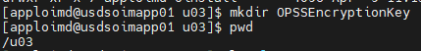

* Go to the existing OIM 11g to the location **“/u01/app/oracle/Middleware/oracle_common/common/bin”** and run the **wlst.sh** script file.

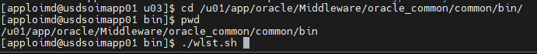

* Run the below command to export the OPSS Key.

**exportEncryptionKey(‘/u01/app/oracle/Middleware/user_projects/domains/oim/config/fmwconfig/jps-config.xml’, ‘/u03/OPSSEncryptionKey’, ‘<your-own-password>’)**

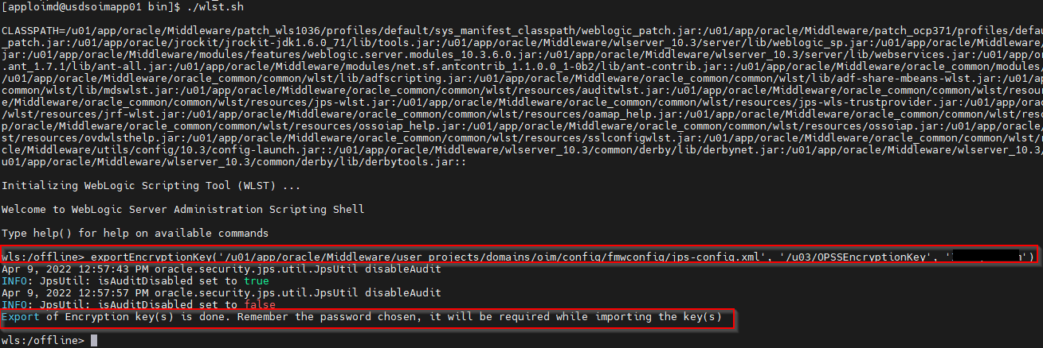

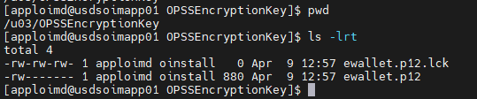

* Copy **“.xldatabasekey”** from existing OIM 11g environment location **“/u01/app/oracle/Middleware/user_projects/domains/oim/config/fmwconfig”** to **“/u03/ OPSSEncryptionKey/”.**

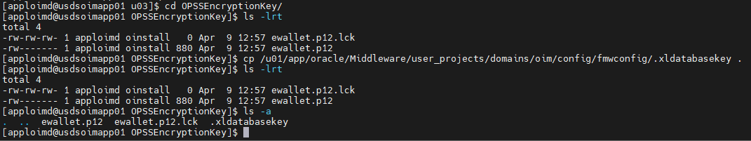

## Running Pre-Upgrade Readiness Check

* Go to the location in OIM 12c **“/u03/oracle/product/Oracle_Home/oracle_common/upgrade/bin”** and run the below command.

**./ua -readiness**

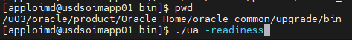

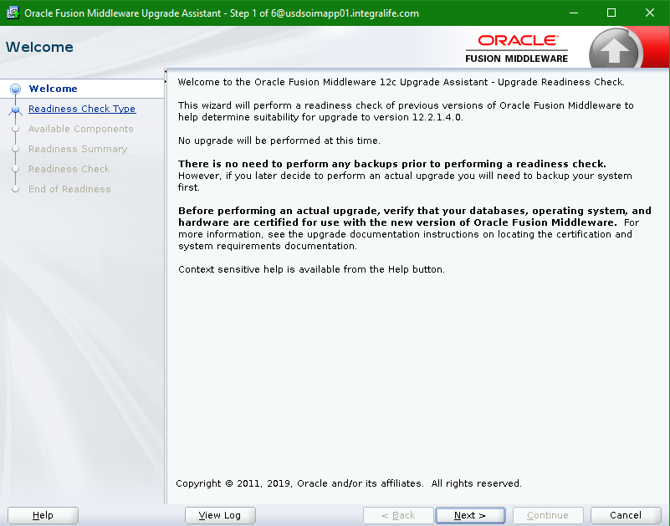

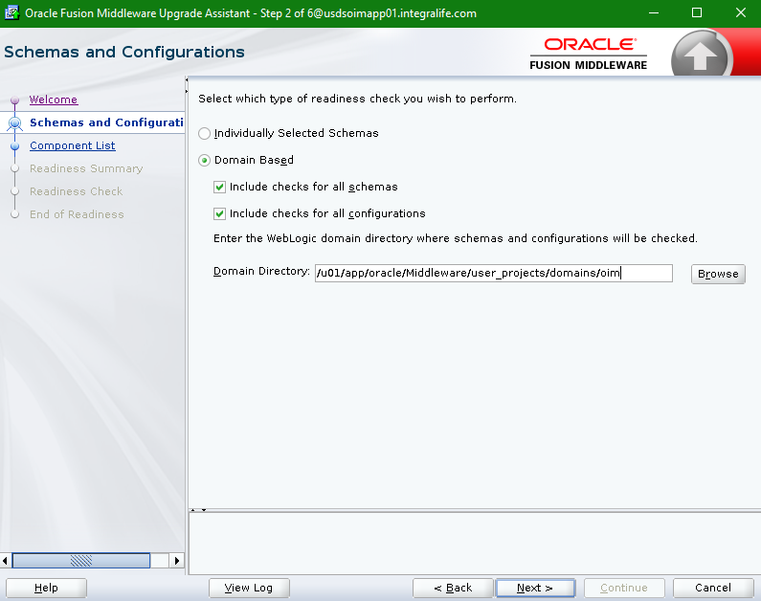

**Note: If OIM 11g domain home is in different machine than copy the entire domain to OIM 12c machine and provide absolute path of 11g domain.**

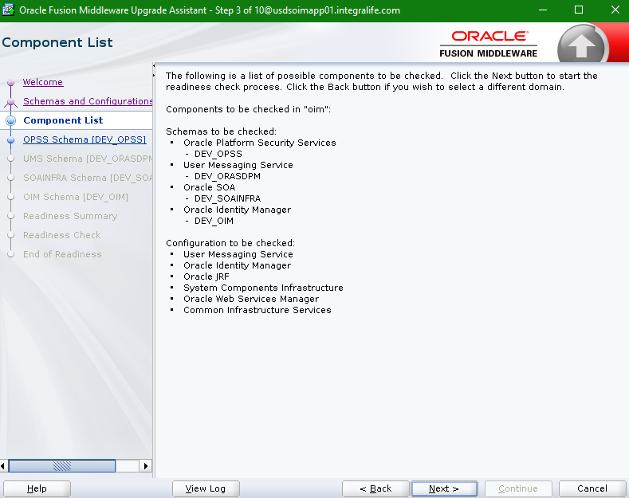

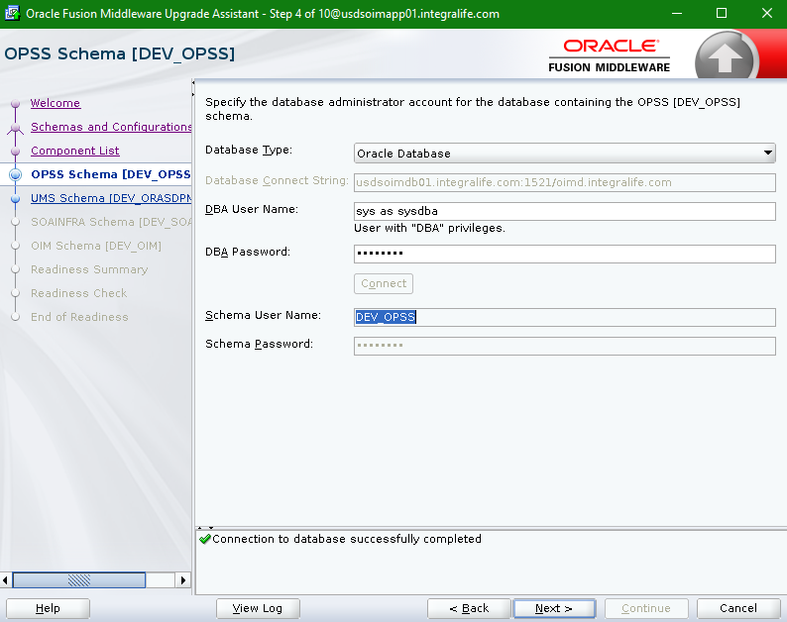

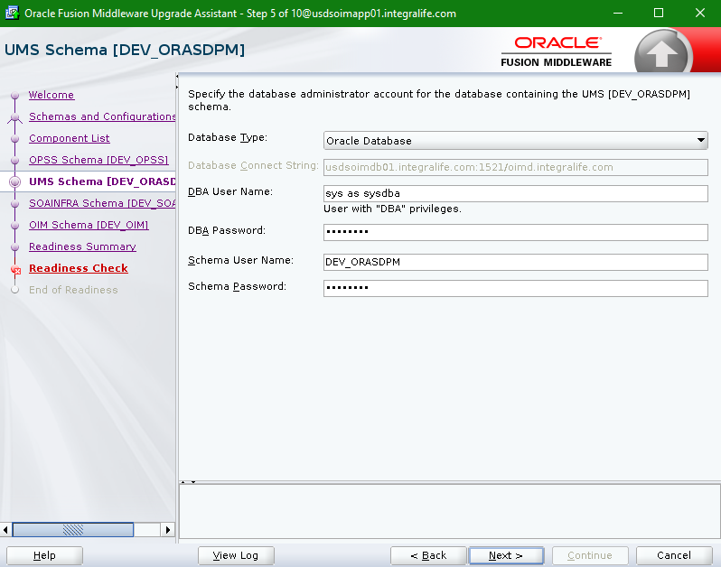

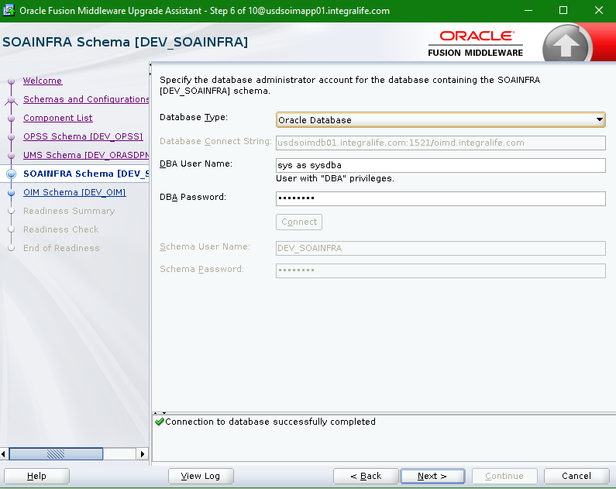

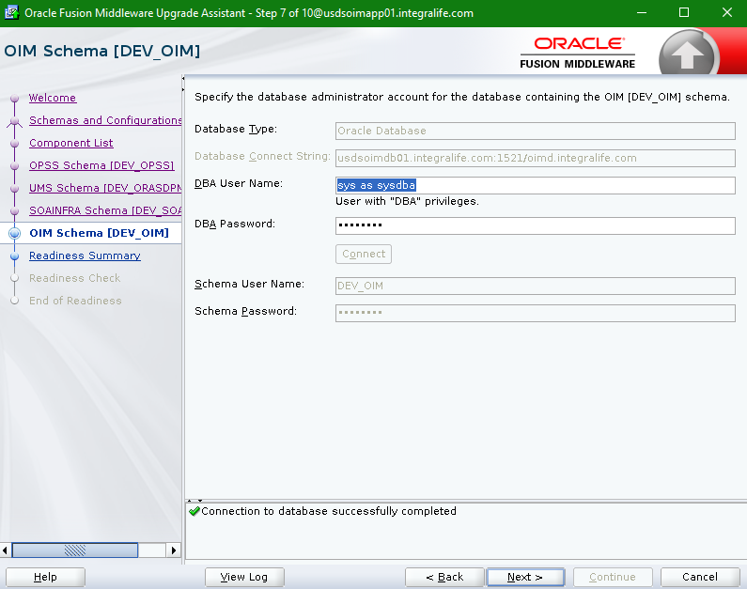

* Click on Save Response File button and then click on Next button.

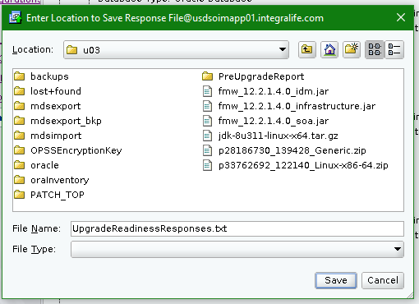

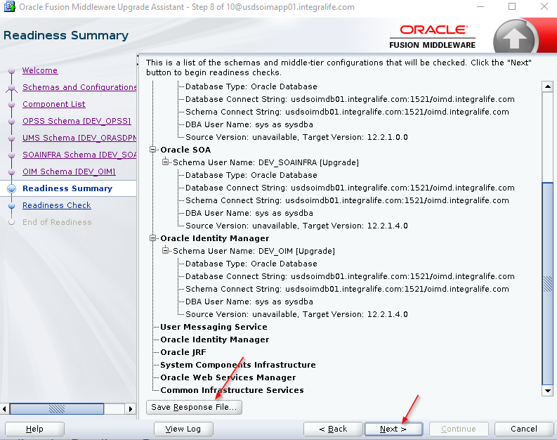

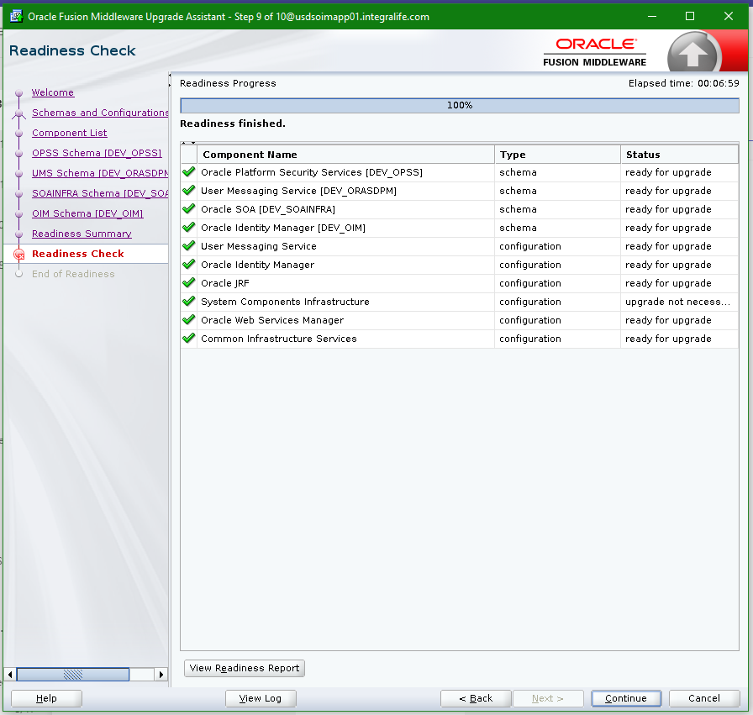

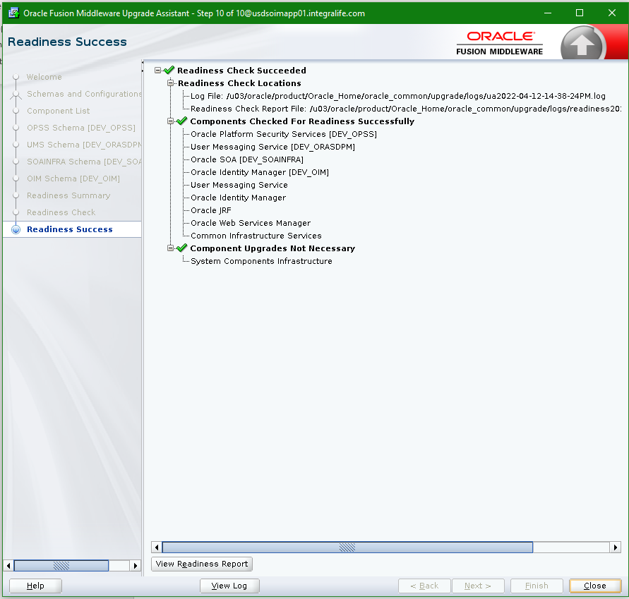

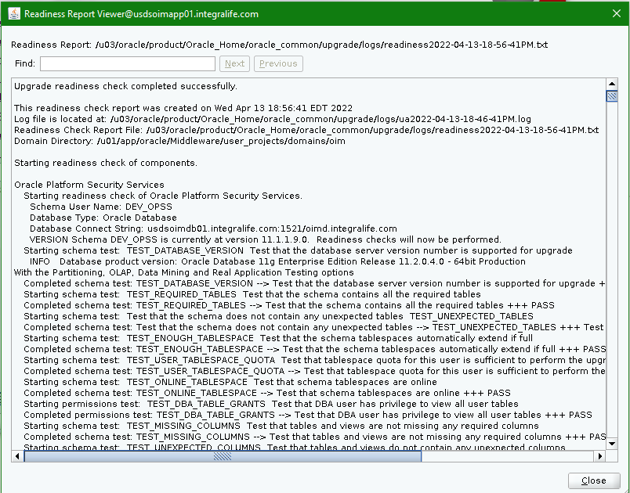

# Stop Servers and Process

* Ensure all the OIM 11g and OIM 12c servers are down before proceeding into the next step.

# Upgrade Product Schemas

* Run the below query to verify the schema in **“schema_version_registery”** table.

**select comp_id,comp_name,mrc_name,owner,version,status,modified from SYSTEM.schema_version_registry;**

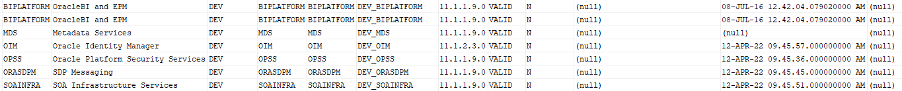

* Go to the location **“/u03/oracle/product/Oracle_Home/oracle_common/upgrade/bin”** and set the below java option to before upgrading the product schema.

**export UA_PROPERTIES="-Dfile.encoding=UTF-8"**

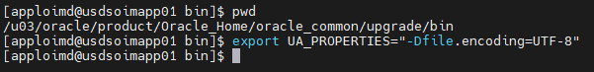

* Run the **./ua** command from the location **“/u03/oracle/product/Oracle_Home/oracle_common/upgrade/bin”.**

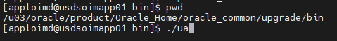

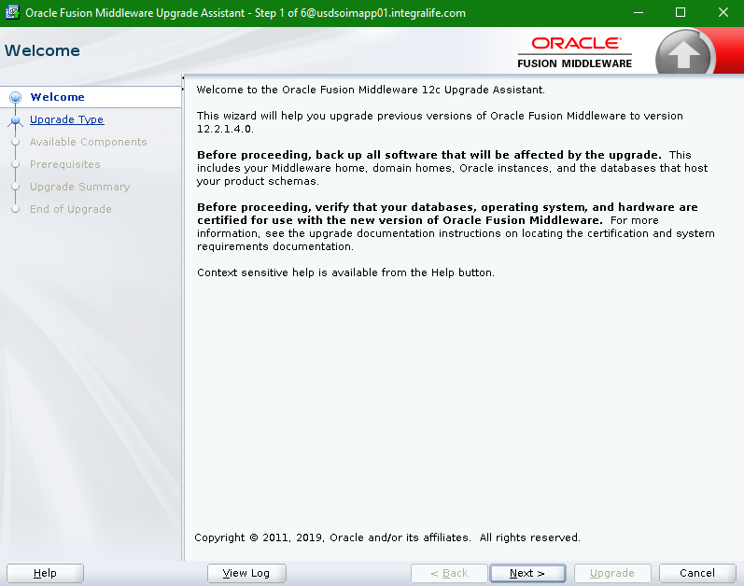

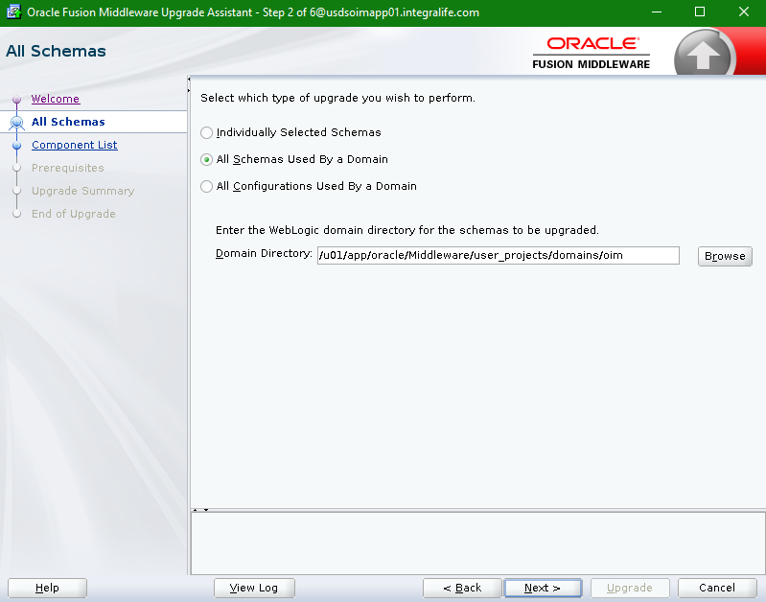

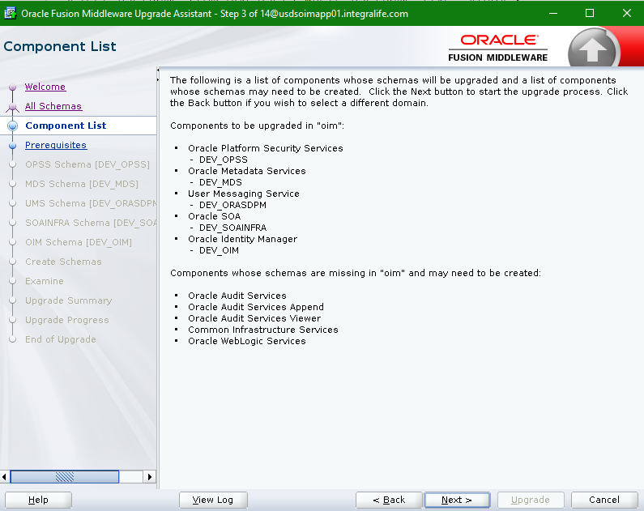

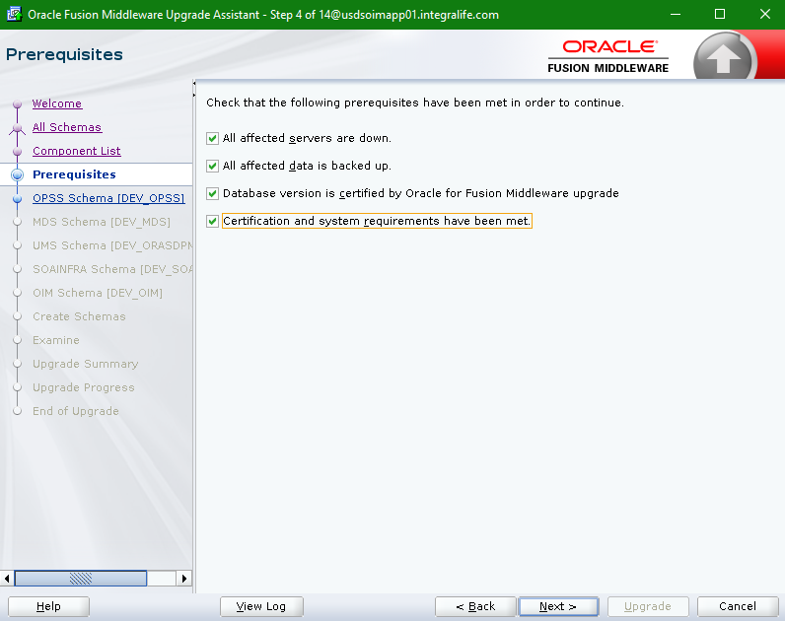

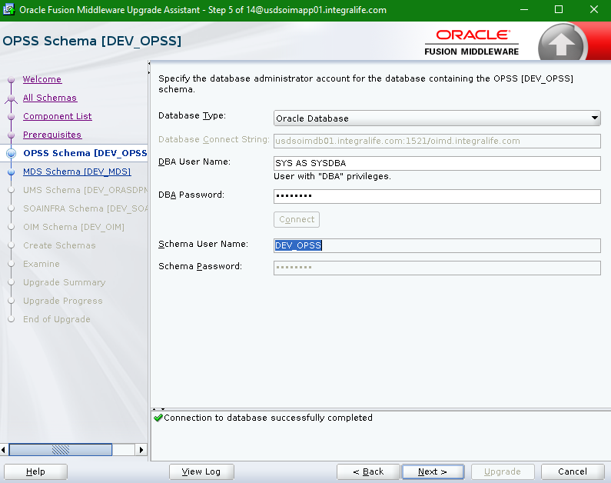

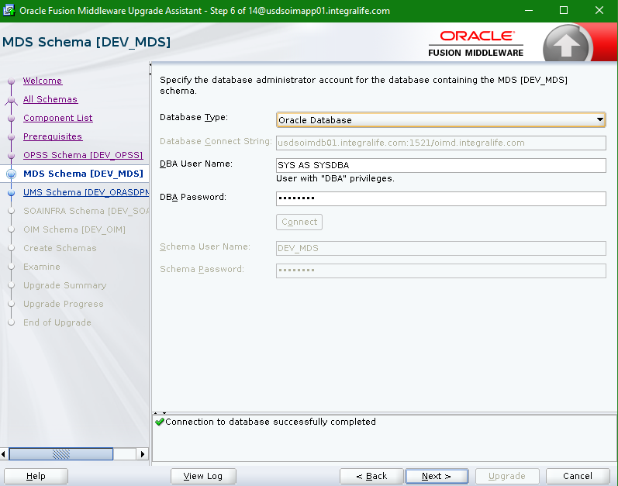

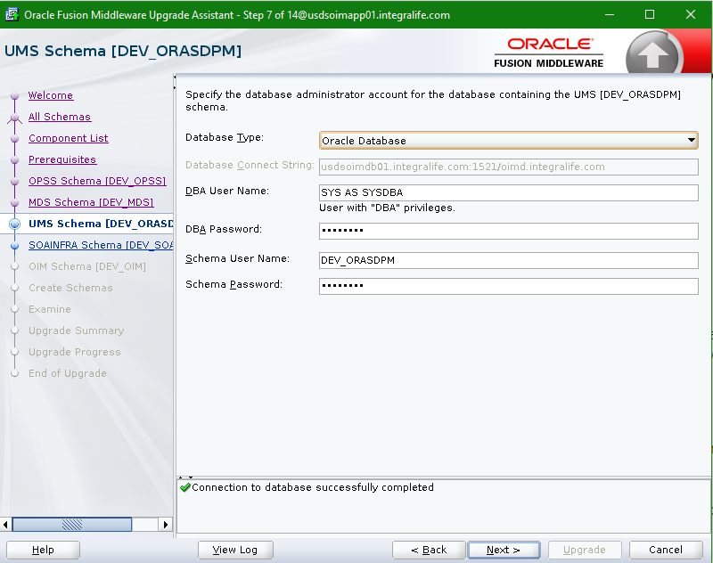

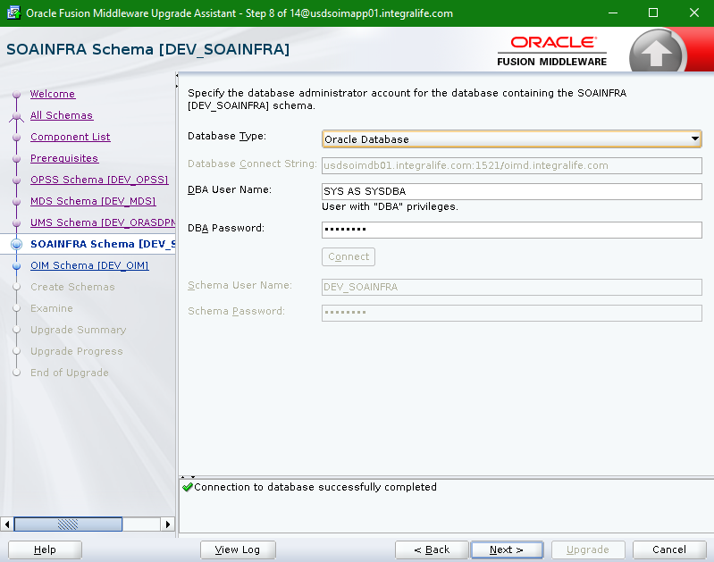

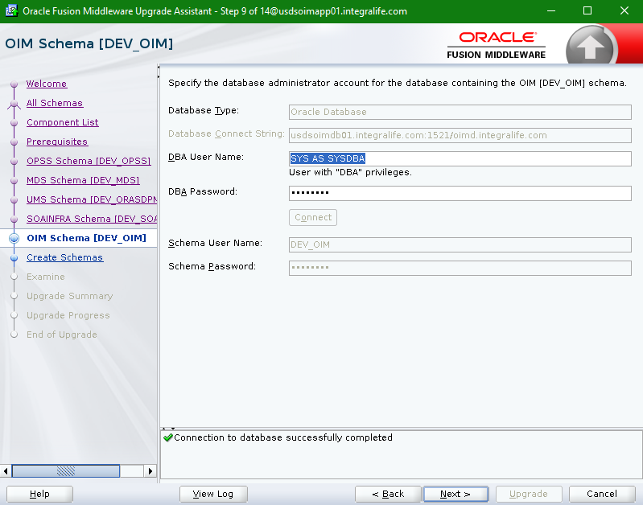

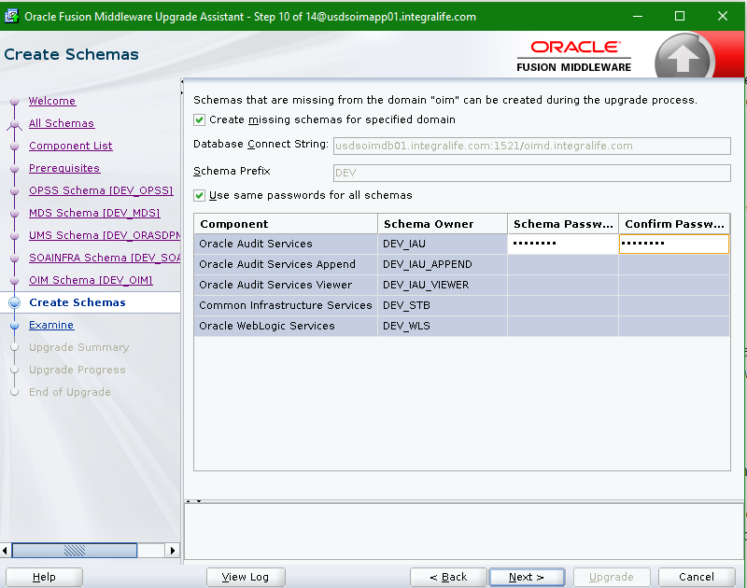

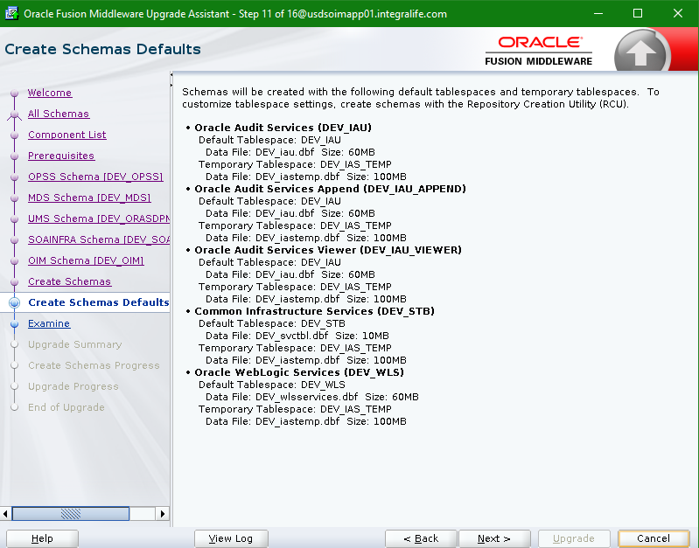

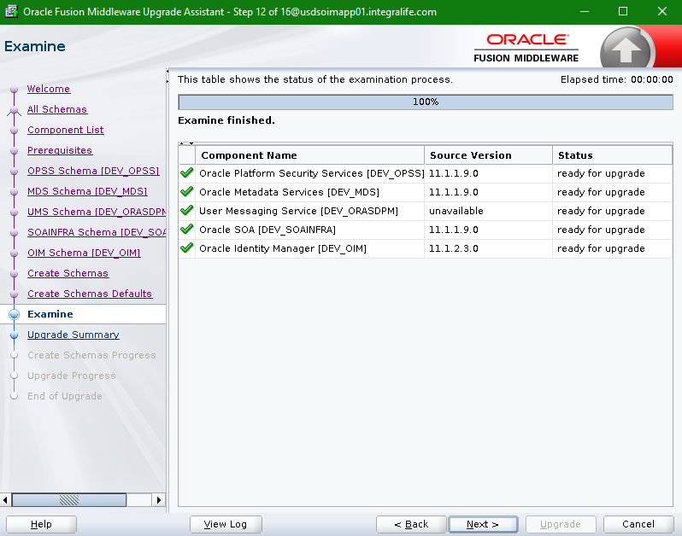

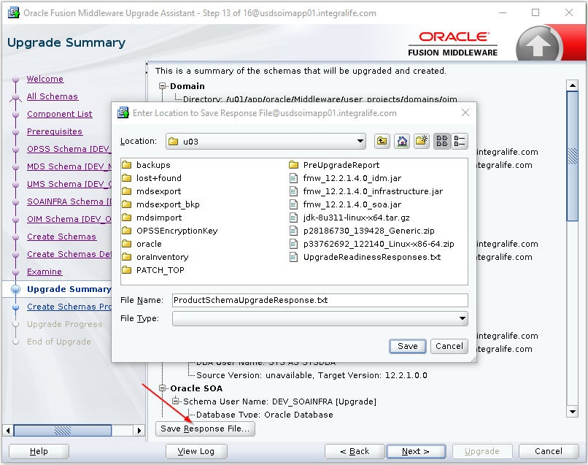

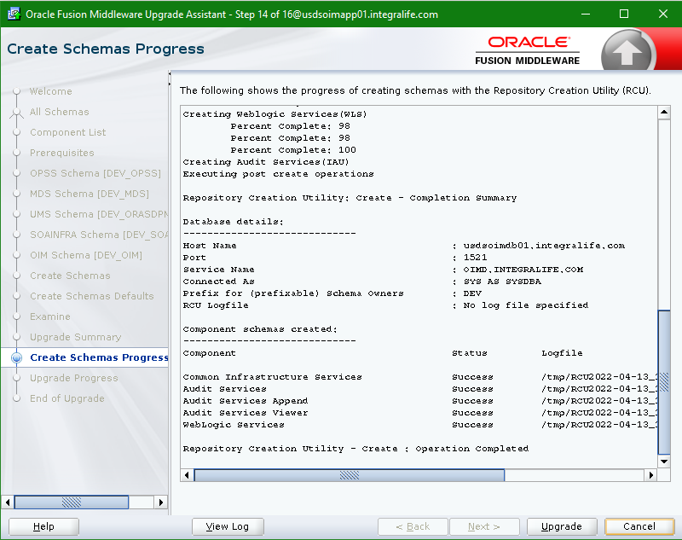

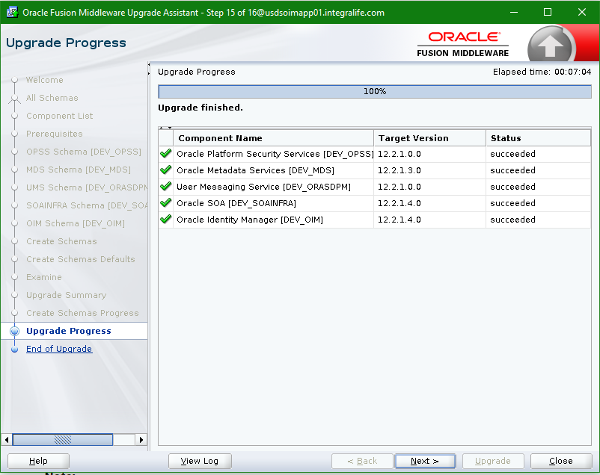

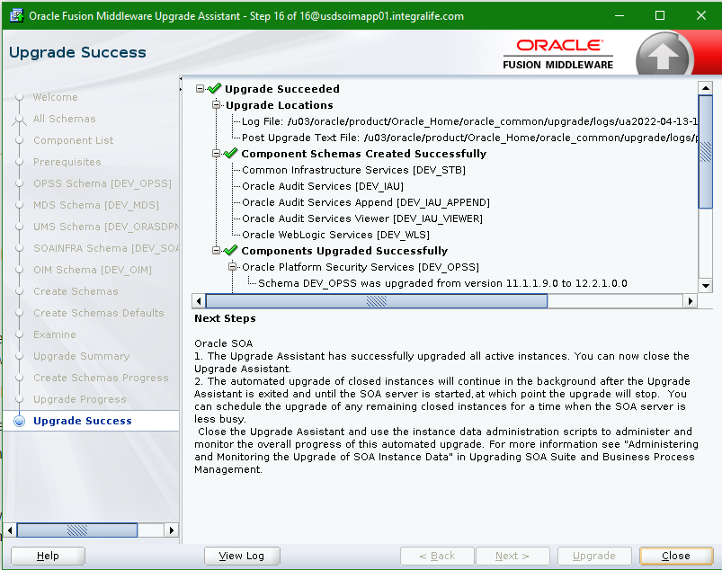

* Run the below query to validate the schema version in database.

**select comp_id,comp_name,mrc_name,owner,version,status,modified from SYSTEM.schema_version_registry;**

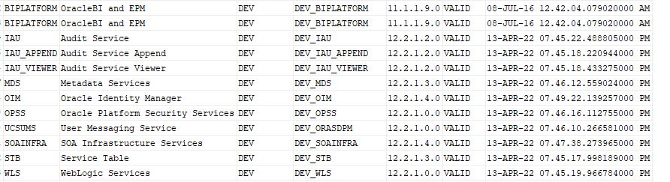

# Cleaning Temporary Directory

* Before starting the upgrade process, clean the /tmp directory on all the OIM 12c PS4 machines to avoid the failures in OIM upgrade process.

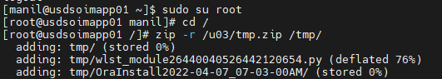

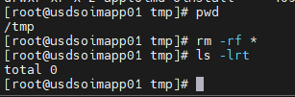

# Rewiring the Domain

* Ensure OIM, SOA Managed Servers, and Node Manager is down in all the nodes.
* Ensure only Database (11g & 12c) and WebLogic Admin Server (12c) is up and running.
* Provide read and write permissions to the directory **“upgrade”** from the location **“/u03/oracle/product/Oracle_Home/idm/server”**.

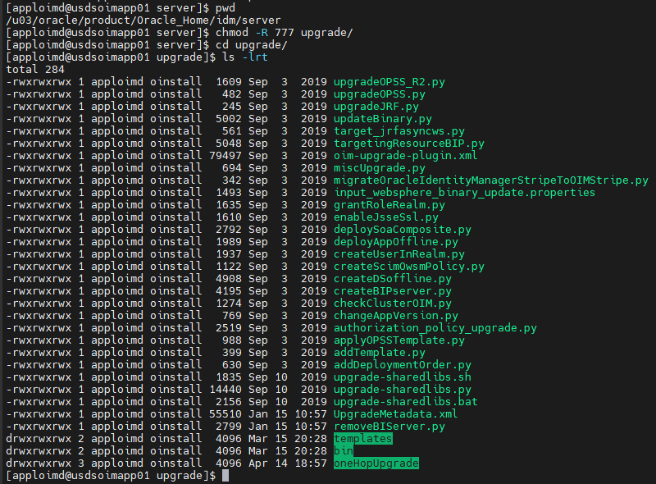

* Provide the read and write permission to the directory which have the OPSS encryption key exported files.

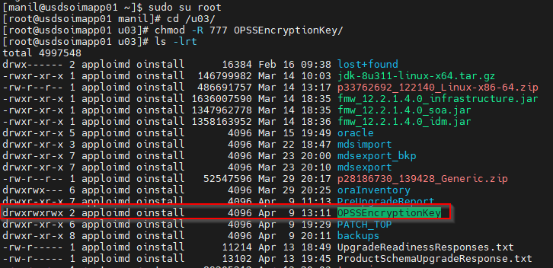

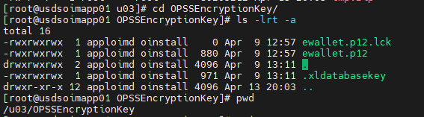

* Go to the location **“/u03/oracle/product/Oracle_Home/idm/server/upgrade/oneHopUpgrade”** and update the **“oneHop.properties”** files.

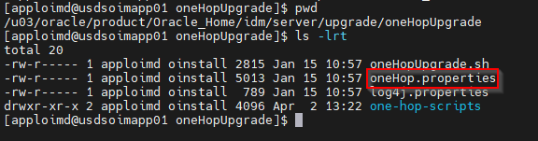

|  |  |
| --- | --- |
| **Property Name** | **Value** |
| domain_home | /u03/oracle/config/domains/oimdomain |
| admin_server_host | usdsoimapp01.integralife.com |
| admin_server_port | 7003 |
| admin_server_user | weblogic |
| ORACLE_HOME | /u03/oracle/product/Oracle_Home |
| JAVA_HOME | /u03/oracle/java |
| 12csp4_opss_data_source_name | OPSSDataSourceUpgrade |
| 12csp4_opss_jndi_name | jdbc/OpssDSUpgrade |
| DATASOURCES1 | name:ApplicationDB, user:DEV_OIM |
| DATASOURCES2 | name:EDNLocalTxDataSource, user:DEV_SOAINFRA |
| DATASOURCES3 | name:mds-oim, user:DEV_MDS |
| DATASOURCES4 | name:opss-data-source, user:DEV_OPSS |
| DATASOURCES5 | name:LocalSvcTblDataSource, user:DEV_STB |
| DATASOURCES6 | name:opss-audit-DBDS, user:DEV_IAU_APPEND |
| DATASOURCES7 | name:WLSSchemaDataSource, user:DEV_WLS |
| DATASOURCES8 | name:opss-audit-viewDS, user:DEV_IAU_VIEWER |
| DATASOURCES9 | name:OraSDPMDataSource, user:DEV_ORASDPM |
| 11gr2ps3_files_path_with_rw_permission | /u03/OPSSEncryptionKey |
| 11gr2sp3_db_url | jdbc:oracle:thin:@usdsoimdb01.integralife.com:1521/oimd.integralife.com |
| 11g_OPSS_domain_farm_name | IAM |
| 11g_OPSS_jpsroot | cn=jpsroot |
| noOfRetries_for_admin_server_ping | 20 |
| waitTime_to_stop_admin_server_inMinutes | 5 |

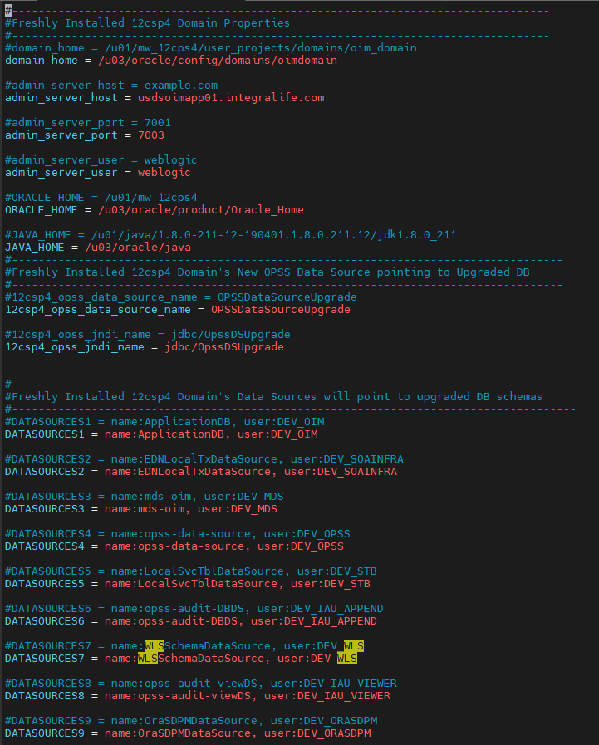

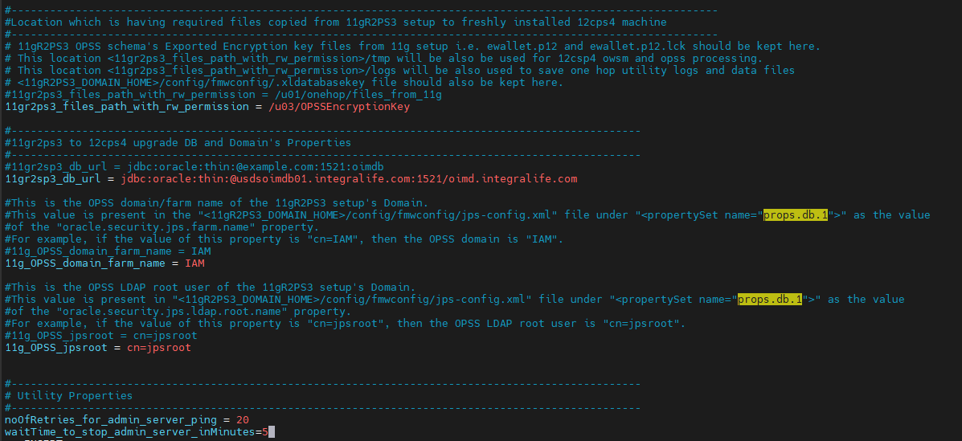

* Execute the **oneHopUpgrade.sh** script file from the location **“/u03/oracle/product/Oracle_Home/idm/server/upgrade/oneHopUpgrade”** and run time provide the required passwords.

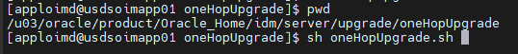

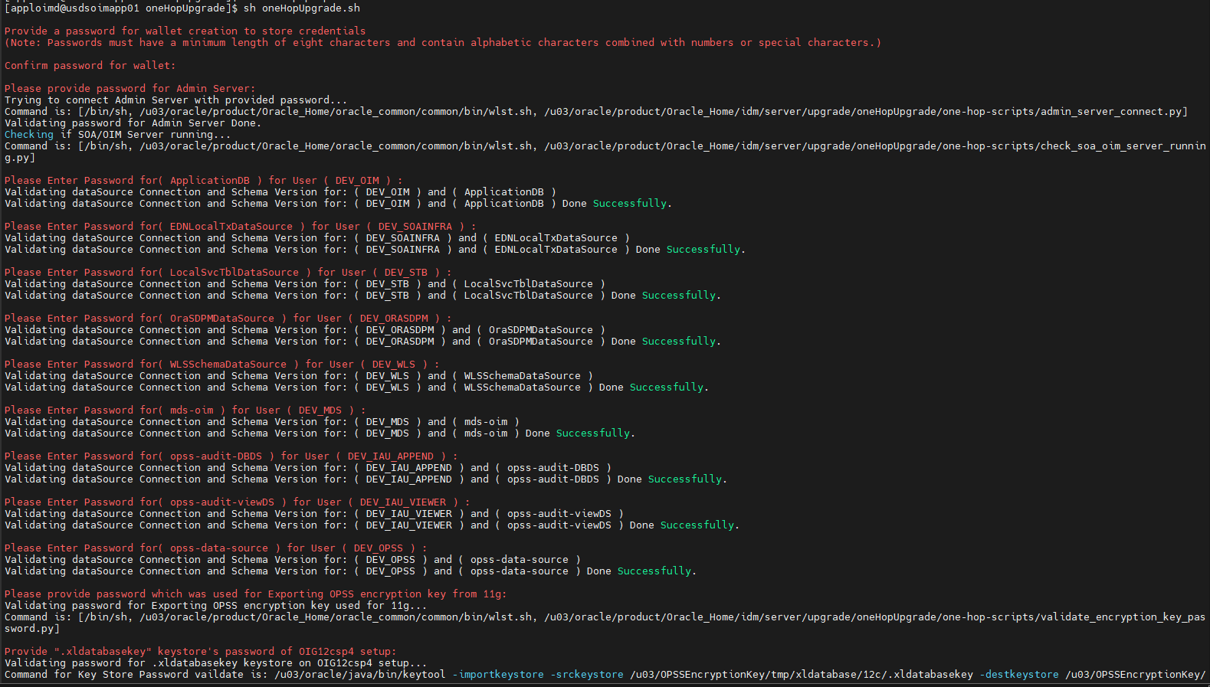

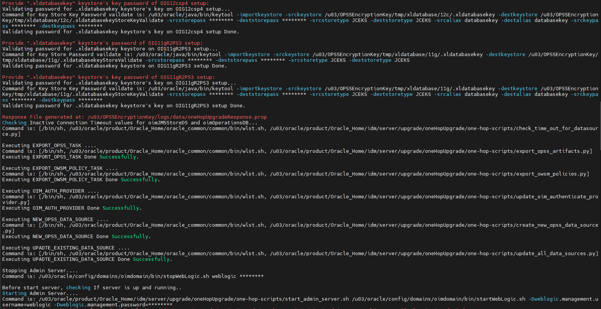

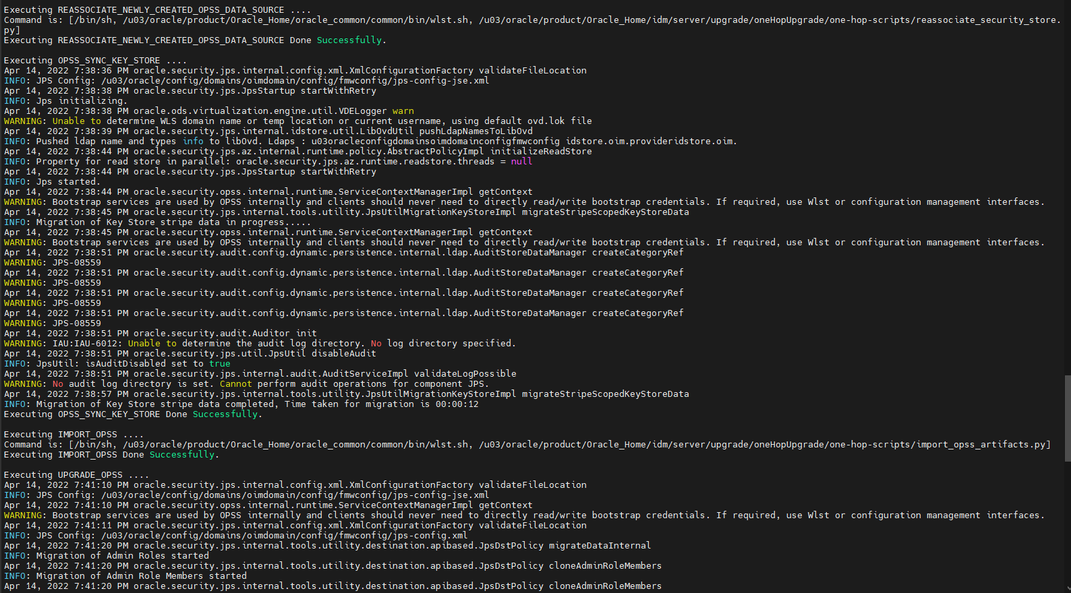

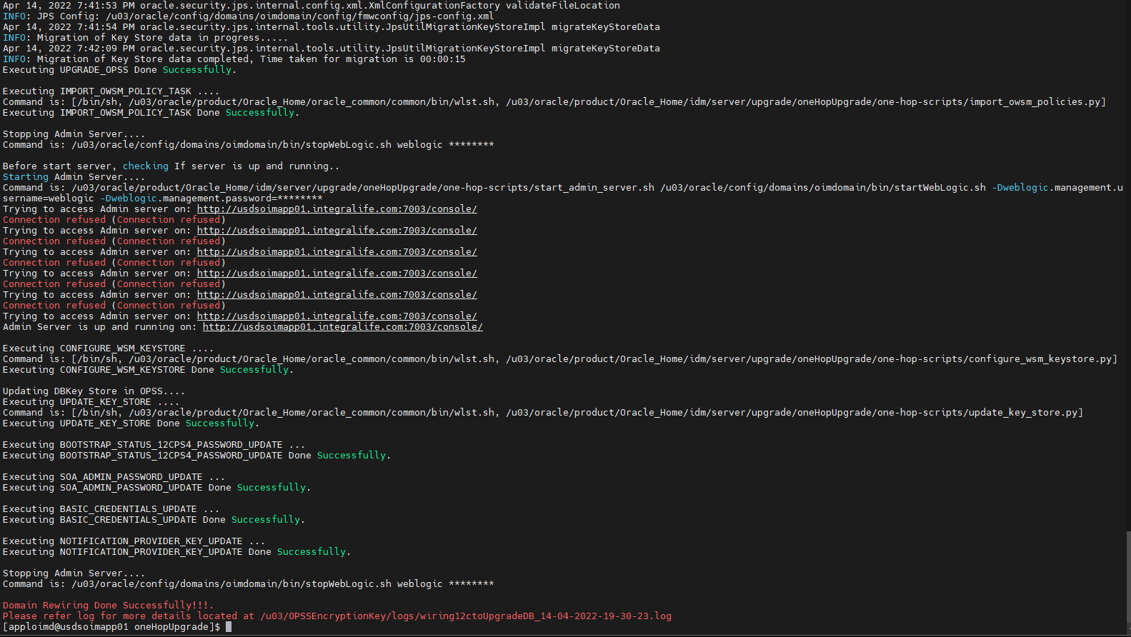

# Restart the Servers

* Start the WebLogic Admin Server

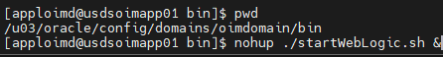

* After Admin Server come to running state, Start SOA Managed Server with the Administration Server URL, and the BPM property set to TRUE.

**./startManagedWebLogic.sh soa_server1 t3://usdsoimapp01.integralife.com:7003 -Dbpm.enabled=true**



* After SOA server comes to a running state, use another putty session to start OIM Managed Server with WebLogic admin server URL.

**./startManagedWebLogic.sh oim_server1 t3://usdsoimapp01.integralife.com:7003**

* During the start of the OIM Managed Server, bootstrap is initiated. After a successful bootstrap, the OIM Managed Server shuts down automatically.

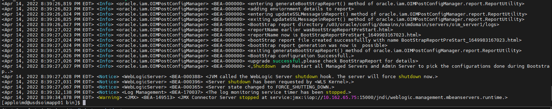

* Stop the SOA managed server(putty session) and WebLogic admin server manually after a successful bootstrap of OIM.
* Restart the servers in following order.

1. WebLogic
2. Node Manager
3. SOA managed server without BPM property
4. OIM managed server

**Note: OIM server will go auto force shut down while starting due to workflow policy update errors. To resolve this issue, refer to the “Failure in Upgrade Workflow Policies Post Bootstrap Task”.**

# Failure in Update Workflow Policies Post Bootstrap Task

* Login into the EM console and navigate to WebLogic Domain🡺Security 🡺 Credentials.
* Expand oim CSF map, select sysadmin CSF Key, and then click on Edit button to change the username to “xelsysadm” and provide the password.

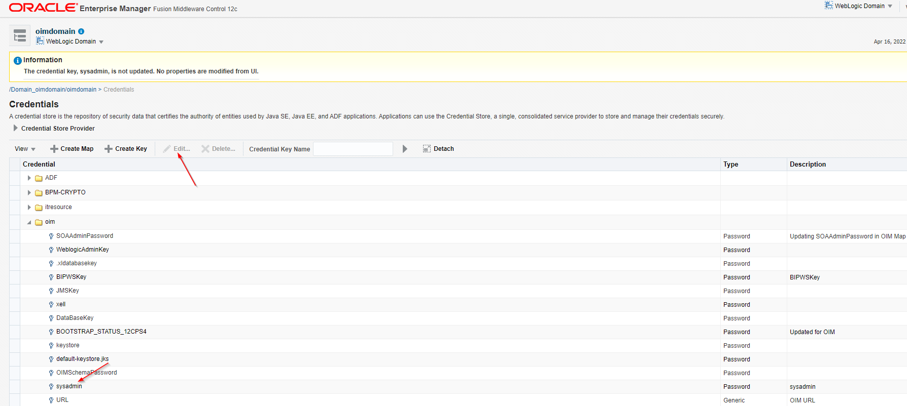

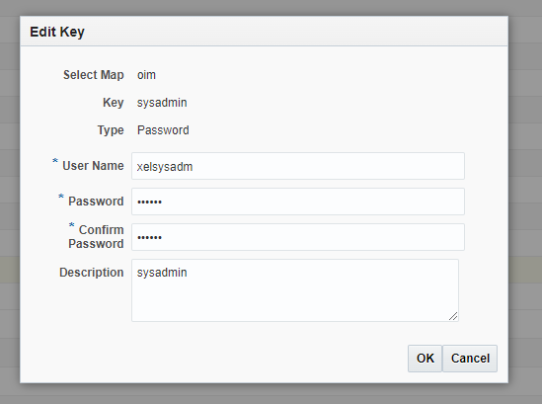

* Open oracle.wsm.security CSF map in the same location and update the Xelsysadm password for OIMAdmin CSF map.

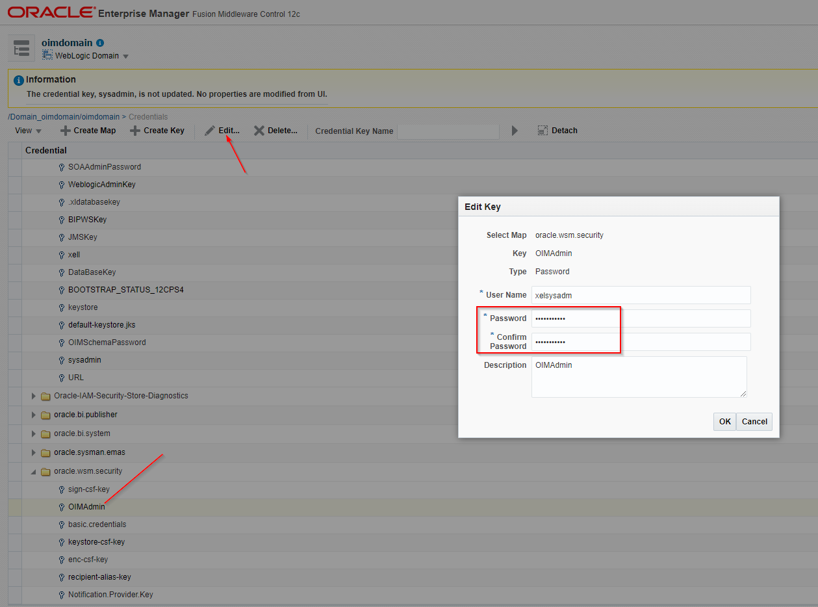

* Start the OIM Managed Server

# Invoke the Mbean

* Invoke the Mbean from EM console to integrate the OIM with SOA server.
* Login into EM console, right click on WebLogic domain and open the System Mbean Browser. Navigate to Application Defined Mbean🡺oracle.iam🡺Server:oim_server1🡺Application:oim🡺IAMAppRuntimeMbean🡺OIMSOAIntegrationMbean🡺Click on “IntegrateWithSOAServer” under Operations tab.

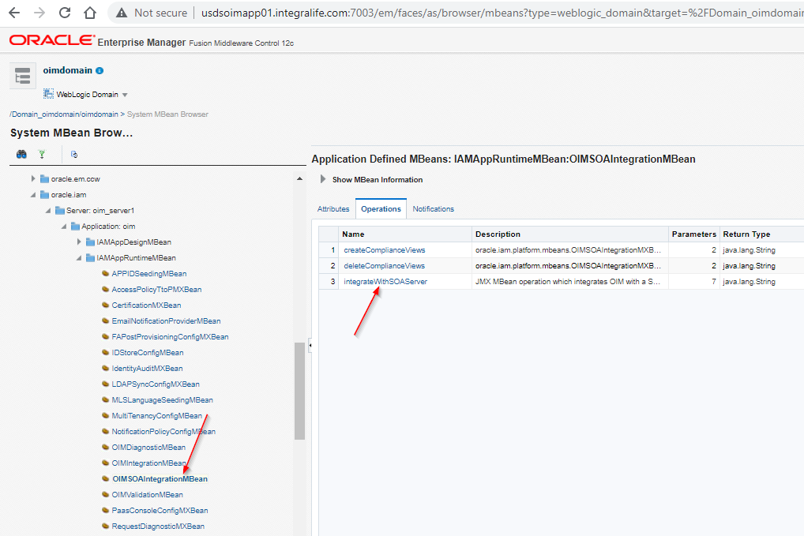

* Provide the below values and click on Invoke button.

|  |  |  |
| --- | --- | --- |
| **Name** | **Description** | **value** |
| p1 | WebLogic Username | weblogic |
| p2 | WebLogic Password | ****** |
| p3 | OIM Front End URL | http://usdsoimapp01.integralife.com:15000 |
| p4 | OIM External Front End URL | http://usdsoimapp01.integralife.com:15000 |
| 55 | SOA SOAP URL | http://usdsoimapp01.integralife.com:9001 |
| p6 | SOA RMI ULR | cluster:t3://soa_cluster |
| p7 | UMS Web Service URL | http://usdsoimapp01.integralife.com:9001/ucs/messaging/webservice |

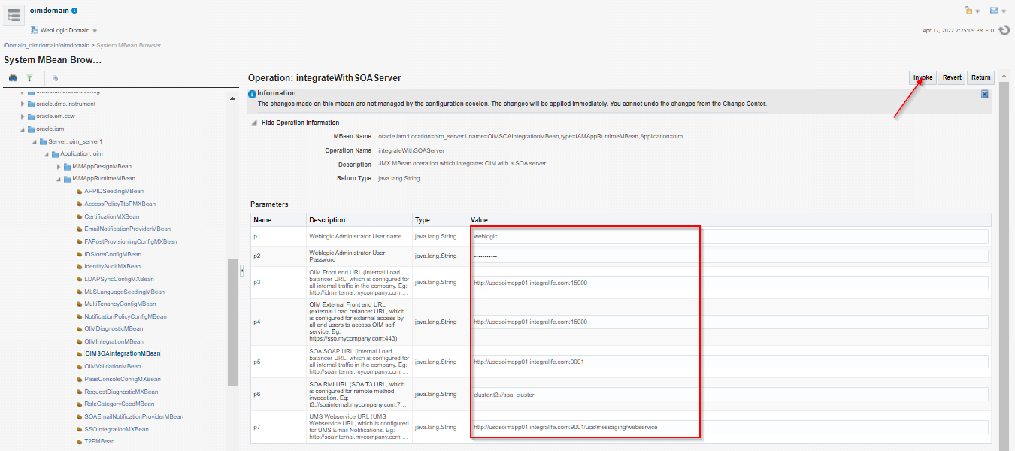

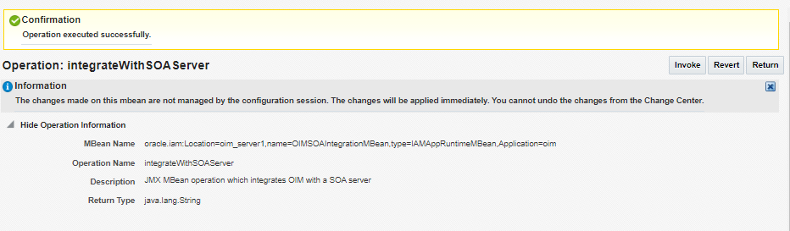

# Update SOA EndPoint URL

1. Login into the EM Console, go to the Target Navigation and select the SOA🡺Right click on soa-infra🡺Home🡺Deployed Composites.

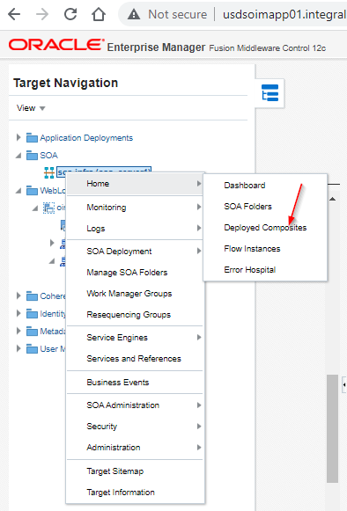

1. Click on “DefaultRequestApproval(6.0)” composite and then click on “CallbackService_2” link.

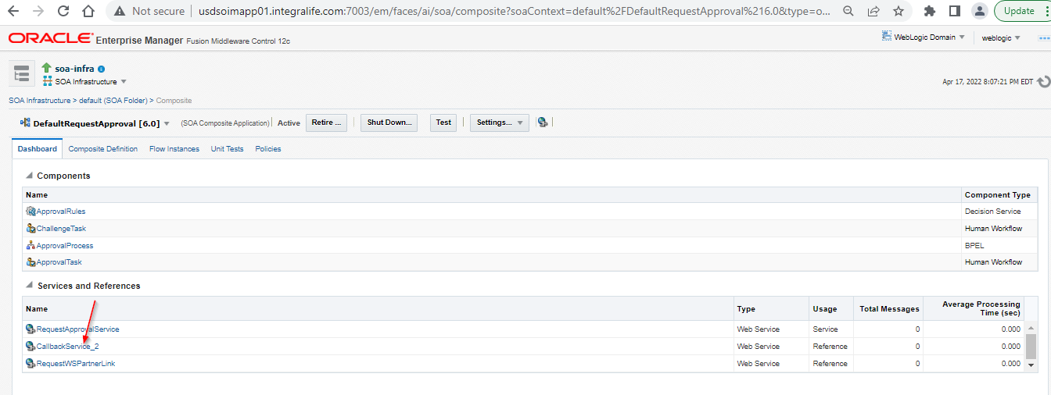

1. Go to properties tab and add the “End Point Address” with below URL and click on Apply button.

**Note: End Point address should be with LB URL in case of clustered environment**

[**http://usdsoimapp01.integralife.com:9001/workflowservice/CallbackService**](http://usdsoimapp01.integralife.com:9001/workflowservice/CallbackService)

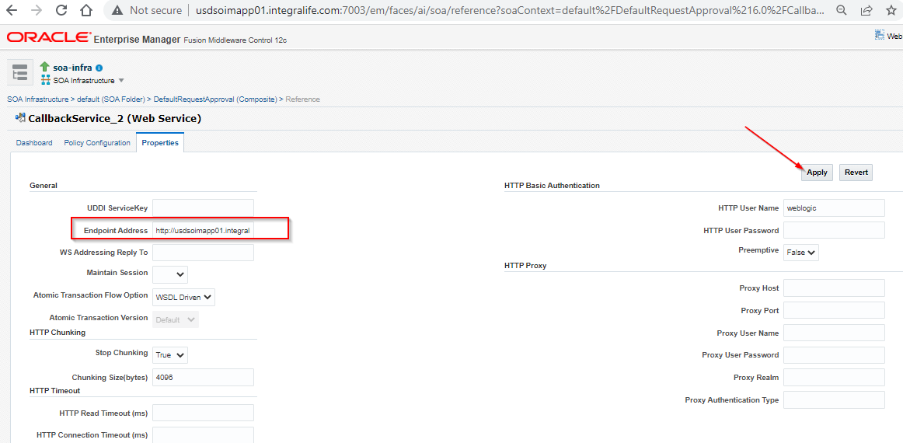

1. Return to the “DefaultRequestApproval(6.0)” and select the “RequestWSPartnerLink”.

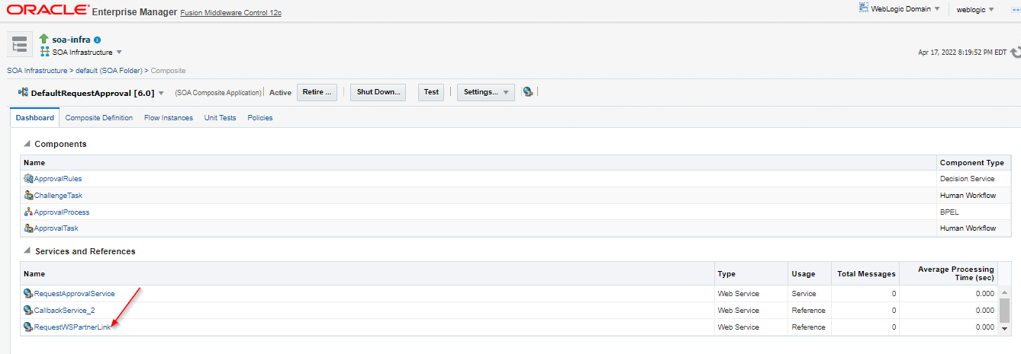

1. Click on the “Properties” tab and add the below URL in “Endpiont Address” field and click on Apply button.

**Note: End Point address should be with LB URL in case clustered environment**

<http://usdsoimapp01.integralife.com:9001/workflowservice/RequestDataService>

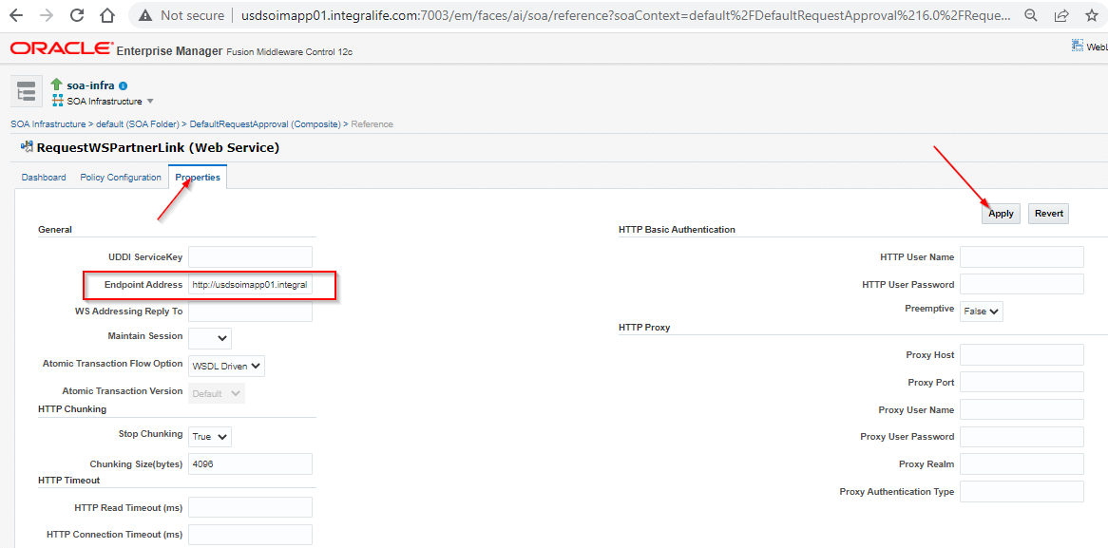

1. Repeat steps 2 to 5 for the following SOA composites.
2. DefaultOperationalApproval[5.0]
3. ProvideInformation[3.0]
4. RoleLCMApproval[1.0]
5. All Custom Composites(If any)
6. Repeat septs 2 and 3 for the following SOA composites.
7. DefaultRoleApproval[3.0]
8. AutoApproval[1.0]
9. BeneficiaryManagerApproval[3.0]
10. RequestrManagerApproval[3.0]
11. DefaultSODApproval[2.0]
12. Open the DefaultSODApproval[2.0] composite from the same location of EM console and open the **SodCheckServicePortImplService** link.

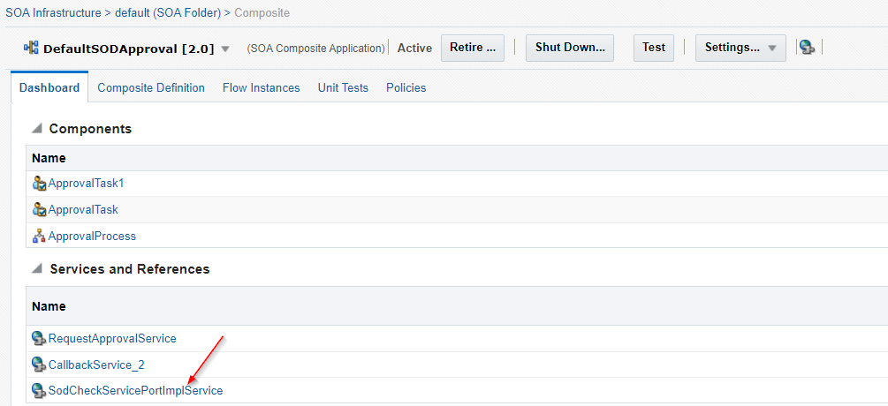

1. Click on the Properties tab and update the below ULR in Endpoint Address property field and click on Apply button.

<http://usdsoimapp01.integralife.com:9001/workflowservice/SodCheckServicePortImplService>

1. Open the **OAACGRoleAssignSOCCheck[1.0]** composite from the same location and open the **RoleSODService** link.

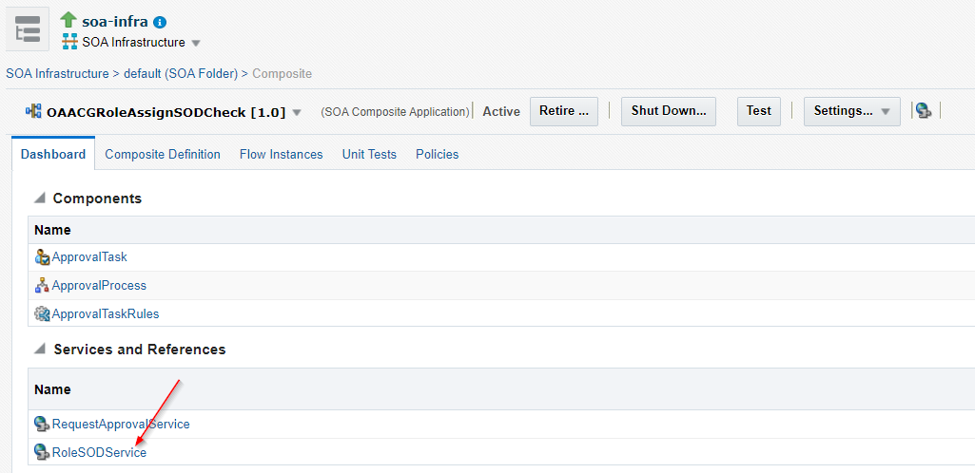

1. Click on the Properties tab and update the below ULR in Endpoint Address property field and click on Apply button.

<http://usdsoimapp01.integralife.com:9001/workflowservice/OAACGRoleSODService>

1. Open the **IdentityAuditRemediation[1.0]** composite from the same location and open the **IdentityAuditWSPartnerLink** and update the below Endpoint address in Properties tab.

<http://usdsoimapp01.integralife.com:9001/workflowservice/IdentityAuditCallbackService>

1. Open the **DisconnectedProvisioning[1.0]** composite from the same location and open the **ProvisioningCallbackService** and update the below Endpoint address in Properties tab.

<http://usdsoimapp01.integralife.com:9001/provisioning-callback/ProvisioningCallbackService>

1. Open the **CertificationProcess[2.0]** composite from the same location and open the **CertificationWSPartnerLink** and update the below Endpoint address in Properties tab.

<http://usdsoimapp01.integralife.com:9001/provisioning-callback/ProvisioningCallbackService>

1. Repeat step 14 for **CertificationOverseerProcess[2.0]** SOA composite.
2. In EM Console, expand SOA Infrastructure, select SOA Administration, and then select Common Properties. Callback Server URL and Server URL values will be blank and not action required. If these values are pointing to the OIM 11g setup, update them to the corresponding values for OIM 12c.

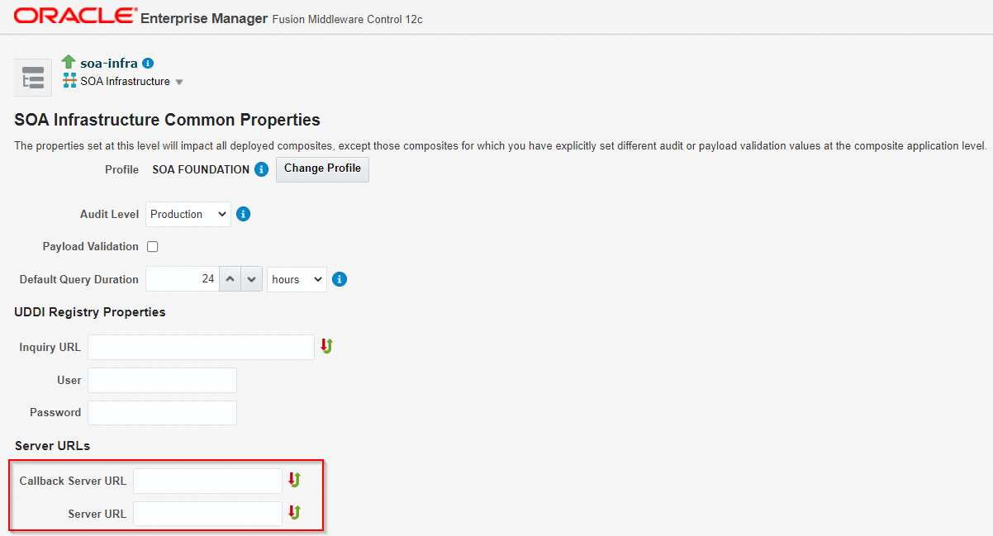

1. Restart all the servers.

# Defining System Properties for Legacy Connectors

* Validate and create the following two system properties and update their values to True.

**Service Account Encrypted Parameter Value**

**Service Account Parameters Value Store**

|  |  |  |
| --- | --- | --- |
| **Property Name** | **Keyword** | **Value** |
| Service Account Encrypted Parameter Value | ServiceAccount.API.EncryptedParamsValue | True |
| Service Account Parameters Value Store | ServiceAccount.ParamsValue.DBStore | True |

* Login into the Identity System Administration console and open the Configuration Properties link.

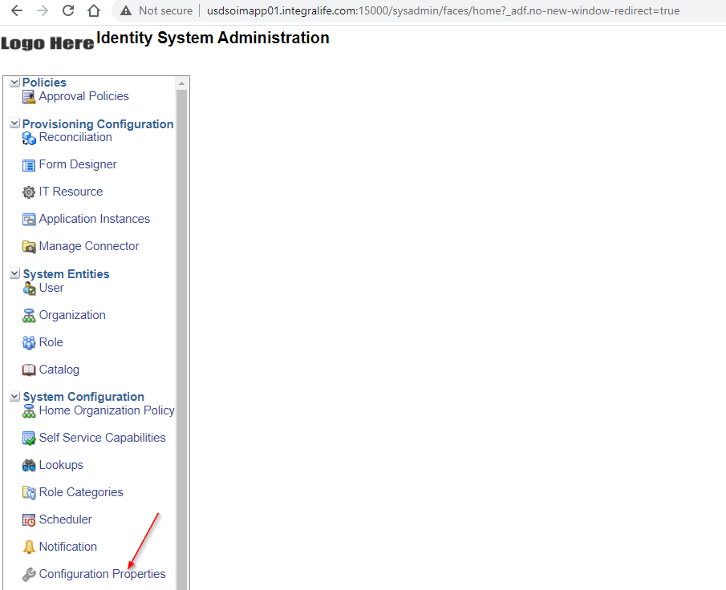

* Service Account Parameters Value Store System property is already available, validate the values.

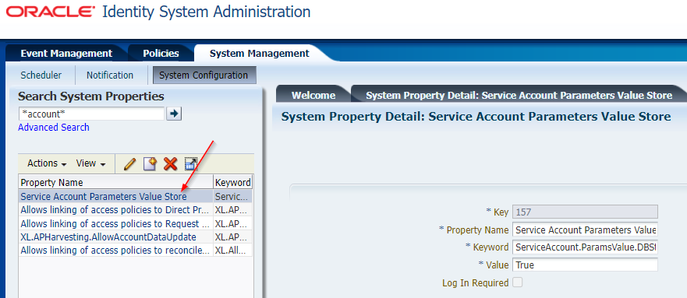

* Click on Create button and create the “Service Account Encrypted Parameter Value” System Property and click on Perform button.

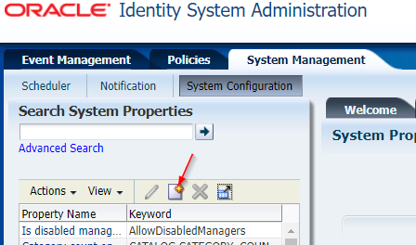

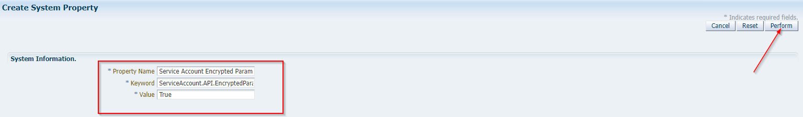

# Change OIM Port

1. Login into EM console and navigate to System MBean Browser under the WebLogic domain. Navigate to Application Defined MBeans🡺oracle.iam🡺Server:oim_server1🡺Application:oim🡺XMLConfig🡺Config🡺XMLConfig.DiscoveryConfig🡺Discovery

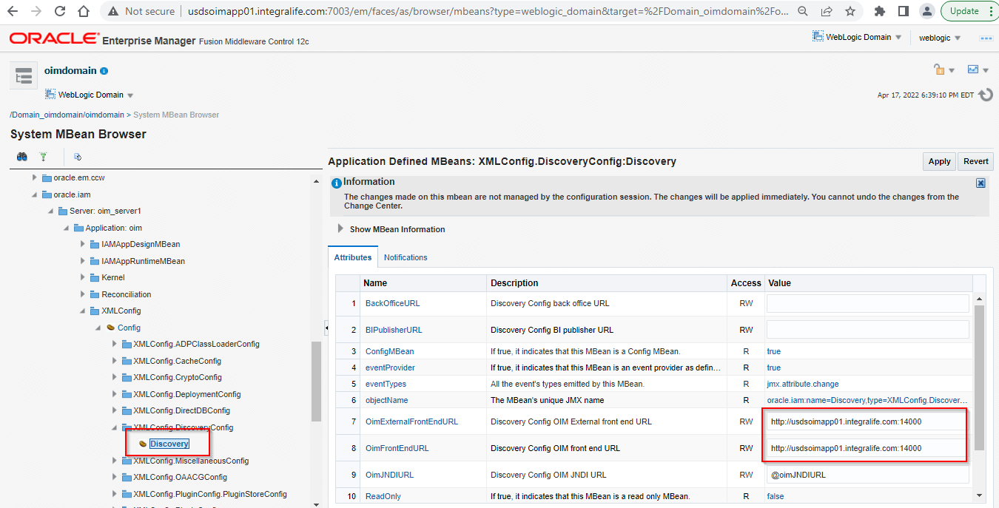

1. Change the OIM port as 15000 for **OIMExternalFronEndURL** and **OIMFromEndURL** and click on Apply button.

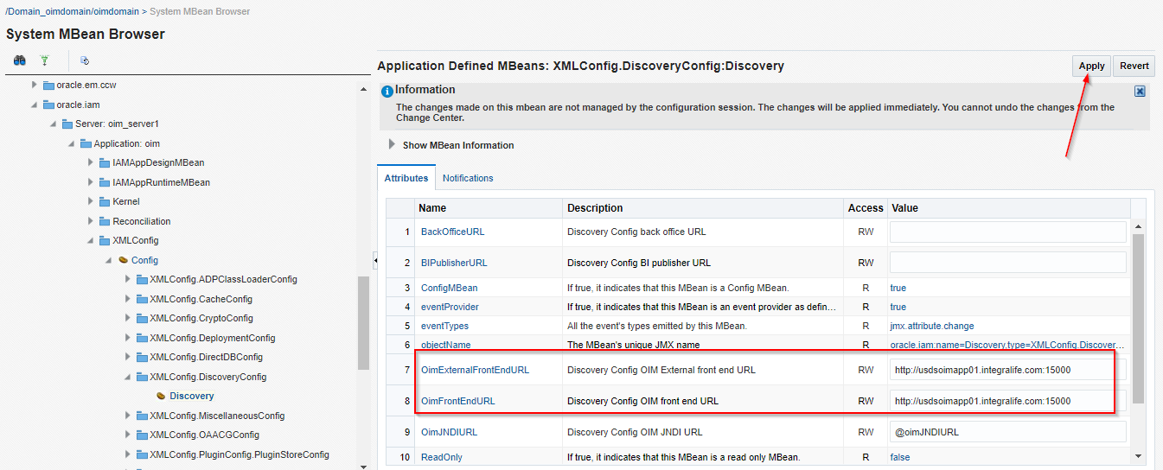

# Update EBS Query Property File Path

* Copy the EBS Query property file(**ebsERQuery.properties)** from the location **“/u01/app/oracle/Middleware/Oracle_IDM1/server/connectorResources/ebsERQuery.properties”** to **“/u03/oracle/product/Oracle_Home/idm/server/connectorResources/”**

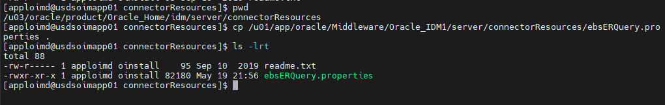

* Login into the Identity System Administration console and update the “**Query Properties File**” parameter for below EBS schedulers as “**/u03/oracle/product/Oracle_Home/idm/server/connectorResources/ebsERQuery.properties**” and click on Apply button.

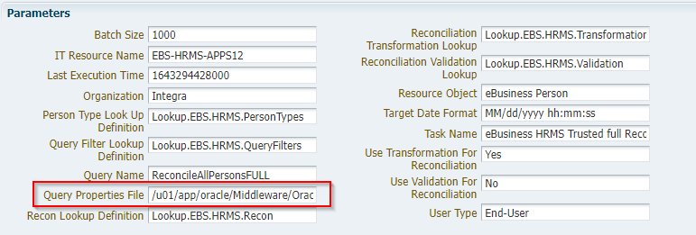

1. eBusiness HRMS Delete Reconciliation
2. eBusiness HRMS Trusted full Reconciliation
3. eBusiness HRMS Trusted Reconciliation
4. INTG eBusiness HRMS Trusted Future full Reconciliation
5. INTG eBusiness HRMS Trusted Future Reconciliation
6. INTG eBusiness HRMS Trusted Manager Reconciliation
7. INTG eBusiness HRMS Trusted Terminated full Reconciliation
8. INTG eBusiness HRMS Trusted Terminated Reconciliation

* Go to the location **“/u03/oracle/product/Oracle_Home/idm/server/XLIntegrations”** and create the directories as **EBSUM/config**.

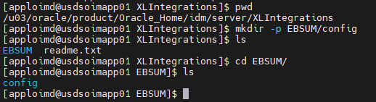

* Copy the EBS UM Query property file from the location **“/u01/app/oracle/Middleware/Oracle_IDM1/server/XLIntegrations/EBSUM/config/ebsUMLookupQuery.properties”** and **“/u01/app/oracle/Middleware/Oracle_IDM1/server/XLIntegrations/EBSUM/config/ebsUMQuery.properties”** to **“/u03/oracle/product/Oracle_Home/idm/server/XLIntegrations/EBSUM/config”**.

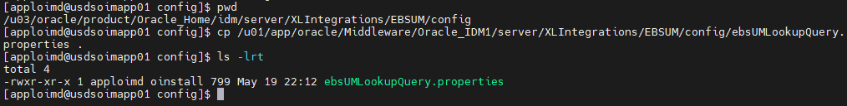

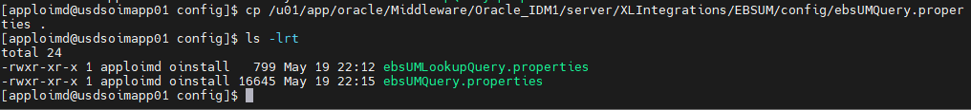

* Login into the Identity System Administration console and update the “**Query Properties File**” parameter for below EBS UM schedulers as

**eBusiness UM Target Resource User Reconciliation -**

“**/u03/oracle/product/Oracle_Home/idm/server/connectorResources/ebsERQuery.properties**”

**eBusiness UM Lookup Definition Reconciliation -**

**/u03/oracle/product/Oracle_Home/idm/server/XLIntegrations/EBSUM/config/ebsUMLookupQuery.properties**

# Update Logging Configuration

* Update the below logging configuration in following files and restart the all servers.

**$DOMAIN_HOME/config/fmwconfig/servers/AdminServer/logging.xml**

**$DOMAIN_HOME/config/fmwconfig/servers/oim_server1/logging.xml**

**$DOMAIN_HOME/config/fmwconfig/servers/soa_server1/logging.xml**

<log_handler name='ebs-er-handler' class='oracle.core.ojdl.logging.ODLHandlerFactory' level='NOTIFICATION:1'>

<property name='logreader:' value='off'/>

<property name='path' value='${domain.home}/servers/${weblogic.Name}/logs/ebs-er.log'/>

<property name='format' value='ODL-Text'/>

<property name='useThreadName' value='true'/>

<property name='locale' value='en'/>

<property name='maxFileSize' value='5242880'/>

<property name='maxLogSize' value='52428800'/>

<property name='encoding' value='UTF-8'/>

</log_handler>

<log_handler name='mp-handler' class='oracle.core.ojdl.logging.ODLHandlerFactory' level='NOTIFICATION:1'>

<property name='logreader:' value='off'/>

<property name='path' value='${domain.home}/servers/${weblogic.Name}/logs/mph.log'/>

<property name='format' value='ODL-Text'/>

<property name='useThreadName' value='true'/>

<property name='locale' value='en'/>

<property name='maxFileSize' value='5242880'/>

<property name='maxLogSize' value='52428800'/>

<property name='encoding' value='UTF-8'/>

</log_handler>

<log_handler name='adcs-handler' class='oracle.core.ojdl.logging.ODLHandlerFactory' level='TRACE:32'>

<property name='encoding' value='UTF-8'/>

<property name='useDefaultAttributes' value='false'/>

<property name='maxFileSize' value='5242880'/>

<property name='useThreadName' value='true'/>

<property name='useSourceClassAndMethod' value='TRACE:1'/>

<property name='locale' value='en'/>

<property name='maxLogSize' value='52428800'/>

<property name='format' value='ODL-Text'/>

<property name='logreader:' value='off'/>

<property name='path' value='${domain.home}/servers/${weblogic.Name}/logs/adcs.log'/>

</log_handler>

<log_handler name='ad-exc-handler' class='oracle.core.ojdl.logging.ODLHandlerFactory' level='NOTIFICATION:1'>

<property name='logreader:' value='off'/>

<property name='path' value='${domain.home}/servers/${weblogic.Name}/logs/adexc.log'/>

<property name='format' value='ODL-Text'/>

<property name='useThreadName' value='true'/>

<property name='locale' value='en'/>

<property name='maxFileSize' value='5242880'/>

<property name='maxLogSize' value='52428800'/>

<property name='encoding' value='UTF-8'/>

</log_handler>

<log_handler name='ebs-um-handler' class='oracle.core.ojdl.logging.ODLHandlerFactory' level='NOTIFICATION:1'>

<property name='encoding' value='UTF-8'/>

<property name='useDefaultAttributes' value='false'/>

<property name='maxFileSize' value='10485760'/>

<property name='useThreadName' value='true'/>

<property name='useSourceClassAndMethod' value='TRACE:1'/>

<property name='locale' value='en'/>

<property name='maxLogSize' value='52428800'/>

<property name='format' value='ODL-Text'/>

<property name='logreader:' value='off'/>

<property name='path' value='/u01/app/oracle/Middleware/user_projects/domains/oim/servers/oim_server1/logs/ebs-um.log'/>

</log_handler>

<log_handler name='manpro-handler' class='oracle.core.ojdl.logging.ODLHandlerFactory' level='NOTIFICATION:1'>

<property name='logreader:' value='off'/>

<property name='path' value='${domain.home}/servers/${weblogic.Name}/logs/manualprov.log'/>

<property name='format' value='ODL-Text'/>

<property name='useThreadName' value='true'/>

<property name='locale' value='en'/>

<property name='maxFileSize' value='5242880'/>

<property name='maxLogSize' value='52428800'/>

<property name='encoding' value='UTF-8'/>

</log_handler>

<log_handler name='customEBS_um.out' class='oracle.core.ojdl.logging.ODLHandlerFactory' level='TRACE:32'>

<property name='useDefaultAttributes' value='false'/>

<property name='format' value='ODL-Text'/>

<property name='path' value='${domain.home}/servers/${weblogic.Name}/logs/customEBS_um.out'/>

<property name='maxFileSize' value='10485760'/>

<property name='useSourceClassAndMethod' value='TRACE:1'/>

</log_handler>

<logger name='OIMCP.EBSER' level='NOTIFICATION:1' useParentHandlers='false'>

<handler name='ebs-er-handler'/>

</logger>

<logger name='INTEGRA.IDM.NOTIFICATION.LOGGER' level='NOTIFICATION:1' useParentHandlers='false'>

<handler name='mp-handler'/>

</logger>

<logger name='OIMCP.ADCS' level='NOTIFICATION:1' useParentHandlers='false'>

<handler name='adcs-handler'/>

</logger>

<logger name='OIMCP.MEXC' level='NOTIFICATION:1' useParentHandlers='false'>

<handler name='ad-exc-handler'/>

</logger>

<logger name='OIMCP.EBSUM' level='TRACE:32' useParentHandlers='false'>

<handler name='ebs-um-handler'/>

<handler name='customEBS_um.out'/>

</logger>

<logger name='OIMCP.MANPRO' level='NOTIFICATION:1' useParentHandlers='false'>

<handler name='manpro-handler'/>

</logger>

# Set Environment Variables

* Login into OIM Linux environment with user “**root**” user and open the **.bash_profile** from the location **“/home/apploimd”** and set the below environment variables and save file.

export APP_SERVER=weblogic

export ANT_HOME=/u03/oracle/product/Oracle_Home/oracle_common/modules/thirdparty/org.apache.ant/1.10.5.0.0/apache-ant-1.10.5

export JAVA_HOME=/u03/oracle/java

export MW_HOME=/u03/oracle/product/Oracle_Home

export WL_HOME=/u03/oracle/product/Oracle_Home/wlserver

export OIM_ORACLE_HOME=/u03/oracle/product/Oracle_Home/idm

export OIM_HOME=/u03/oracle/product/Oracle_Home/idm/server

export DOMAIN_HOME=/u03/oracle/config/domains/oimdomain

export PATH=$ANT_HOME/bin:$JAVA_HOME/bin:$PATH

#Oracle log shortcuts

alias nohuplog='tail -f $DOMAIN_HOME/bin/nohup.out'

alias adminlog='tail -f $DOMAIN_HOME/servers/AdminServer/logs/AdminServer.log'

alias oimoutlog='tail -f $DOMAIN_HOME/servers/oim_server1/logs/oim_server1.out'

alias oimdiaglog='tail -f $DOMAIN_HOME/servers/oim_server1/logs/oim_server1-diagnostic.log'

alias soaoutlog='tail -f $DOMAIN_HOME/servers/soa_server1/logs/soa_server1.out'

alias soadiaglog='tail -f $DOMAIN_HOME/servers/soa_server1/logs/soa_server1-diagnostic.log'

alias wlst='$MW_HOME/oracle_common/common/bin/wlst.sh';

#Oracle Navigation aliases

alias gomwhome='cd $MW_HOME/ && echo "-- ORACLE MIDDLEWARE HOME --"'

alias gooimhome='cd $OIM_ORACLE_HOME/ && echo "-- ORACLE OIM HOME --"'

alias gowlshome='cd $WLS_HOME/ && echo "-- ORACLE WEBLOGIC HOME --"'

alias godomainhome='cd $DOMAIN_HOME/ && echo "-- ORACLE OIM DOMAIN HOME --"'

alias gosoahome='cd /u03/oracle/product/Oracle_Home/soa/ && echo "-- ORACLE SOA HOME --"'

alias goanthome='cd $ANT_HOME/ && echo "-- ORACLE ANT HOME --"'

alias gojavahome='cd $JAVA_HOME/ && echo "-- ORACLE JAVA HOME --"'

alias goadminserver='cd $DOMAIN_HOME/servers/AdminServer/ && echo "-- ORACLE ADMIN SERVER HOME --"'

alias gooimserver='cd $DOMAIN_HOME/servers/oim_server1/ && echo "-- ORACLE OIM SERVER HOME --"'

alias gosoaserver='cd $DOMAIN_HOME/servers/soa_server1/ && echo "-- ORACLE SOA SERVER HOME --"'

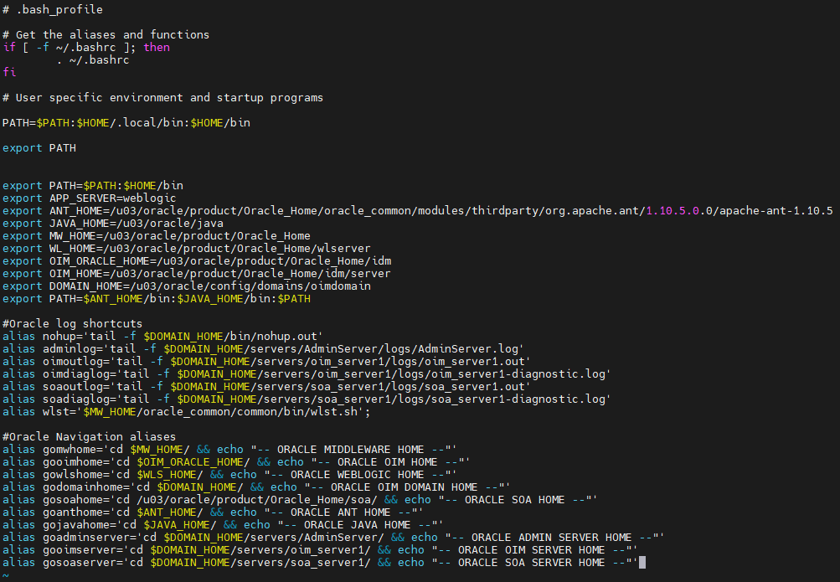

* Run the .bash_profile using below command.

**. .bash_profile**



Upload the Custom Jars to OIM

* Create a directory **OIMUploads/Jars** in the location **“/u03”**.
* Copied the below custom jar files in the location **“/u03/OIMUploads/Jars”.**

**IntegraCodes.jar**

**IntegraCustomCode.jar**

**Intg_AD_Refinement.jar**

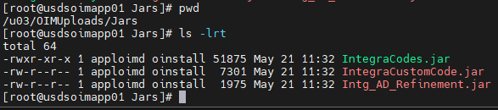

* Go to the location “**/u03/oracle/product/Oracle_Home/idm/server/bin**” and run the script “**UploadJars.sh**”.

Provide below run time inputs to the script:

UserName: xelsysadm

Password: *******

OIM URL: t3://usdsoimapp01:15000

WLS Context: weblogic.jndi.WLInitialContextFactory

JarType: JavaTasks

Jar Locations:

/u03/OIMUploads/Jars/IntegraCodes.jar

/u03/OIMUploads/Jars/IntegraCustomCode.jar

/u03/OIMUploads/Jars/Intg_AD_Refinement.jar

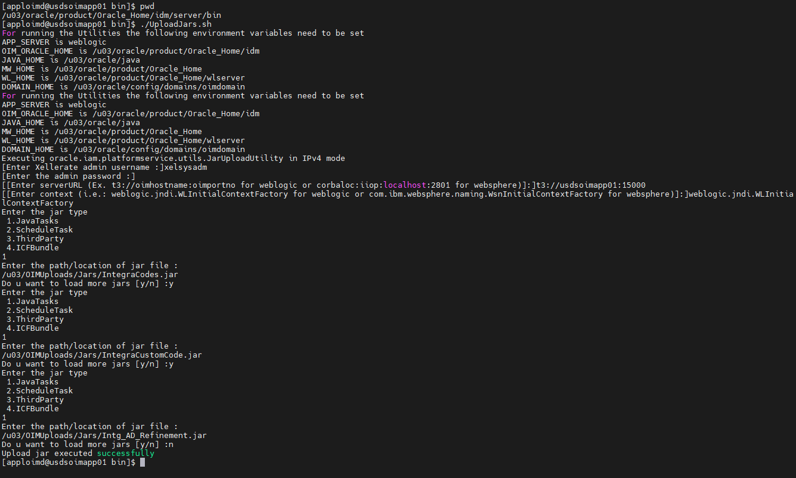

# Configure SSL For AD & Connector Server

* Copy the required connector server certificates(root, sub, local) to OIM Linux machine (/u03/OIMUploads/ExportedCerts).
* Run the below command to import the certificates to OIM WebLogic DemoTrust.jks keystore

**Connector Server Local**

keytool -import -trustcacerts -alias caminolocalnew -file USROIOIM100.camino.local.cer -keystore /u03/oracle/product/Oracle_Home/wlserver/server/lib/DemoTrust.jks -storepass DemoTrustKeyStorePassPhrase

**Active Directory Local**

keytool -import -trustcacerts -alias caminolocal -file USROIOIM100.camino.local.cer -keystore /u03/oracle/product/Oracle_Home/wlserver/server/lib/DemoTrust.jks -storepass DemoTrustKeyStorePassPhrase

**CAMINO Root and Sub**

keytool -import -trustcacerts -alias caminosub -file USROIOIM100.camino.sub.cer -keystore /u03/oracle/product/Oracle_Home/wlserver/server/lib/DemoTrust.jks -storepass DemoTrustKeyStorePassPhrase

keytool -import -trustcacerts -alias caminoroot -file USROIOIM100.camino.root.cer -keystore /u03/oracle/product/Oracle_Home/wlserver/server/lib/DemoTrust.jks -storepass DemoTrustKeyStorePassPhrase

* Run the below command to list the certificates from the keystore.

keytool -list -keystore /u03/oracle/product/Oracle_Home/wlserver/server/lib/DemoTrust.jks -storepass DemoTrustKeyStorePassPhrase

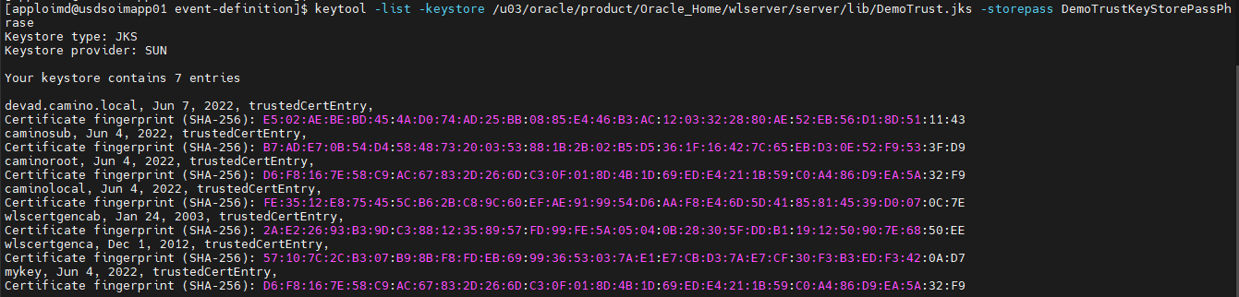

Notes:

1. Currently SSL is configured for Active Directory only(OIM Provisioning🡪Active Directory)
2. SSL is not configured for any of the OIM Instances Non-Prod & Prod
3. Export the AD certificates from existing OIM middleware domain or request new certificate for OIM – AD SSL communication.
4. If certificates are not available, request to generate new one or we can export from existing keystore.
5. To debug SSL issues, add below java properties in $DOMAIN_HOME/bin/setDomainEnv.sh file.

EXTRA_JAVA_PROPERTIES="-Doracle.xml.schema/Ignore_Duplicate_Components=true -Dssl.debug=true -Dweblogic.StdoutDebugEnabled=true -Dweblogic.security.SSL.verbose=true -Djavax.net.debug=all -Dweblogic.debug.DebugSecuritySSL=true -Dweblogic.debug.DebugSSL=true -Dweblogic.StdoutDebugEnabled=true -Dweblogic.log.StdoutSeverityLevel=Debug -Dweblogic.log.LogSeverity=Debug ${EXTRA_JAVA_PROPERTIES}"

export EXTRA_JAVA_PROPERTIES

1. Make sure import the root, sub, and local certificates to DemoTrust.jks

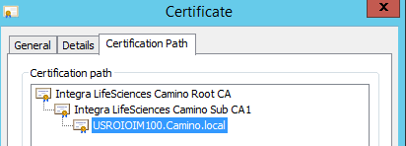

1. Make sure SAN names are properly defined after signing the certificate. SAN names should be the exact name which we used in IT Resource of AD and AD connector server host names.

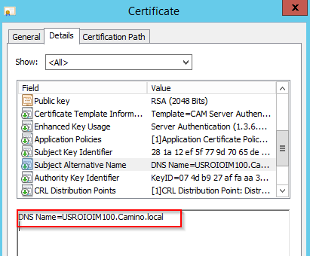

1. Make sure AD host name and Connector server host name should ping form IAM Linux machine
2. Make sure server name defined in the “Lookup.AD.Detials” is matched the Certificate SAN name

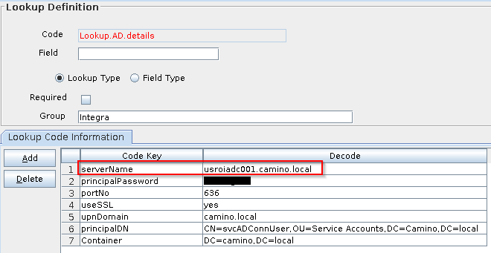

# Upgrade AD Connector Server

* Download 12.2.1.3.0 .net connector server from Oracle Technology Network.
* Copy the downloaded connector server to Windows server where the existing connector server installed(usroiadc001.camino.local).
* Take the backup of existing connector server directory and extract the newly copied connector server zip file in windows box.

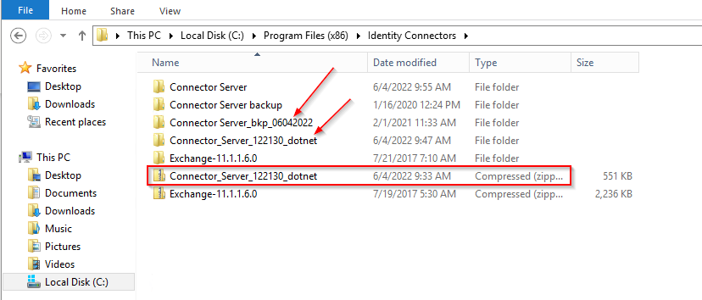

* Go to the location “**C:\Program Files (x86)\Identity Connectors\Connector_Server_122130_dotnet**” and copy the following files to the existing connector server directory i.e., **“C:\Program Files (x86)\Identity Connectors\Connector Server”**

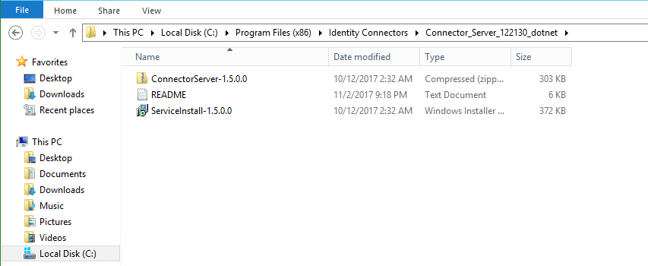

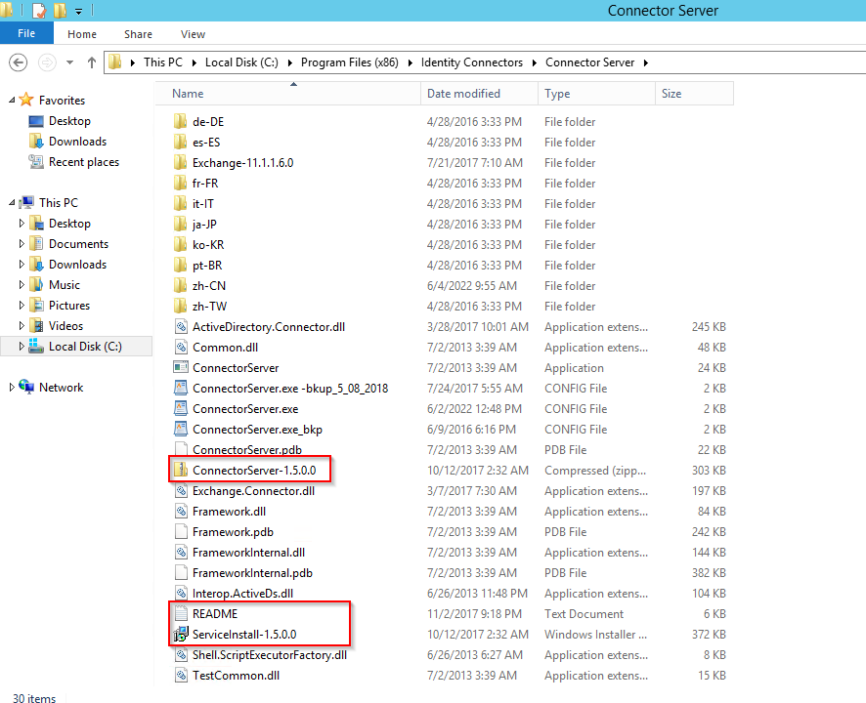

* Run the “ServiceInstall-1.5.0.0.msi” file to install the new version of connector server from the location “C:\Program Files (x86)\Identity Connectors\Connector Server”.

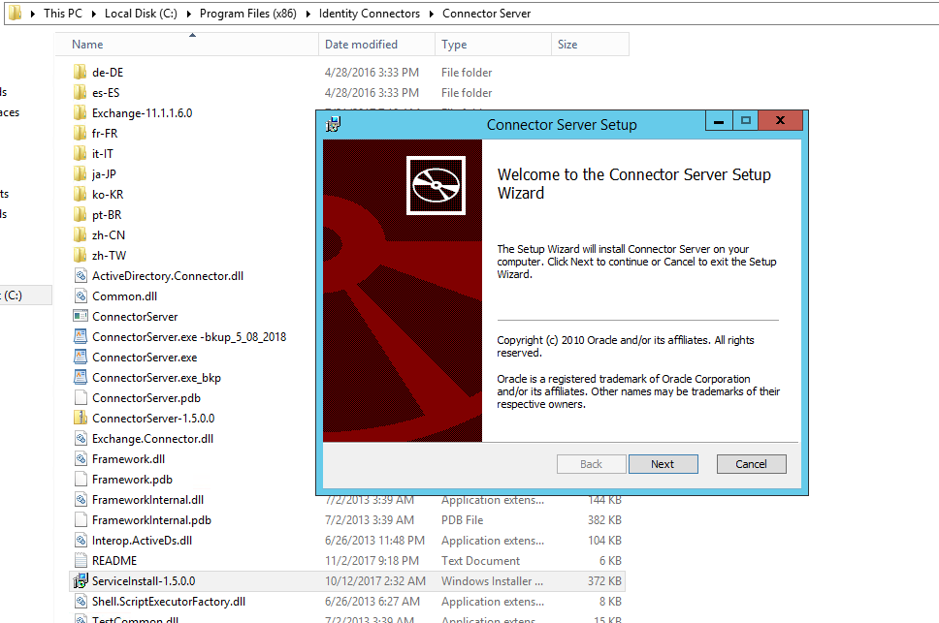

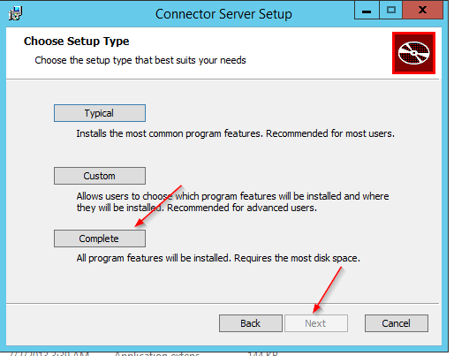

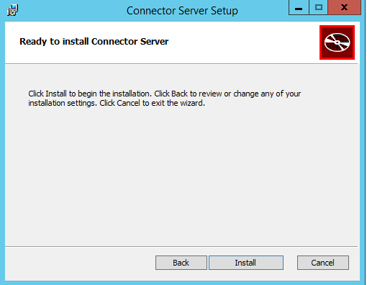

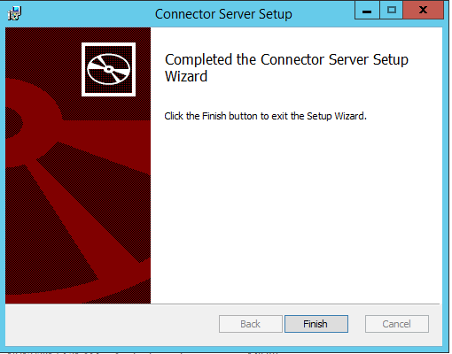

* Open the ConnectorServer.exe.CONFIG file and update the below properties as per existing configuration.

<add key="connectorserver.port" value="8758" />

<add key="connectorserver.usessl" value="true" />

<add key="connectorserver.certificatestorename" value="sslstore" />

<add key="connectorserver.protocol" value="TLS12"/>

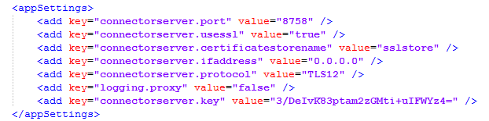

* Open the command prompt with “Run as Administrator” and go to the location “C:\Program Files (x86)\Identity Connectors\Connector Server”.

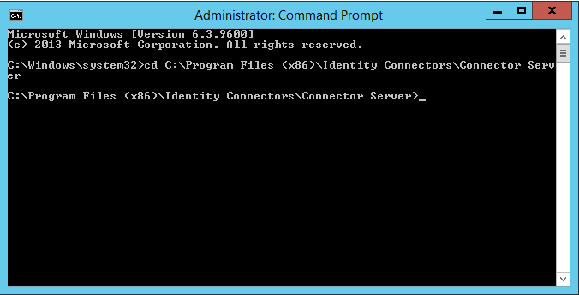

* Run the below command to set the Connector Server Key.

**ConnectorServer.exe /setKey 12345**

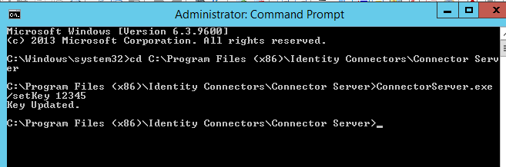

* Go to the Services and Start the Connector Server.

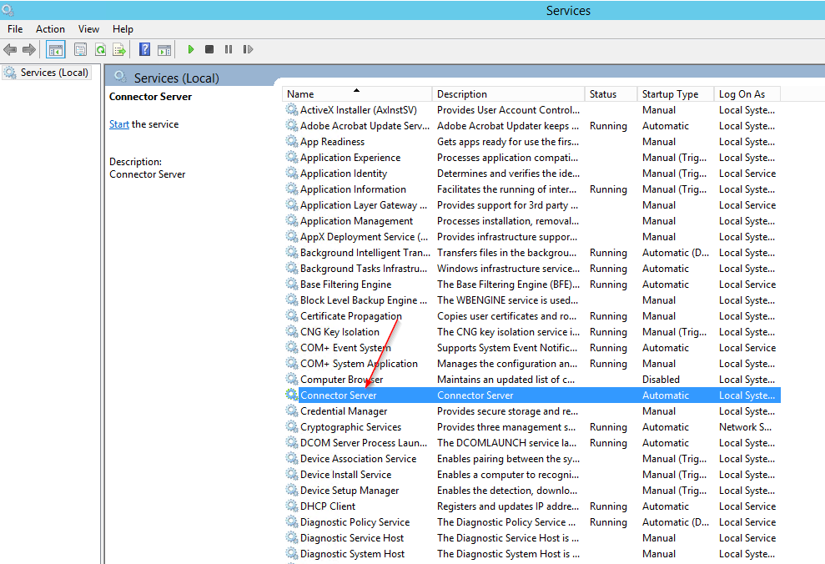

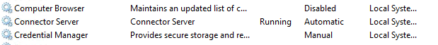

* Import the certificate to “sslstore” using below command.

**C:\>certutil -f -addstore sslstore C:\ USROIOIM100.camino.local.cer**

**Note: Make sure “SSLSTORE” must contain only one certificate. Remove the existing unused or expired certificates from SSLSTORE.**

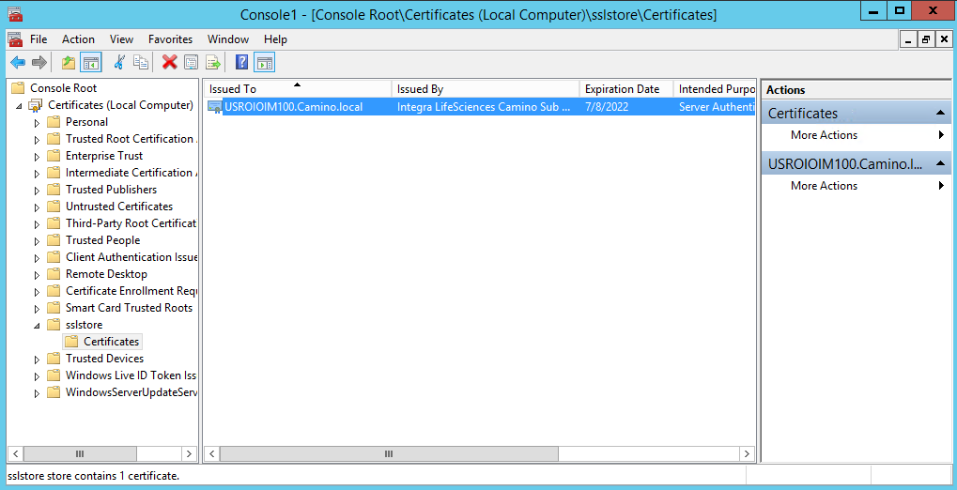

* Login into the Identity System Administration console and open the “Active Directory Connector Server” & “Exchange Connector Server” IT Resource. Click on Edit and update the key value as **12345** and save.

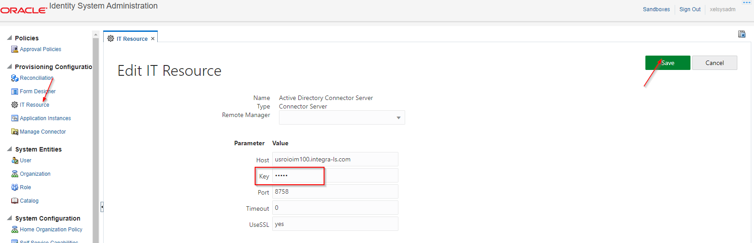

# Validate and Update Email Driver Properties

* Login into the EM console, open the email driver properties in User Messaging Service.

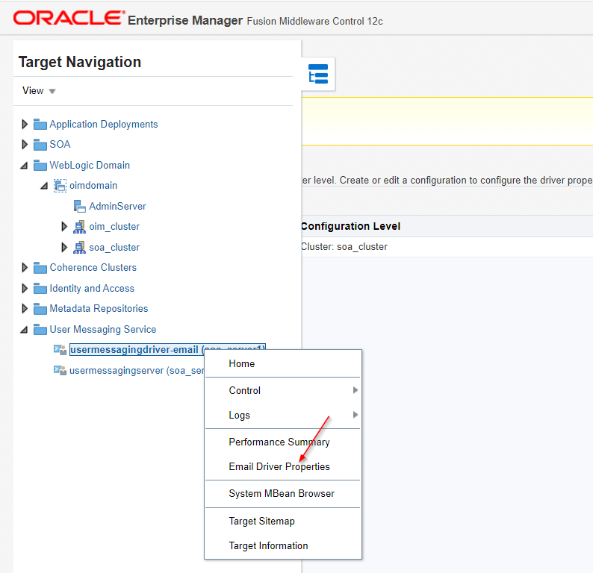

* Validate the configuration if the configuration is not found create new email driver properties.

**Note: Refer Pre-Requisites section to validate the production email driver properties**

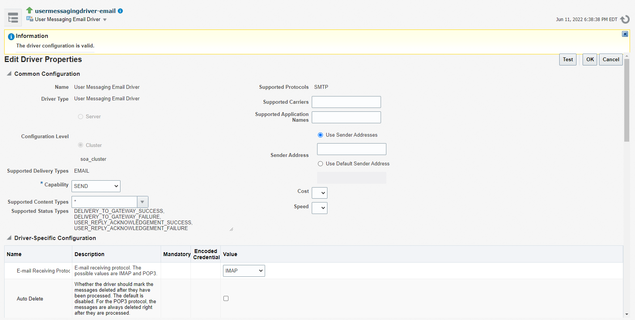

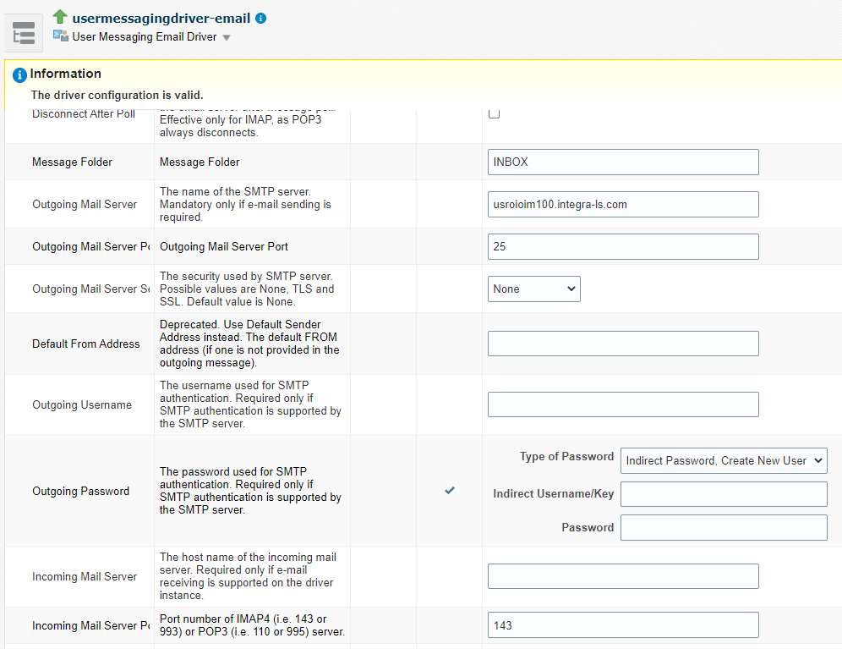

* Login into the Identity System Administration console and open the Email Server IT Resource. Make sure hostname is configured properly in IT Resource

**Production:**

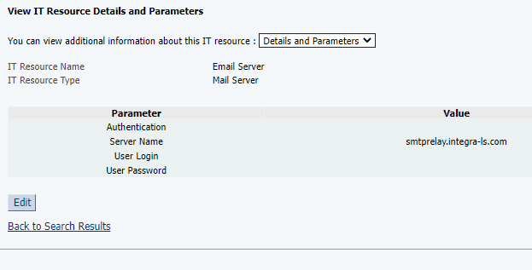

# Upgrade Issues & Resolution

**Issue #1**: Active Directory Account Provisioning Failed due to custom class loader issue (chkusrLogin).

**Resolution:** Following Jars should be uploaded to the OIMHOME_JARS table in oim database.

1. IntegraCodes.jar
2. IntegraCustomCode.jar
3. Intg_AD_Refinement.jar
4. AD_Refinement.jar

**Issue #2:** User Interface Issue of OIM Identity and System Administration Consoles

**Resolution:** Login into the Identity System Administration console and set value as “DEFAULT” for the following system properties.

1. Skin Family for OIM UI
2. Skin Version for OIM UI

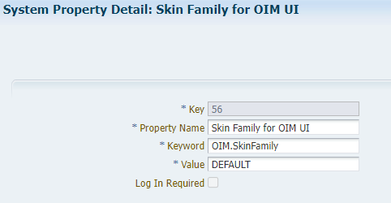

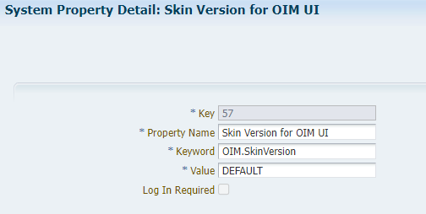

**Issue #3:** SSL Issue of Active Directory and Connector Server

**Resolution**: Refer Configure SSL For AD & Connector Server Section

**Issue #4:** Email Server Issue

Resolution: Refer Validate and Update Email Driver Properties Section

**Issue #5:** Unable to provision to Exchange

**Resolution:**

1. “Recipient Type” attribute value should be “UserMailbox” in Exchange Access Policy.

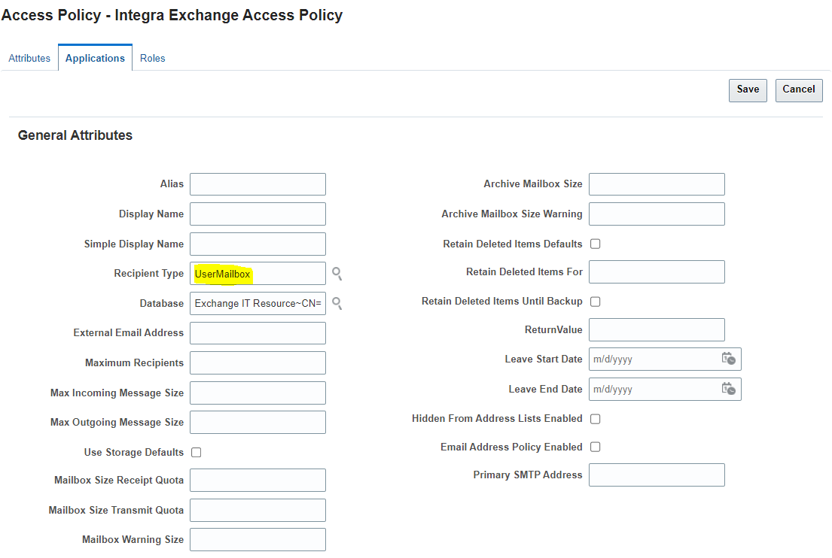

1. Temporary fix in dev environment to auto pre-populate “Database” value which is exist in DEV Exchange Server

**34~CN=Mailbox Database 0195043372,CN=Databases,CN=Exchange Administrative Group (FYDIBOHF23SPDLT),CN=Administrative Groups,CN=CaminoExchangeOrg,CN=Microsoft Exchange,CN=Services,CN=Configuration,DC=Camino,DC=local**

**Issue #6:** Error in logs while provisioning to AD account

java.lang.IllegalArgumentException: Value cannot be null.

Parameter name: Parameter 'uid' must not be null.

**Resolution:**

**Issue #7: <oracle.net.ns.NetException; local class incompatible: stream classdesc serialVersionUID = -661724712185082403, local class serialVersionUID = -4739282140558043459**

**Resolution:**

**Issue #8:** **java.lang.ClassNotFoundException: oracle.iam.connectors.ebs.common.vo.EBSResourceConnectionImpl**

**Issue #9: An error occurred while searching for access policies: oracle.iam.platform.entitymgr.exception.EntitySearchException: java.lang.NullPointerException**

**Backup for OIM 11g testing**

**Host file**

**10.162.2.2 uspsglfs01-glfs.integralife.com uspsglfs01-glfs**

**10.162.2.3 uspsglfs02-glfs.integralife.com uspsglfs02-glfs**

**10.162.2.87 uspsglfs03-glfs.integralife.com uspsglfs03-glfs**

**172.16.11.39 usroiadc001.camino.local usroiadc001**

**172.16.152.243 usroioim100.camino.local usroioim100**

**172.16.11.39 usroiadc001.integra-ls.com usroiadc001**

**172.16.152.243 usroioim100.integra-ls.com usroioim100**

# Install & Configure EBS HRSM 12c Connector

# AD and Exchange Connectors Patch Upgrade

* Take the complete backup of Database and export the MDS
* Download the below patched from Oracle Support

1. 28414711 – AD Connector Patch
2. 28630108 – Exchange Connector Patch
3. 34265350 – Exchange Connector Patch

## 28414711 – AD Connector Patch

1. Creating a new scheduled job "AD User Group Membership Recon".

Login to Sysadmin Console and import "AD User Group Membership Recon.xml" DM xml file. This will create a new scheduled job "AD User Group Membership Recon".

1. Creating a new scheduled job "AD User Target Reconciliation".

Login to Sysadmin Console and import "AD User Target Reconciliation.xml" DM xml file. This will create a new scheduled job "AD User Target Reconciliation".

1. Update Connector Server.
2. Login to Connector Server Windows box and stop the Connector Server
3. Take a backup of Connector Server HOME directory
4. Replace ActiveDirectory.Connector.dll with the one provided in the patch
5. Start the Connector Server.
6. Update main configuration lookup 'Lookup.Configuration.ActiveDirectory'.
7. Navigate to Sysadmin console, click on Lookups menu.
8. Search and open the lookup 'Lookup.Configuration.ActiveDirectory' for editing.
9. Add below two new entries.

* Add value 'Process Recon Event Batch Size' for Code column and value '500' for Meaning column.
* Add value 'Process Recon Event Thread Pool Size' for Code column and value '10' for Meaning column.
* Add value 'Any Incremental Recon Attribute Type' for Code column and value 'true' for Meaning column.
* Save the Lookup and exit.

1. Import the BulkAdapter.xml which is available in the PATCH using DM Import via Sysadmin Console.
2. Add the "UD_ADUSER Updated" Process Task of the "AD User" Process Definition in the following way.

* On the Design Console, expand Process Management node and then double-click Process Definition.
* Search for and open the "AD User" process definition.
* Create new task by clicking New under Tasks tab
* Provide the task name "UD_ADUSER Updated" and provide Task Description as "UD_ADUSER Updated"
* Make sure that Conditional, Allow Cancellation while Pending and Allow Multiple Instances check boxes are selected and click on the Save icon.
* On the Integration tab, click Add in the Event Handler/Adapter region.
* Click the Adapter and add the "adpADIDCUPDATEMULTI" from the adapter list
* Click the Save icon.
* On the Integration tab, double-click the variables for which mapping is required. This is indicated by N at the start of the variable.
* For each variable, select the values for the Map To and Qualifier lists as given in the following table.

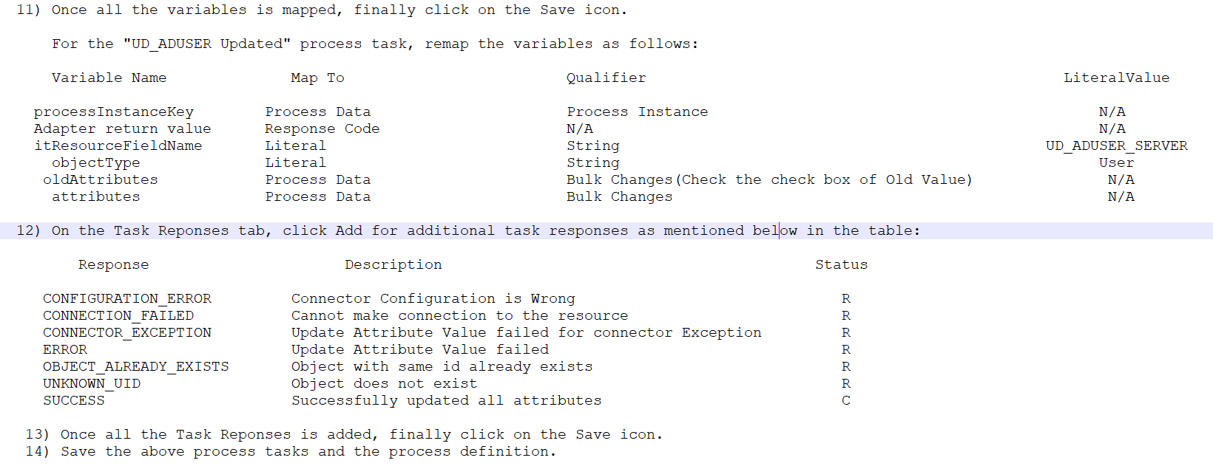

1. Re-start OIM server.

## 28630108 – Exchange Connector Patch

* Stop the connector server.
* Take a backup of the existing Exchange.Connector.dll and Replace it with the Exchange.Connector.dll provided in the Patch.
* Restart the connector server.
* Login to design console.
* Search and open 'Lookup.Exchange.Configuration'.
* Add new entry with code key 'ReplacePrimarySmtpAddressOnUpdate' and decode 'false'.
* Re-start OIM.

## 34265350 – Exchange Connector Patch

* Stop the connector server.
* Take a backup of the existing Exchange.Connector.dll and Replace it with the Exchange.Connector.dll provided in the Patch.
* Restart the connector server.